Test Procedure for the LCLS-II-HE Undulator Quadrupole Magnets
(Revision 01)
This test procedure is intended to cover mechanical fiducialization and magnetic measurements of the Production Units of the four LCLS-II-HE undulator quadrupole magnets at SLAC. It requires three bipolar power supplies (one ±6 A for the main coils; two ±1 A for the trim coils)
Receiving:
The following information is to be noted upon receipt of the magnets by the SLAC MM group:
Received by (initials): | SDA
Date received (dd-mmm-yyyy): | 5/28/2024
SLAC barcode number: | 4269
Vendor serial number on the magnet: | 071
Shipping damage (Y or N): | N

Preparation:
A beam direction arrow, with text “beam direction”, is to be applied before the start of the measurements to the top side of the magnet. The beam direction will be for the SXR undulator quad. A sticker stating that this is a SXR undulator quad is to be applied to the top side of the magnet. The polarity labels must be consistent with a SXR quadrupole.
Beam-direction arrow in place (initials): | SDA

Fiducialization:
The magnet is to be fiducialized by the Quality Inspection group. This will require the installation of removable tooling balls. The fiducialization process will include the determination of the geometric axis of the pole faces and should yield the following data: (a) the location of the tooling balls with respect to the center of this geometric axis when the poles are aligned precisely horizontally; (b) all six distances between the four tooling balls on the four individual quadrants; (c) the pole face curves so that their radial offset, azimuthal offset and pole rotation can be determined.
CMM operator (initials): | KC

URL of on-line CMM fiducialization data (please modify or correct if necessary):
http://www-group.slac.stanford.edu/met/MagMeas/MAGDATA/LCLS-II-HE/Quad/4269

Procedures:
Ramp Rates and Wait Times:
Main Coil – 1 A/s
Trim Coil – 0.2 A/s
Three Linear Ramp
Wait time of 10 s for ramp and standardize.
PROC01: Magnet Standardization:
Standardize the magnet by changing the quadrupole current, starting from 0 A to +6 A, then through 3 full cycles from +6 A to -6 A and back up to +6 A.

PROC02: Measurement of the change of the magnetic quadrupole center as a function of quadrupole excitation current:
a) Starting at –4.5 A, measure the magnetic quadrupole center for the following current settings:
–4.5, –5.0, –5.5, –5.0, –4.5, –4.0, –3.5, –4.0, –4.5
b) Starting at +4.5 A, measure the magnetic quadrupole center for the following current settings:
+4.5, +5.0, +5.5, +5.0, +4.5, +4.0, +3.5, +4.0, +4.5

PROC03: Magnet Warm Up:
Magnet should be run for 5 hours (at least, can be run for more) at -4.5 Amps to reach nominal temperature

Magnetic Measurements:
Enter URL of on-line magnetic measurements data:
http://www-group.slac.stanford.edu/met/MagMeas/MAGDATA/LCLS-II-HE/Quad/4276

- Label the quadrupole main connections so a positive current produces a positive (horizontally focusing) field polarity for the quadrupole field, as shown below:
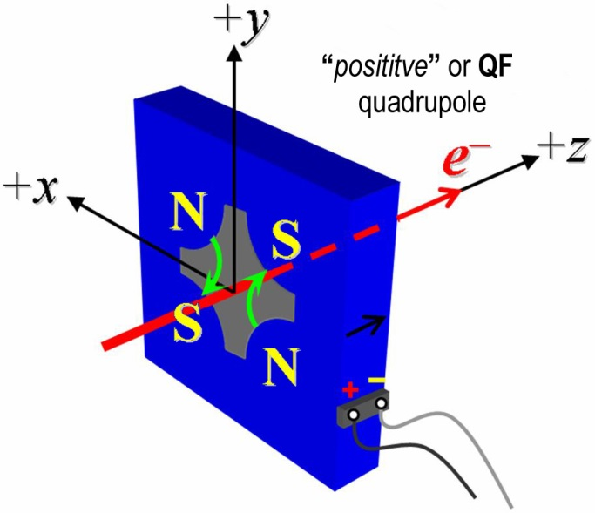
Figure 1: The undulator quadrupole magnets are all defined as “positive” polarity.

- Mark the polarity near the magnet leads with clear “Q+” and “Q−” labels as shown above.
Quad field polarity has been labeled (initials): | SDA

- Label the horizontal trim connections so a positive current produces a positive field polarity as shown below:
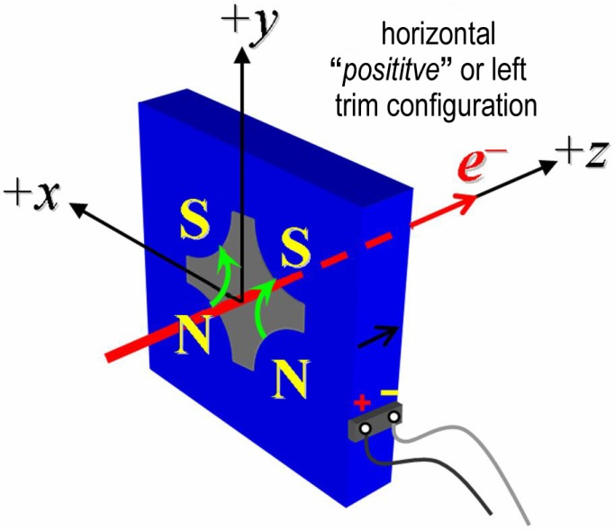
Figure 2: The undulator quadrupole magnets are all defined as “positive” horizontal trim polarity.
- Mark the polarity near the magnet leads with clear “H+” and “H−” labels as shown above.
Horizontal trim polarity has been labeled (initials): | SDA

- Label the vertical trim connections so a positive current produces a positive field polarity as shown below:
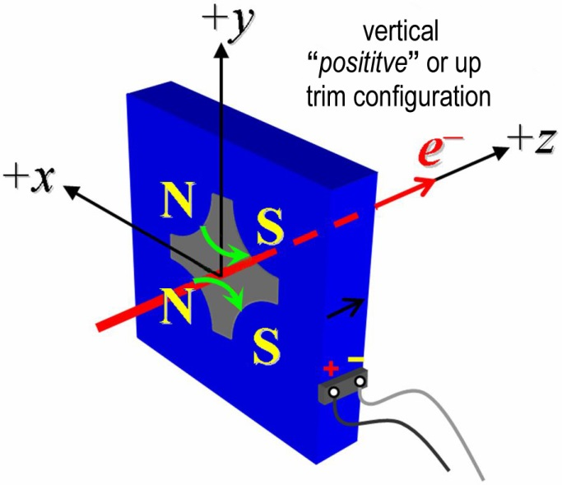
Figure 3: The undulator quadrupole magnets are all defined as “positive” vertical trim polarity.

- Mark the polarity near the magnet leads with clear “V+” and “V−” labels as shown above.
Vertical trim polarity has been labeled (initials): | SDA

- Measure the inductance and resistance of the quadruple coils:
Inductance of coils at 100 Hz (mH): | 55.25 mH
Resistance of coils (Ω): | 0.5314 Ω
Coil Temperature | 23.9 °C

- Measure the inductance and resistance of the horizontal trim coils:
Inductance of horizontal trim coils (mH): | 2.408 mH
Resistance of horizontal trim coils (Ω): | 0.4672 Ω

- Measure the inductance and resistance of the vertical trim coils:
Inductance of vertical trim coils (mH): | 2.368 mH
Resistance of vertical trim coils (Ω): | 0.4674 Ω

- Connect the quadrupole field magnet terminals (Q+, Q-) in the correct polarity as established above, to a bipolar power supply (preferably MCOR6) with maximum current |I| ≥ 6 A. Check that the trim terminals are disconnected.
Quad terminals have been connected (initials): | SDA

- Run the quadrupole current at 4.5 A for 5 hours and record the ambient temperature and the temperature of one coil and the magnet steel temperature.
Ambient temperature (xx.x °C): | 27.0 °C
Final magnet steel temperature (xx.x °C): | 31.0 °C
Final magnet coil temperature (xx.x °C): | 33.7 °C

- Follow PROC03 to warm up the magnet. Standardize the magnet according to PROC01, finally ending at −6 A.
Standardization complete (initials): | SDA
Pause used at each max. and min. (s): | 10 Seconds

- Measure the length-integrated field gradient, ∫Gdl, for quadrupole current settings from −6.0 A to +6.0 A in 0.5-A steps (25 ‘up’ measurements), and then back down from +6 A to −6.0 A in 0.5-A steps (25 ‘down’ measurements). Measure the field harmonics at quadrupole currents of +4.5 A and −4.5 A using a rotating probe.
Rotating coil name | 0_25DQB26
Rotating coil radius (m): | 0.0029972
Harmonics data file name: | Hardat.ru1, Harplt.ru1
Filename of ∫Gdl up & down data: | Strdat.ru1, strplt.ru1

- Standardize the magnet according to PROC01, finally ending at −6A. Follow PROC03 to warm up the magnet. Determine the magnetic quadrupole ‘Center Reference’ at a quadrupole current of −4.5 A to be used in the following procedure steps, with respect to the magnet fiducials. Measure the change of the magnetic quadrupole center with respect to the ‘Center Reference’ as a function of quadrupole excitation current according to PROC02. Keep magnet at temperature per PROC03.
Filename of data: | Strdat.ru2, strplt.ru2

- Connect the horizontal trim field terminals (H+, H-) with the correct polarity as established above, to a bipolar power supply with maximum current |I| ≥ 1 A.
Operator (initials): | SDA

- Connect the vertical trim field terminals (V+, V-) with the correct polarity as established above, to a bipolar power supply with maximum current |I| ≥ 1 A.
Operator (initials): | SDA

- With the quadrupole current at +4.5 A run both, the horizontal and vertical trim currents up to +1 A for 5 hours to warm the magnet up (record temperature).
Ambient temperature (xx.x °C): | 22.3 °C
Final magnet core temperature (xx.x °C): | 25.8 °C
Final magnet coil temperature (xx.x °C): | 28.8 °C

- With both, the horizontal and vertical trim currents at 0.0 A, standardize the magnet with the quadrupole field supply according to PROC01, finally ending at +4.5 A (destination QF, corresponding to length-integrated field gradient, ∫Gdl of +3 T).

The next two measurements will measure the trim corrector hysteresis. Ideally, each trim corrector should shift the magnetic center, in one plane only. Measure the change of the magnetic quadrupole center with respect to the ‘Center Reference’ as a function of trim excitation current for trims ranges of +/- 1 Amp. The following are the trim current settings with a quadrupole current of +4.5 A:
Description | H-Cur | V-Cur
Center | 0 A | 0 A
Upper Right Corner | +1 A | + 1 A
Lower Right Corner | + 1 A | - 1 A
Lower Left Corner | - 1 A | - 1 A
Upper Left Corner | - 1 A | + 1 A
Center | 0 A | 0 A

+/- 1 Amp Center Data Filename | Ctrdat.ru3

- With both, the horizontal and vertical trim currents at 0.0 A, standardize the magnet with the quadrupole field supply according to PROC01, finally ending at+4.5 A (destination QF, corresponding to length-integrated field gradient, ∫Gdl of +3 T).
- Measure the change of the magnetic quadrupole center with respect to the ‘Center Reference’ as a function of trim excitation current for the following trim current settings (maximum range) and at a quadrupole current of +4.5 A:
Description | H-Cur | V-Cur
Center | 0 A | 0 A
Upper Right Corner | +0.5 A | + 0.5 A
Lower Right Corner | + 0.5 A | - 0.5 A
Lower Left Corner | - 0.5 A | - 0.5 A
Upper Left Corner | - 0.5 A | + 0.5 A
Center | 0 A | 0 A

+/- 0.5 Amp Center Data Filename | Ctrdat.ru4

- Measure the change of the magnetic quadrupole center with respect to the ‘Center Reference’ as a function of small trim excitation current changes for the following trim current settings and at a quadrupole current of +4.5 A: The coupling to the orthogonal plane needs to be negligibly small (1 µm or less for small current changes).
Description | H-Cur | V-Cur
Home | +0.5 A | +0.5 A
Upper Right | +0.6 A | + 0.6 A
Lower Right | + 0.6 A | + 0.4 A
Lower Left | +0.4 A | +0.4 A
Upper Left | +0.4 A | +0.6 A
Home | +0.5 A | +0.5 A

+/ 0.1 Amp Center Data Filename: | Ctrdat.ru5

- Measure the length-integrated trim fields, ∫Bdl, as a function of trim excitation current. for the following trim current settings. The measurement is to be taken at the ‘Center Reference’ for a quadrupole current of +4.5 A.
Description | H-Cur | V-Cur
Center | +0 A | + 0 A
Horizontal Left-Kick | +1 A | + 0 A
Horizontal Right-Kick | -1 A | + 0 A
Vertical Up-Kick | +0 A | + 1 A
Vertical Down-Kick | +0 A | - 1 A
Left & Up Kick | +1 A | + 1 A
Left & Down Kick | + 1 A | - 1 A
Right & Down Kick | - 1 A | - 1 A
Right & Up Kick | - 1 A | + 1 A

Filename of ∫Bdl trim data: | Strdat.ru6, strplt.ru6

- Fiducialize the quadrupole tooling balls with respect to the magnetic center based on vibrating wire measurements in the CMM.
Data file name: | Quad 4269 Wire Fiducial Tooling Ball Data.txt

- Upon completion of tests, send link to all data to Heinz-Dieter Nuhn. Acceptance of magnet should be given by email to Magnetic Measurements Group.
Acceptance file from H.-D. Nuhn | UQU-Results-Traveler-4269.pdf

