LEIT Background Field Measurements
Scott Anderson, SLAC National Accelerator Laboratory
April 30, 2026

Abstract
This note details the background field measurements made for Low Emittance Injector Tunnel (LEIT) before installation of the concrete floor

Introduction
The LCLS-II High Energy (LCLS-II-HE) project at the SLAC National Accelerator Laboratory raises the existing LCLS-II superconducting linac energy from 4.5 GeV to 8.2 GeV. This energy upgrade allows photon production at shorter wavelengths and higher energies for cutting edge X-ray science. To realize the required beam brightness and stability, a new superconducting Low Emittance Injector (LEI) is being constructed in a dedicated tunnel parallel to the existing superconducting linac. The LEI incorporates a high-gradient superconducting RF gun and low–mean-transverse-energy photocathodes to deliver electron beams with emittances significantly below those of the existing LCLS-II injector. Background fields larger than the Earth’s field can adversely affect the beam and components in the accelerator, most notably superconducting cavities. Measurements were made on a representative number of the concrete/shotcrete support materials to determine their residual magnetic field before they are installed in the LEIT. Measurements were also made in a subsection of the unfinished LEIT, to obtain a baseline background field level before the concrete floor is installed. Background field measurements will be made in the LEIT when it is completed.

Support Material Measurements
Measurements were made on two lattice girders, two galvanized steel members with welded headed studs and two 20 foot lengths of 3/4 inch diameter rebar, all of which are pictured in figures 1-3 below. The measurements were performed using a 1 axis hall probe, 3 inches from the objects, to determine the highest and the average remanent fields from the materials. The results are summarized in the table below.

Material | Maximum Field @ 3” | Average Field | Comment
 | (G) | (G)
Lattice Girder | 2.4 | 0.1 | Field <= 0.2 G except at end plates where the fields were 1.0 to 2.4 G range.
20’ Rebar | 2.5 | 0.0 | Field varies along length between +/-2.0 G changing every 12-20”
Galvanized Angle | 0.4 | 0.0 | Field 0.0 except at the ends where it was 0.4 G
Table 1: Support Material Remnant Field Measurements
Measurements were also made approximately 24 inches above each set of materials, to see if any amount of stray field could be detected at the distance used for the tunnel measurements. None of the material showed any field at this distance. One can conclude that installing this material would not change the background field of the LEIT.

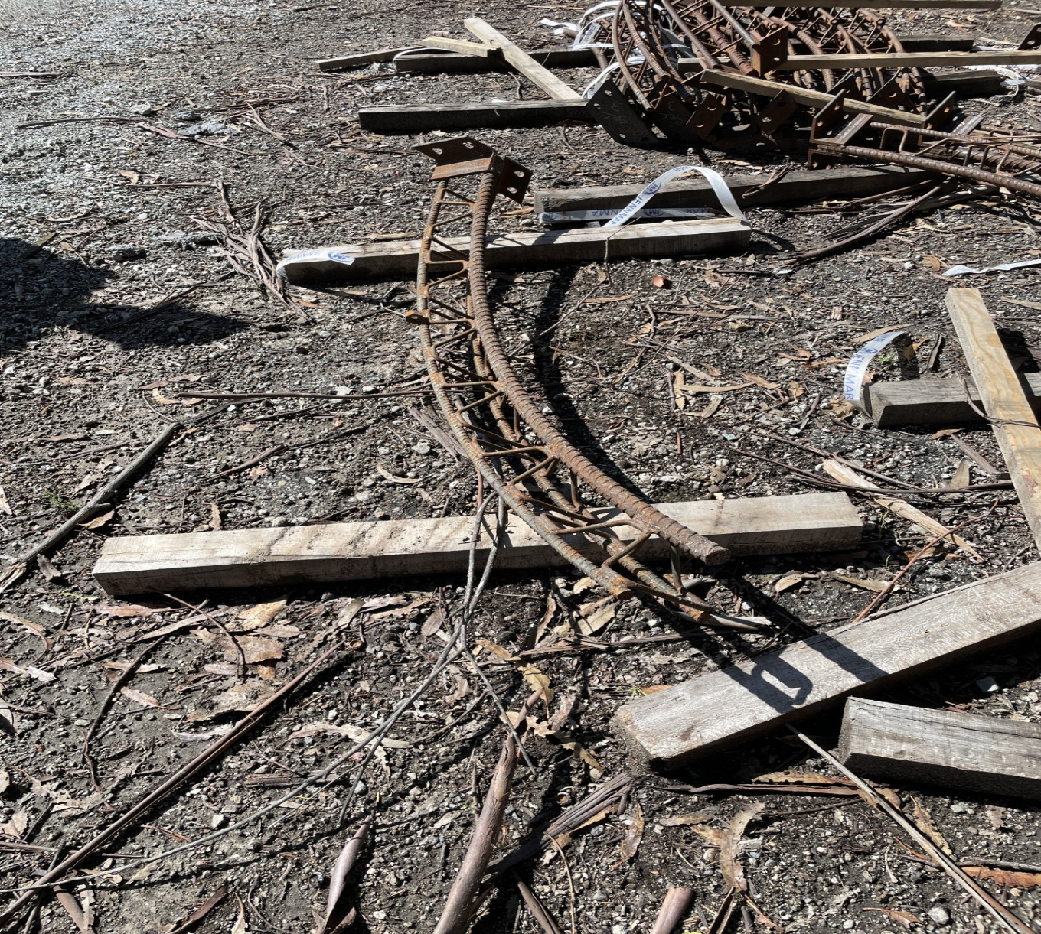

Figure 1: Lattice Girder

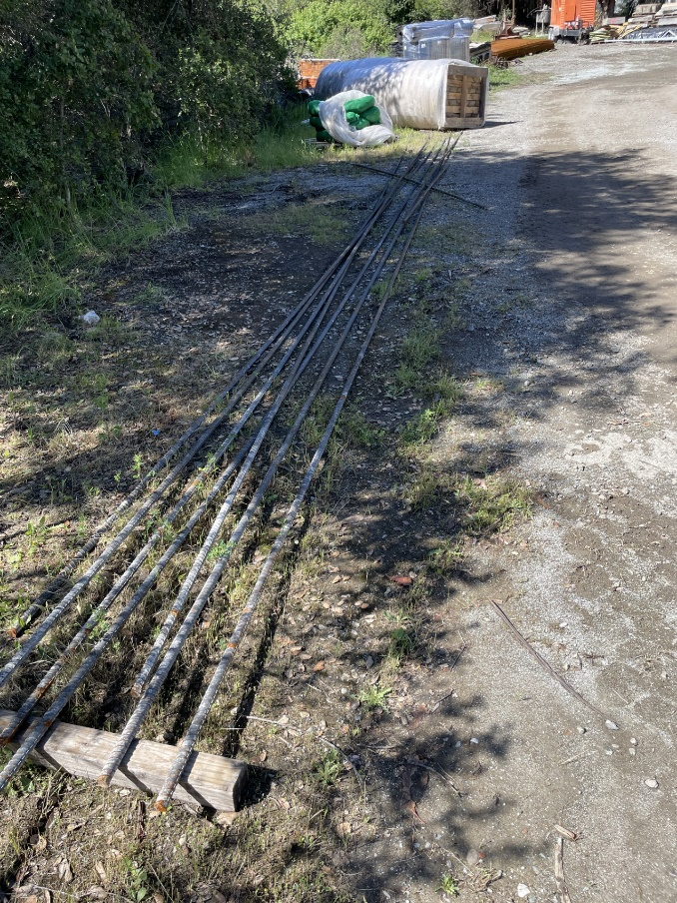
Figure 2: 20 foot, ¾ inch Rebar

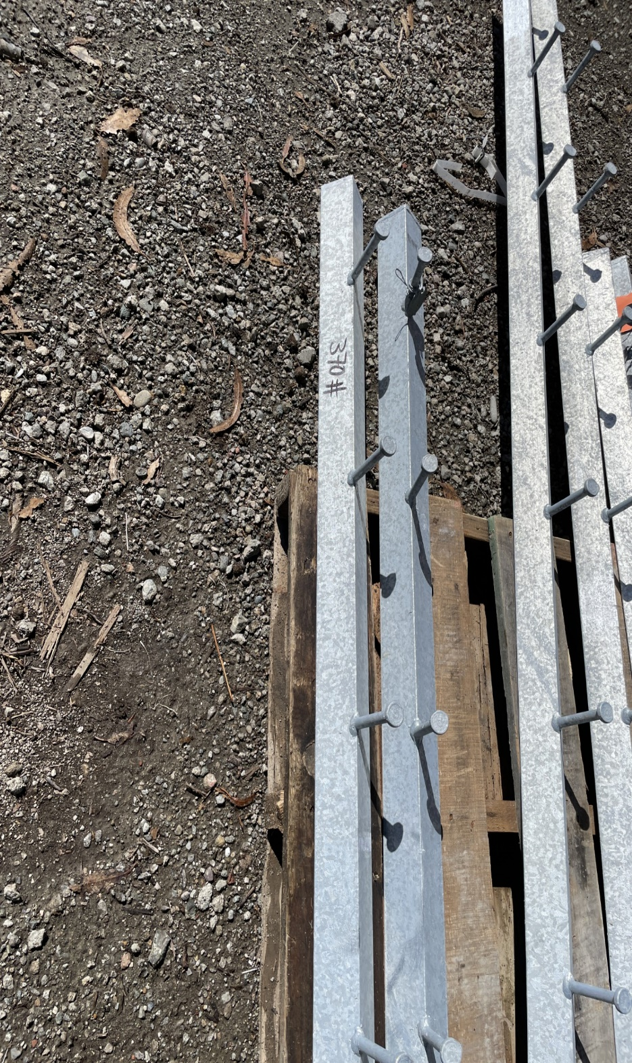
Figure 3: Galvanized Steel Angles with Studs

Unfinished Tunnel Background Measurements

Measurements were conducted in the unfinished tunnel, to get a baseline of the background field, before the concrete floor is installed. The measurements were made with a Bartington 3 axis fluxgate probe whose voltage signals were read out by a Keysight 34970 multimeter. A 5 foot by 30 foot area (~1.5 x 9 m), the dark gray area in figure 4, was chosen for measurements, because the super conducting bunching module will be placed there and stray fields can affect cavity performance. Measurements were done 24 inches off the ground (0.61 m), for 30 feet along the centerline of the box, which is the beam centerline and at x = +/- 0.75 m (2.46 ft) from this centerline. The Z starting point was 70’ from the tunnel entrance or Z = -27.8892 meters in Linac coordinates. Measurements were made every 0.5 meters (1.64 feet) in Z.

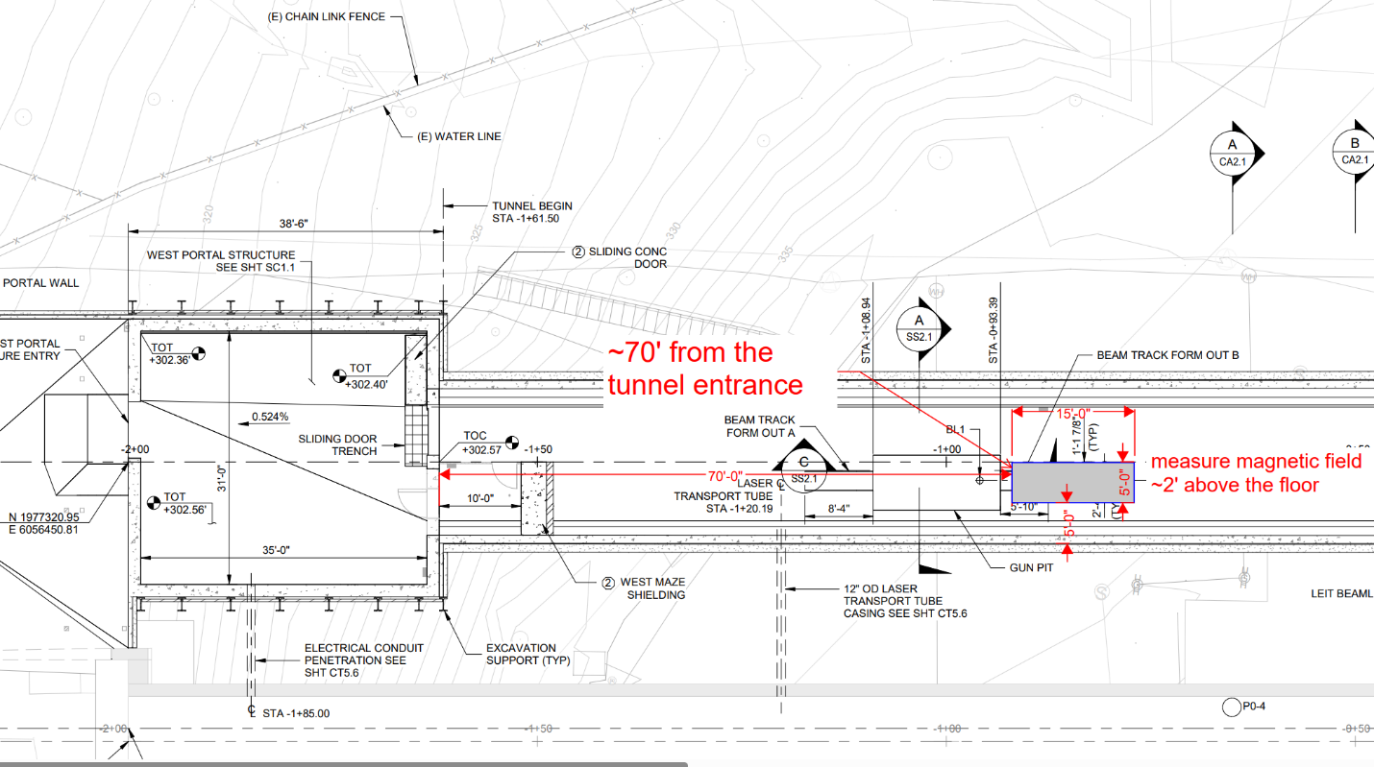
Figure 4: LEIT Measurement Map

The LEIT measurement results are graphed in Figure 5 below. The field measurements are consistent with background measurements made in the Linac Tunnel, Sector 0 -10, which are shown in Figure 6. The mean magnitudes of the LEIT field measurements are statistically consistent to the mean magnitudes of the Sector 0 – 10 field measurements and the maximum LEIT fields are not higher than the maximum Sector 0-10 fields.

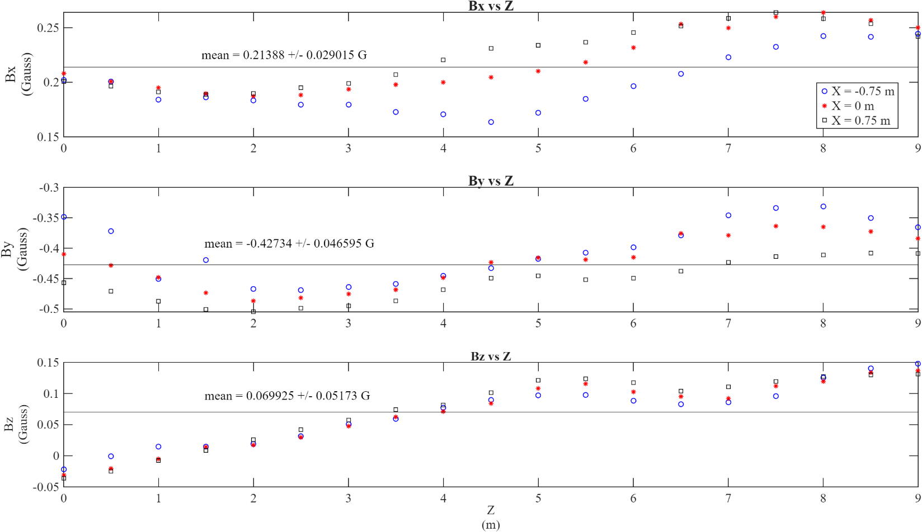
Figure 5: Bx, By, and Bz Background Field in unfinished LEIT

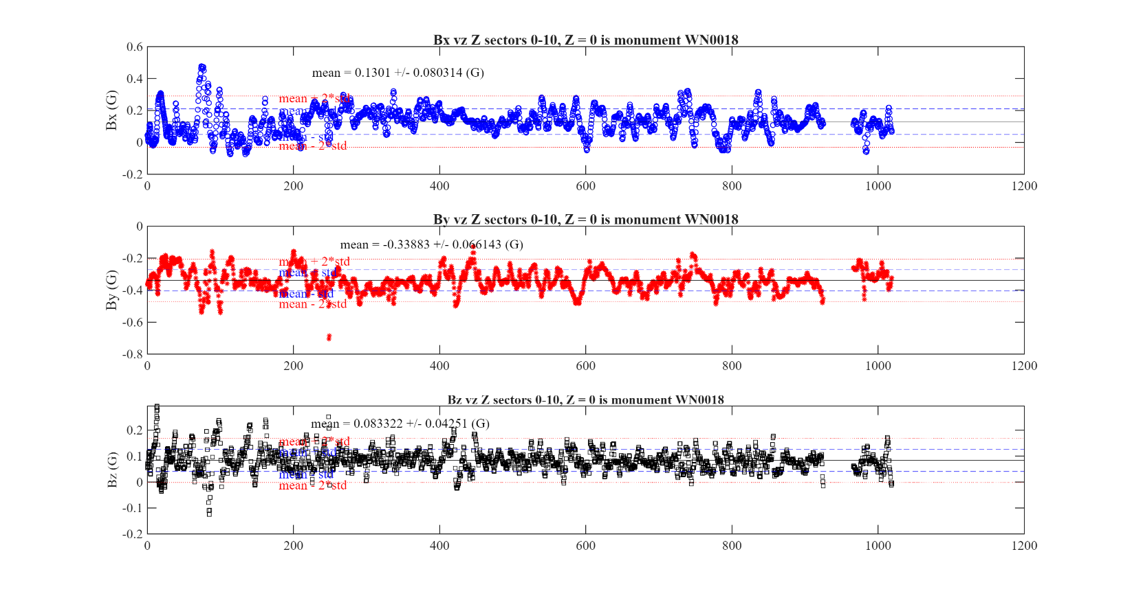
Figure 6: Bx, By, and Bz Background Field in Sector 0-10

Conclusion
Proximity and background field measurements were conducted on concrete/shotcrete support materials and in a subsection of the unfinished LEI tunnel, which will have a superconducting buncher module. The proximity field measurements on the support materials showed fields up to 2.5 G at 3 inches from the materials. The lattice girders were only magnetized at their end plates and the 20 foot rebar was randomly magnetized along their lengths. The galvanized steel angles showed no magnetized. At approximately 24 inches there was no detectable stray magnetic field, at the 0.1 G level, from all the material. The material measured is a subset of what will be installed. It would be prudent to do field measurements at 1-2 feet above all material to be installed, to catch any strongly magnetized material before it would be cast in concrete.

The LEIT field measurements were made in the unfinished tunnel, to get a baseline of the background field, before the concrete floor and ceiling is installed. The resulting measurements are statistically consistent to the Sectors 0 – 10 background field measurements, where superconducting RF modules are or will be installed. Final measurements will be made in the LEIT when the tunnel is finished and before any beamline components are installed. The measurements made in the unfinished tunnel will be used in comparison to these final measurements to determine the effect of the support materials on the final background field in the LEIT.

Appendix
The data files, setup documents and analysis are available on the SLAC Magnetic Measurements website at:

https://www-group.slac.stanford.edu/met/MagMeas/MAGDATA/LCLS-II-HE/Background_Fields/LEIT/

Acknowledgements
The author would like to thank the Russ Pollard et al at Obayashi USA, Jordon Fereira, Irene Bendanillo and Chris Adolphsen for there help with making the measurements and with understanding their context.

Work supported in part by the DOE Contract DE-AC02-76SF00515. This work was performed in support of the LEI and LCLS-II-HE projects at SLAC.

