  - FACET-II PAX Chicane Dipoles Unipolar Polynomials from Bipolar Measurements
The FACET-II chicane dipole main coil will be run using the down data (maximum current of 14.5 A to minimum current of 0 A, because the magnetic measurements were made using a bipolar supply but the installed mangets will be run with a unipolar supply. The problem is that the FACET-II chicane dipole main coil polynomials were derived from measurements using a bipolar supply from -14.5 to 14.5 amps and not from unipolar supply 0 to 14.5 amps. If we run them using a unipolar supply, the actual integrated field from a given current as calculated from the polynomial will be off by an amount and that is most pronounced at lower currents, but is still significant at larger currents.
I've made bipolar (-12 to 12 A) and unipolar (0 to 12 A) measurements on the spare CBXFEL chicane dipole, which is a similar type of magnet, and it shows that if one uses the 'Up data', i.e. going from minimum to maximum current to make the polynomial, the difference between the bipolar data and unipolar data is very large at small currents, moderate at the middle currents and is only within the residual fit error at the highest currents. (See plots FACET-II Chicane Dipole % Residual vs Current for Bipolar and Unipolar Measurements Full Range Up Data.png for the full range % residuals and FACET-II Chicane Dipole % Residual vs Current for Bipolar and Unipolar Measurements Up Data.png for the larger current residuals below in figures 1 and 2
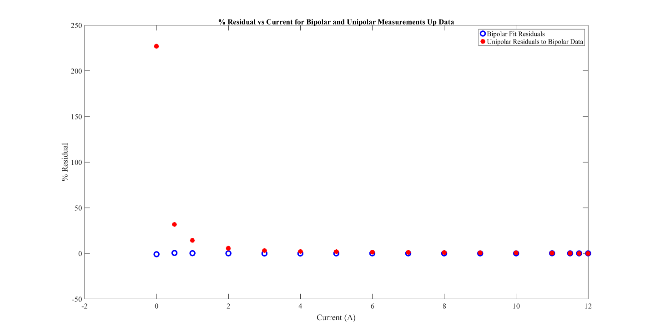
Figure 1: FACET-II Chicane Dipole % Residual vs Current for Bipolar and Unipolar Measurements Full Range Up Data

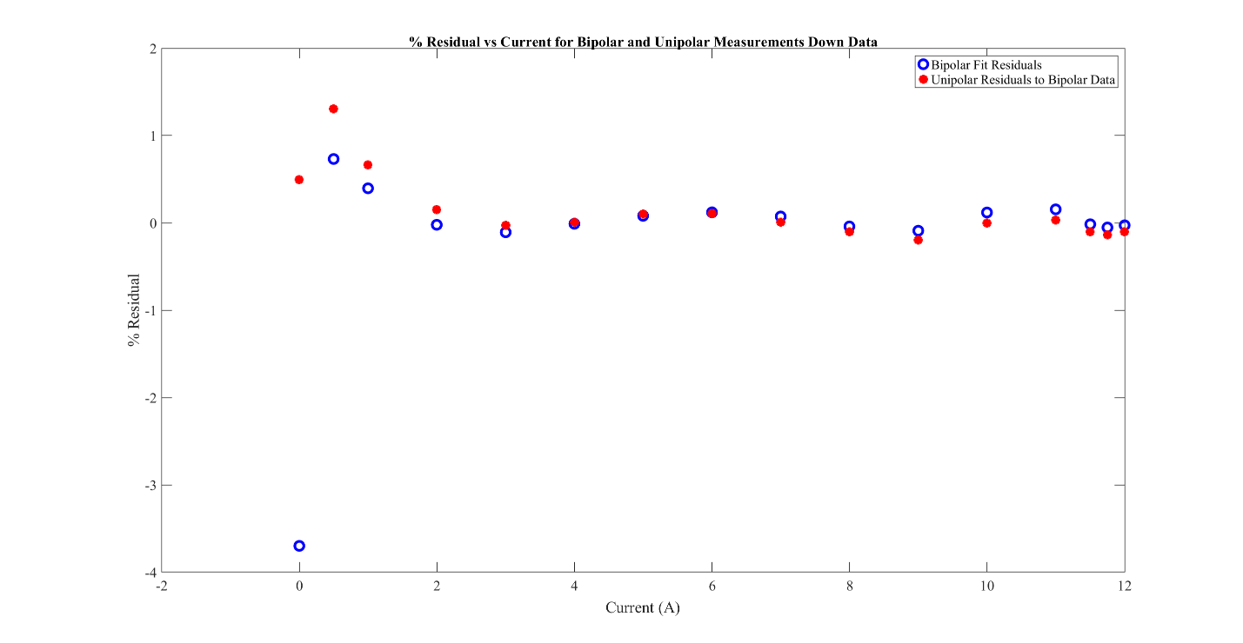
Figure 2: FACET-II Chicane Dipole % Residual vs Current for Bipolar and Unipolar Measurements Full Range Down Data
These plots show the % residuals for the fit of the bipolar data, in a range of 0 to +12 A, and the % difference between the unipolar and bipolar fit values. (i.e. 100*(BL unipolar - BL bipolar fit)/ BL unipolar. These plots show that at lower currents the unipolar data is off by many percent from the bipolar fit values for the integrated field strength and only at very highest currents are they close. Thus if we use the bipolar Up data to make the integral field from current calculation, the field values will be off by this amount. This means if we cannot use bipolar power supplies, we will have to measure at least one of the magnets in a unipolar manner to get a useable Up data polynomial.
If instead we were to use the 'Down data' bipola (max to min current) to make the polynomial, then the residuals for the bipolar fit and unipolar data match very well over the whole range! (see plot FACET-II Chicane Dipole % Residual vs Current for Bipolar and Unipolar Measurements Full Range Down Data.png). It is possible to set these magnets going down from the maximum current after the standardize and this is what has been implemented in the EPICs code. This solution meant that we would not have to swap the power supply type or remeasure the magnets and the error on magnet field values would be as good as the fit residuals.

