
Document Title: SLAC Traveler for S20 XC1EX Corrector Magnet
Author(s): Phoebe Alva Rosa, Doug Storey
…Revision History
Revision | Date Released | Description of Change
R0 | July 25, 2025 | Original Release.

This traveler is intended to cover reception, preparation, and magnetic measurements of the sector 20 corrector magnet XC1EX. This magnet will replace the existing XCOR:LI20:3276 corrector.
This traveler has been adapted from the FACET BC20BE and BC20CE dipole magnet travelers.

Receiving:
The following information is to be noted upon receipt of the magnets by the SLAC MM group:
Received by (initials): | SDA
Date received (mm-dd-yyyy): | 09-30-2025

Preparation:
A beam direction arrow, with text “beam direction”, is to be applied as shown in Figure 1.
Beam-direction arrow, barcode and MAD Name stickers in place (initials): | SDA
MAD name | XC1EX
Barcode | 4786

Magnetic Measurements:
- Verify that the magnets are complete and undamaged, including wiring connections.
Incoming inspection OK (initials): | SDA
Date of arrival to mag. meas.(mmm-dd-yyyy): | 09-31-2025

Enter URL of on-line magnetic measurements data (please modify or correct if necessary):
http://www-group.slac.stanford.edu/met/MagMeas/MagData/FACET-II/Corr/4786

- Measure the inductance and resistance of the main magnet coils:
Inductance of main coil (mH): | 3.13 mH
Resistance of main coil (Ohms): | 0.3890 Ohm

- Determine the main-coil connection polarity (with main supply outputting positive current) which produces a “positive” field polarity for dipoles as shown in Figure 1 below.

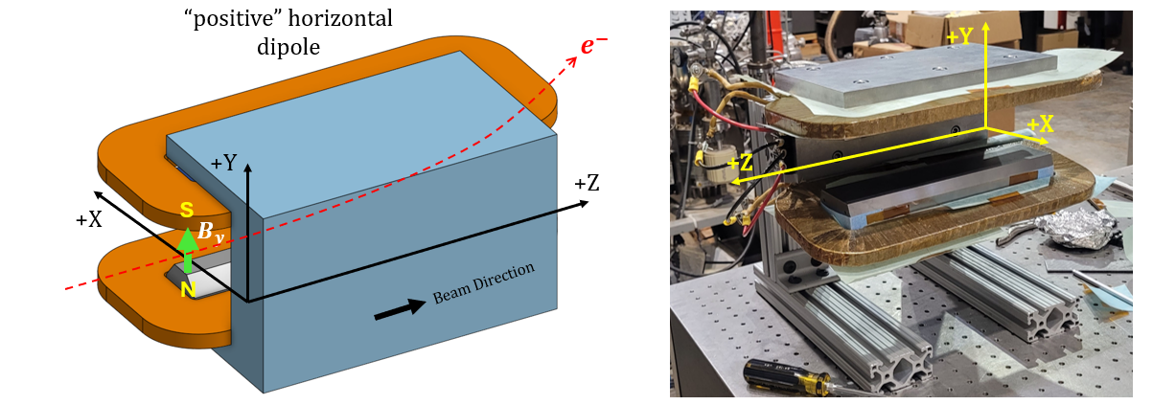
Figure 1: Dipoles have “positive” polarity when the electron beam is bent back towards the “wall-side” (+X) of the accelerator housing (as opposed to aisle-side).

- Mark the polarity near the main magnet leads with clear “+” and “−” labels on/near the terminal block.
Main coil polarity set to Positive from Figure 1 is (P): | Positive

- Connect the main magnet terminals in the correct polarity, as established above, to a bipolar power supply with a current range of ±12 A. Measure the temperature of both coils and the core at 12 amps for 7 hours.
Top Coil Temperature (ºC) | 48.6
Bottom Coil Temperature (ºC) | 46.8
Core Temperature (ºC) | 34.4
Ambient Temperature (ºC) | 21.3

- Standardize the magnet from -12 to 12 to -12 amps 3 times using a linear ramp of 2 A/s, with a 10 second wait time. Use the same ramp characteristics for trimming the magnet too.
- Maintaining this cycle history, measure the length-integrated vertical dipole field, ∫B_{y}dl, from -12 A to 12 A in 1-A steps, including zero (25 ‘up’ measurements). Please record (below) the magnetic field strength (in kG-m) at ± 12 A. Then, still maintaining the cycle history, measure ∫B_{y}dl back down from 12 A to -12 A in 1-A steps, including zero (25 ‘down’ measurements).
Field Strength at +12 A | 0.06268 kG-m
Field Strength at -12 A | 0.06223 kG-m
Filename & run number of ∫B_{y}dl up & down data: | Wiredat.ru1

- With stretched wire, measure the vertical length-integrated field component over a horizontal span of ±10 mm in 2 mm intervals at 12 A.

Filename & run # of ∫B_{y}dl vs. x data at 12 A: | Wirevsx.ru2

- Upon completion of tests, email URL of on-line data to Doug Storey (dstorey@slac.stanford.edu) for determination if the magnet is accepted, with Phoebe Alva Rosa (aphoebe@slac.stanford.edu) in cc. Upon acceptance of magnet, analysis data will be placed in the on-line data folder.
Magnet accepted: | Yes
Assigned beamline location (MAD-deck name): | XC1EX
Magnet marked with assigned MAD-deck name (initials): | SDA

