SLAC Magnetic Measurement Plan for A-Line 3.15Q76 Quadrupole Q38

This traveler is intended to cover mechanical fiducialization and magnetic measurements of the A-Line quadrupole to be put in MAD name slot Q38. The magnet type is a 3.15Q76 quadrupole magnet; it is historically known as an 8 cm quadrupole (ALINE_Q8CM). It will be designated a 3.15Q76 type magnet for these measurements. The magnet will be installed in the A-Line in the BSY. The A-Line 3.15Q76 quadrupole Q38 has a positive polarity. The top level assembly drawing is AD-902-272-00-05.

Receiving:
The following information is to be noted upon receipt of the magnet by the SLAC MM group:
Received by (initials): | SDA
Date received (mm/dd/yyyy): | 5/13/2025
SLAC barcode number: | 4785
AEC Serial number on the magnet: | 24081

Preparation:
A beam direction arrow, with text “beam direction”, is to be applied to the magnet with a sticker. The power bussing is on the downstream end of the magnet.
Beam-direction arrow in place (initials): | SDA

Fiducialization:
Fiducialization must be done before magnetic measurements. The magnet is to be fiducialized by the Alignment group. This will include the determination of the location of the geometric axis of the poles of the magnet, and location of tooling balls with respect to the center of this geometric axis. The pole radii from the centerline should be noted in the report.

Alignment (initials):

URL of on-Line CMM fiducialization data (please modify or correct if necessary):
http://www-group.slac.stanford.edu/met/MagMeas/MAGDATA/ALINE/ Fiducial Reports/

Magnetic Measurements:
Enter URL of on-Line magnetic measurements data (please modify or correct if necessary):
http://www-group.slac.stanford.edu/met/MagMeas/MAGDATA/A-Line/quadrupole /Q38

- Measure the inductance and resistance of the magnet:
Inductance of coils (mH): | 0.996 mH
Resistance of coils (Ohms): | 0.0337 Ohm
Ambient temperature in degrees C | 20.0 ºC

- Determine the connection polarity (with main supply outputting positive current) which produces a “positive” field polarity for A-Line 3.15Q76 quadrupole as shown below:

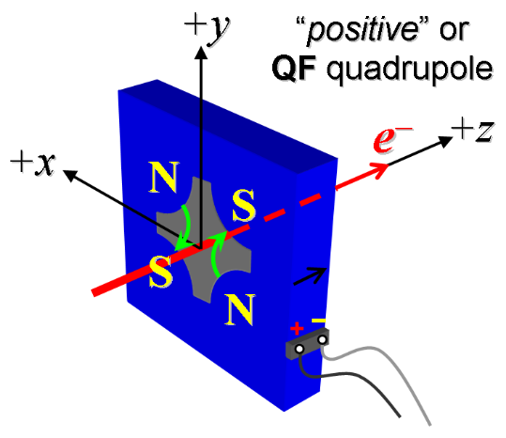
Figure 1. The magnet A-Line Q38, 3.15Q76 quadrupole is “positive”.

- Mark the polarity near the magnet leads with clear “+” and “−” labels as shown above.
Magnet polarity chosen from Fig. 1 is (P): | P

- Run the magnet up to 300 A for 2 hours and measure its coil, steel and input and output water temperatures.
Upper Left Coil (°C) | 30.02 °C
Upper Right Coil (°C) | 30.24 °C
Lower Left Coil (°C) | 31.02 °C
Lower Right Coil (°C): | 30.76 °C
Ambient temperature (°C): | 23.35 °C
Supply Water (°C): | 28.82 °C
Return Water (°C): | 31.09 °C
Water Flow (gpm) | 3.23 gpm

- Confirm the pole-tip field at each pole using a Hall probe using an excitation current of 300 A.
Hall probe pole-tip field at 300 A (mean of 4 poles): | 0.1063 +/- 0.001 T @ 300.004 A

- Standardize the magnet. Each standardize cycle is a ramp from 0 A to 300 A and back to 0 A. Standardize the magnet 3 times, use a three-linear ramp rate of 30 A/sec with a three-linear ramp style and a 20 second wait time. Record the ramp rate used.
Standardization complete (initials): | SDA
Ramp type and rate used (A/sec): | Three Linear 30 A/sec

- Measure the integral gradient, ∫Gdl, from 0 to 300 A in 20 amp steps. Measure BL vs X at 100, 200 and 300 A, with a x range of +/- 30 mm in 5 mm steps.
Filename of ∫Gdl data: | wiredat.ru2, wireplt.ru2
Filename of BL vs X data : | wirevsx.ru3, wirepltvsx.ru3

- Measure BL vs X at 300 A three timed with a x range of +/- 30 mm in 5 mm steps.
Filename of BL vs X data at 100, 200 and 300 A | wirevsx.ru4, wirepltvsx.ru4

- Measure the field vs z at 300 A from -20 cm to + 20 cm at X = 2 cm, with z = 0 defined at the edge of the pole end. Note the pole ends stick out 50.8 mm past the core end.
Filename of Field vs Z data: | bhvszdat.ru5, bhvszplt.ru5

- Upon completion of tests, email URL of data to Mark Woodley. Mark Woodley will determine if the magnet is accepted. Upon acceptance of magnet, analysis data will be placed in the data folder.
Magnet accepted and Analysis file(s) put into A-Line data folder (initials):
Assigned beamline location (MAD-deck name): | Q38

