SLAC Magnetic Measurement Plan for Unipolar and Bipolar measurements on 1.26Q3.5 Quadrupole to a maximum field of 5kG

7/13/2026

Scott Anderson

This plan details the measurements for a 1.26Q3.5 quadrupole magnet at a lower field of 5 kG, compared to the nominal 20 kG, to provide polynomial values for the 1.26Q3.5 quadrupoles that are used in the injector areas. Tests have shown that running these magnets with a maximum field of +/- 5kG will reduce the difference between the up and down hysteresis curves. The quadrupole will be measured in a bipolar and unipolar manner. Before each set of measurements, the quadrupole will be degaussed.

Receiving:
The following information is to be noted upon receipt of the magnets by the SLAC MFD group:
Received by (MMG initials): | SDA
Date setup (dd-mmm-yyyy): | 7/14/2026
SLAC barcode number: | 000422
Vendor serial number on the magnet: | 35

Magnetic Measurements:
Enter URL of on-line magnetic measurements data (please modify or correct if necessary):
http://www-group.slac.stanford.edu/met/MagMeas/MAGDATA/LCLS/quad/000422/

- The magnet has a QF polarity and will be measured that way:
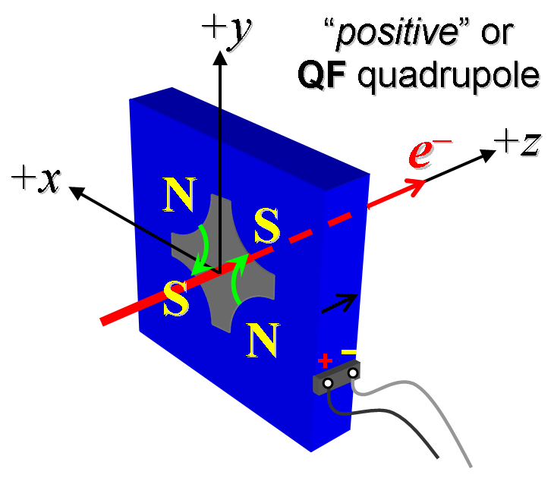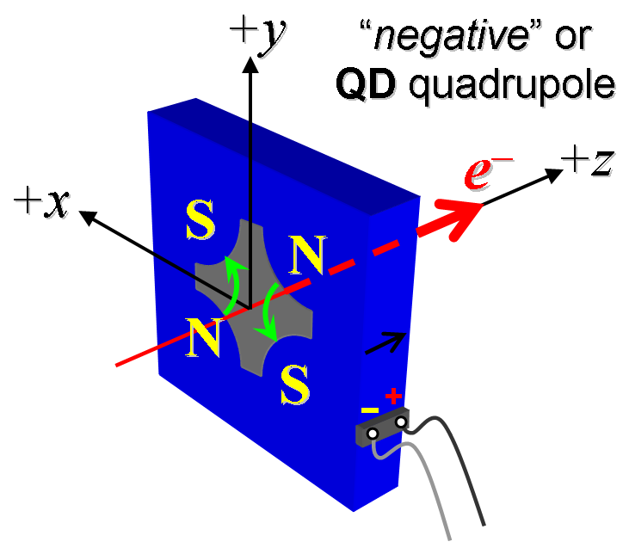
Figure 1. The “positive” polarity (left), and the “negative” polarity (right).

- Connect the magnet terminals in the correct polarity as established above, to a power supply with maximum current I ≥ 12 A (e.g., MCOR12). Use "3-Linear Ramping Trim" control.

- Degauss the magnet. Note the details of degauss method below.
Degauss Type | f = 0.89 totals point = 45 Imax = 12 A
Degauss Currents | Degauss currents for f = 0.89 using I = (-(-1).^n).*-f.^n*Imax where totals point = 45  Degauss I = {12.00000, -10.68000, 9.50520, -8.45963, 7.52907, -6.70087, 5.96378, -5.30776, 4.72391, -4.20428, 3.74181, -3.33021, 2.96388, -2.63786, 2.34769, -2.08945, 1.85961, -1.65505, 1.47300, -1.31097, 1.16676, -1.03842, 0.92419, -0.82253, 0.73205, -0.65153, 0.57986, -0.51607, 0.45931, -0.40878, 0.36382, -0.32380, 0.28818, -0.25648, 0.22827, -0.20316, 0.18081, -0.16092, 0.14322, -0.12747, 0.11344, -0.10097, 0.08986, -0.07997, 0.0};
Degauss Filename | Strdat.ru3

- Standardize the magnet, starting from zero to 3 A and back to zero, through three full cycles, finally ending at zero, with a flat-top pause time (at both 0 and 3 A) of 10 seconds. Use a ramp rate of 1 A/sec, if possible, and record the ramp rate used.
Standardization complete (initials): | SDA
Ramp rate used (A/sec): | 1 A/sec

- Measure the length-integrated field gradient, ∫Gdl, from 0 to 3 A in 0.25-A steps and then back down from 3 A to 0 in 0.25 A steps.
Filename & run number of ∫Gdl up & down data: | Strdat.ru4

- With rotating coil, measure the magnet harmonics at 3 A current setting. Multipole values should be given as a percentage of the quadrupole moment evaluated at the probe radius.
Filename & run number of harmonic data: | Hardat.ru4
Probe radius used for harmonics (mm): | 0.0127446
Rotating Coil Designation (Name) | 1DQSB26_B2

- Degauss the magnet using the method above.
- Standardize the magnet, starting from -3 to 3 A to -3 A, through six full cycles, finally ending at -3 A, with a flat-top pause time (at both -3 and 3 A) of 10 seconds. Use a ramp rate of 1 A/sec, record the ramp rate used.
Standardization complete (initials): | SDA
Ramp rate used (A/sec): | 1 A/sec

- Measure the length-integrated field gradient, ∫Gdl, from -3 to 3 A in 0.25-A steps and then back down from 3 A to -3 A in 0.25 A steps.
Filename & run number of ∫Gdl up & down data: | Strdat.ru6

- With rotating coil, measure the magnet harmonics at 3 A current setting. Multipole values should be given as a percentage of the quadrupole moment evaluated at the probe radius.
Filename & run number of harmonic data: | Hardat.ru6
Probe radius used for harmonics (cm): | 0.0127446
Rotating Coil Designation (Name) | 1DQSB26_B2

- Confirm the pole-tip field using a Hall probe at an excitation current of 3 A.
Hall probe pole-tip field at 3 A (mean of 4 poles): | 0.075 +/- 0.005 T

- Measure the inductance and resistance of the magnet:
Inductance of coil (mH): | 10.23 mH
Resistance of coil (Ohms): | 0.390 Ohm
Ambient temperature in degrees C | 25.5 C

- Upon completion of tests, send data to Mark Woodley via email for analysis.
Magnet analyzed:
Assigned beamline location (MAD-deck name): | SPARE

