SXR undulator fiducialization test.
Introduction
Fiducialization of LCLS-I undulators included two steps.
First step, location of the undulator magnetic axis was defined at the magnetic measurement bench w.r.t the special magnets (end magnets) attached to the both ends of the undulator, see picture 1.

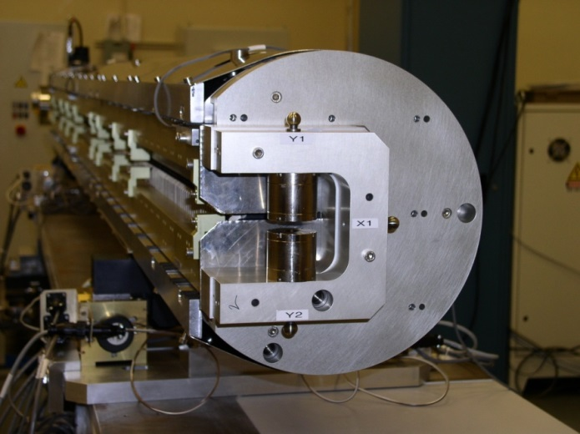
Picture 1. End magnet mounted on LCLS-I undulator

Second step, the undulator was moved on CMM. All end magnet tooling balls and the undulator fiducials were measured. Knowing the magnetic axis position w.r.t. the end magnet’s tooling balls from the first step, the x and y coordinates of the undulator fiducials were calculated in the undulator magnetic axis coordinate system.
The SXR undulators are too big to be measured on CMM. Therefore, the fiducialization procedure has to be changed. Instead of CMM, all geometrical measurements to be done at the magnetic measurement bench using a laser tracker. A test was performed to make sure the new fiducialization procedure will meet the accuracy requirements.

Test set-up and results

The test was performed using the SXR reference undulator, which is one of the LCLS-I undulators modified so that it’s poles are set to 7.2mm gap parallel (no cant angle). The reference undulator was tuned and fiducialized using both the old and the new procedure.
The new procedure uses two additional fiducialization magnets (PMs), similar to the end magnets. Four new conical bases were permanently mounted on each of the PMs to accommodate a Laser Tracker sphere reflector (see picture 2).
Distances between the PMs tooling balls and centers of the conical bases were measured on CMM.
After that the PMs were installed permanently on the pedestals next to the undulator and were measured with Hall probe to find location of their zero field points and define the undulator magnetic axis location. Using these measurements, the coordinates of the undulator fiducials were calculated. The same coordinates were measured with the Laser Tracker and results were compared.
The results are shown in table 1.
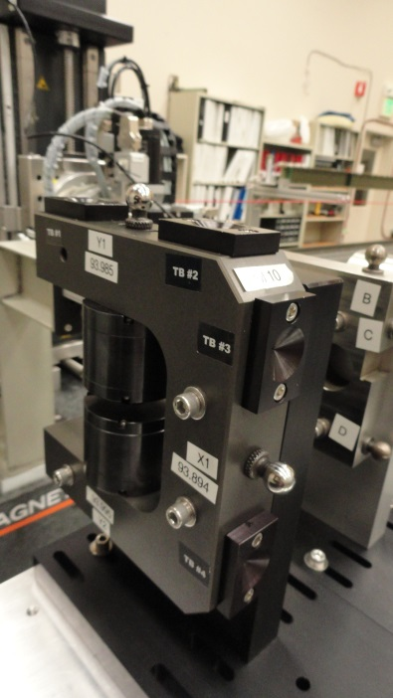
Picture 2. Four conical bases mounted on a PM, two on top and two on the side.

Table 1. Difference in coordinates of undulator fiducials (Laser Tr. - CMM) (mm)

TB # | x | y
1 |  | -0.006
2 |  | -0.002
3 |  | 0.014
4 |  | 0.006
5 | 0.025
6 | 0.018
7 | 0.014
8 | 0.008
RMS | 0.007 | 0.009
Average | 0.016 | 0.003

The tooling balls 1 to 4 are located on the top of the undulator and used to compare y-coordinates.
The tooling balls 5 to 8 are located on the side of the undulator and used to compare x-coordinates.
The r.m.s. errors for both coordinates are below 10 microns. There is an offset of 16 microns in x-coordinates, which is within the tolerances.
The fiducialization procedure meets the accuracy requirements for LCLS-II SXR undulators.

