LCLS2 SXR Undulator

Alignment Engineering Group
L2?????
SN 29A804-021
July 10, 2020

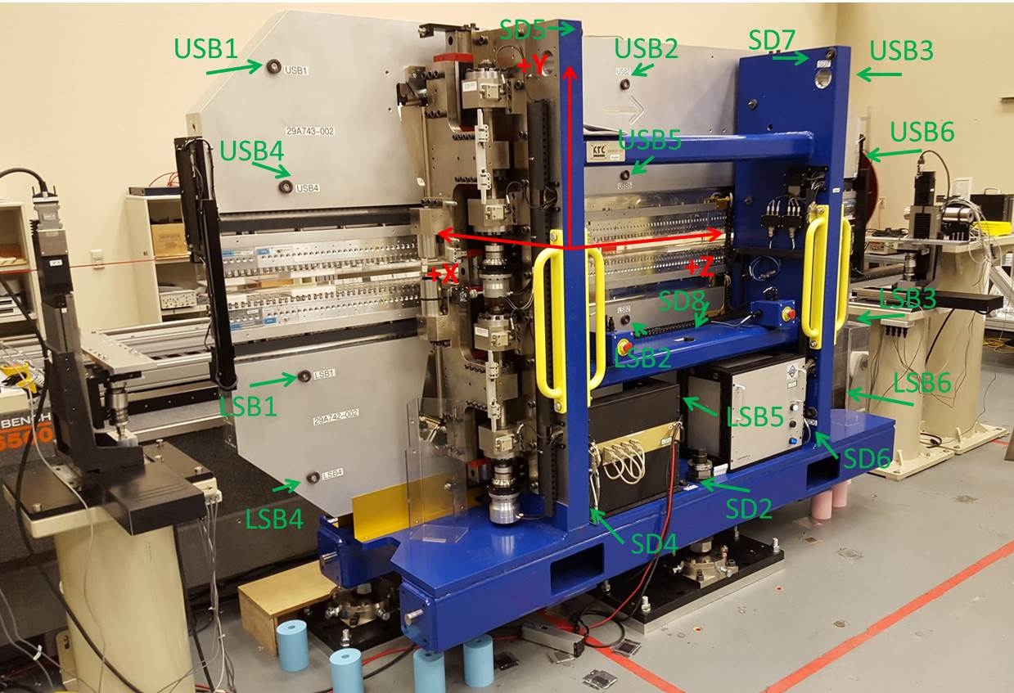

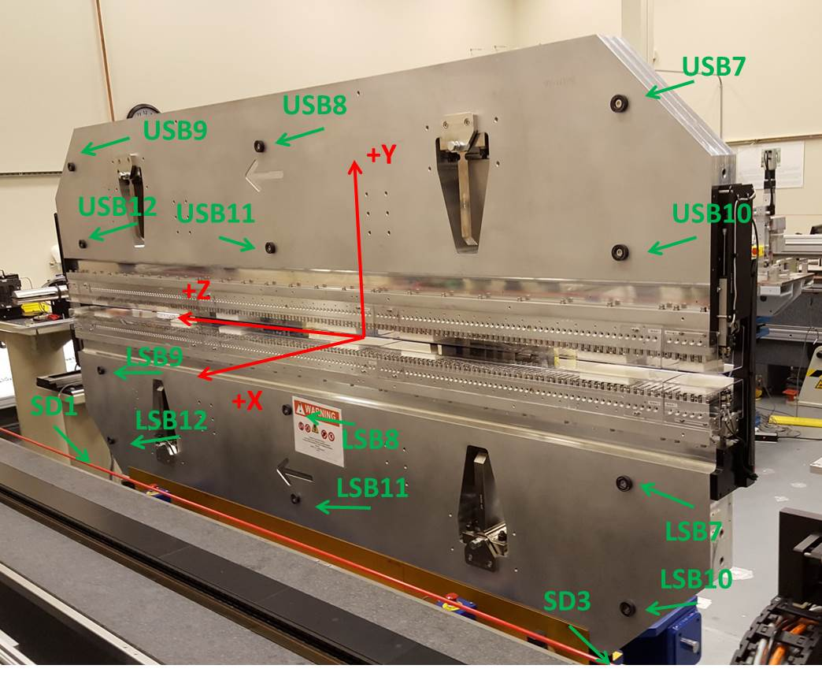

Tooling ball values to center of 1.5 inch sphere, all units are inches. Coordinates are to the SXR Undulator Magnetic Axis.
Tooling Ball | Z (in) | X (in) | Y (in)
LSB1 | -57.4796 | -3.4903 | -10.4854
LSB2 | -0.0109 | -3.4850 | -10.4809
LSB3 | 57.4720 | -3.4912 | -10.4833
LSB4 | -57.4815 | -3.4913 | -24.2665
LSB5 | -0.0052 | -3.4874 | -24.2617
LSB6 | 57.4683 | -3.4931 | -24.2426
LSB7 | -57.4811 | 3.4847 | -10.4737
LSB8 | -0.0102 | 3.4911 | -10.4826
LSB9 | 57.4615 | 3.4810 | -10.4763
LSB10 | -57.4908 | 3.4823 | -24.2580
LSB11 | -0.0140 | 3.4889 | -24.2598
LSB12 | 57.4642 | 3.4796 | -24.2472
SD1 | 50.9739 | 7.2575 | -34.6793
SD2 | -3.9406 | -19.5370 | -34.7221
SD3 | -51.0020 | 7.2227 | -34.6805
SD4 | -25.5939 | -21.7031 | -29.5748
SD5 | -25.5928 | -21.6994 | 29.4720
SD6 | 25.6652 | -21.6709 | -29.5748
SD7 | 25.6549 | -21.6858 | 29.4815
SD8 | 0.0369 | -17.0089 | -12.2907
USB1 | -57.4906 | -3.4817 | 24.2479
USB2 | -0.0056 | -3.4850 | 24.2574
USB3 | 57.4657 | -3.4831 | 24.2462
USB4 | -57.4835 | -3.4862 | 10.4857
USB5 | -0.0129 | -3.4900 | 10.4878
USB6 | 57.4734 | -3.4888 | 10.4791
USB7 | -57.4701 | 3.4958 | 24.2525
USB8 | 0.0105 | 3.4917 | 24.2563
USB9 | 57.4916 | 3.4926 | 24.2581
USB10 | -57.4648 | 3.4920 | 10.4843
USB11 | 0.0077 | 3.4866 | 10.4708
USB12 | 57.4885 | 3.4875 | 10.4774

Center | Z (m) | X (m) | Y (m) | Z (in) | X (in) | Y (in)
PM10M | -2.815816 | -0.026129 | 0.000319 | -110.8589 | -1.0287 | 0.0126
PM11M | 2.726267 | -0.026389 | 0.000102 | 107.3333 | -1.0389 | 0.0040
RFM | -2.671049 | 0.048843 | -0.000346 | -105.1594 | 1.9230 | -0.0136

PM10 and Granite coordinate system with Yurii shifts.
 |  | From Yurii |  |  | Measured
Device | Z (m) | X (m) | Y (m) | Z (m) | X (m) | Y (m) | dX (mm) | dY (mm)
PM10 | -0.368850 | -0.102486 | 0.000363 | -2.815816 | -0.102470 | 0.000344 | 0.016 | -0.019
PM11 | 5.173260 | -0.102714 | 0.000108 | 2.726267 | -0.102730 | 0.000127 | -0.016 | 0.019
RefBlock |  |  |  | -2.671049 | -0.027498 | -0.000321

