LCLS2 SXR Undulator

Alignment Engineering Group
L2?????
SN 29A804-020
February 28, 2019

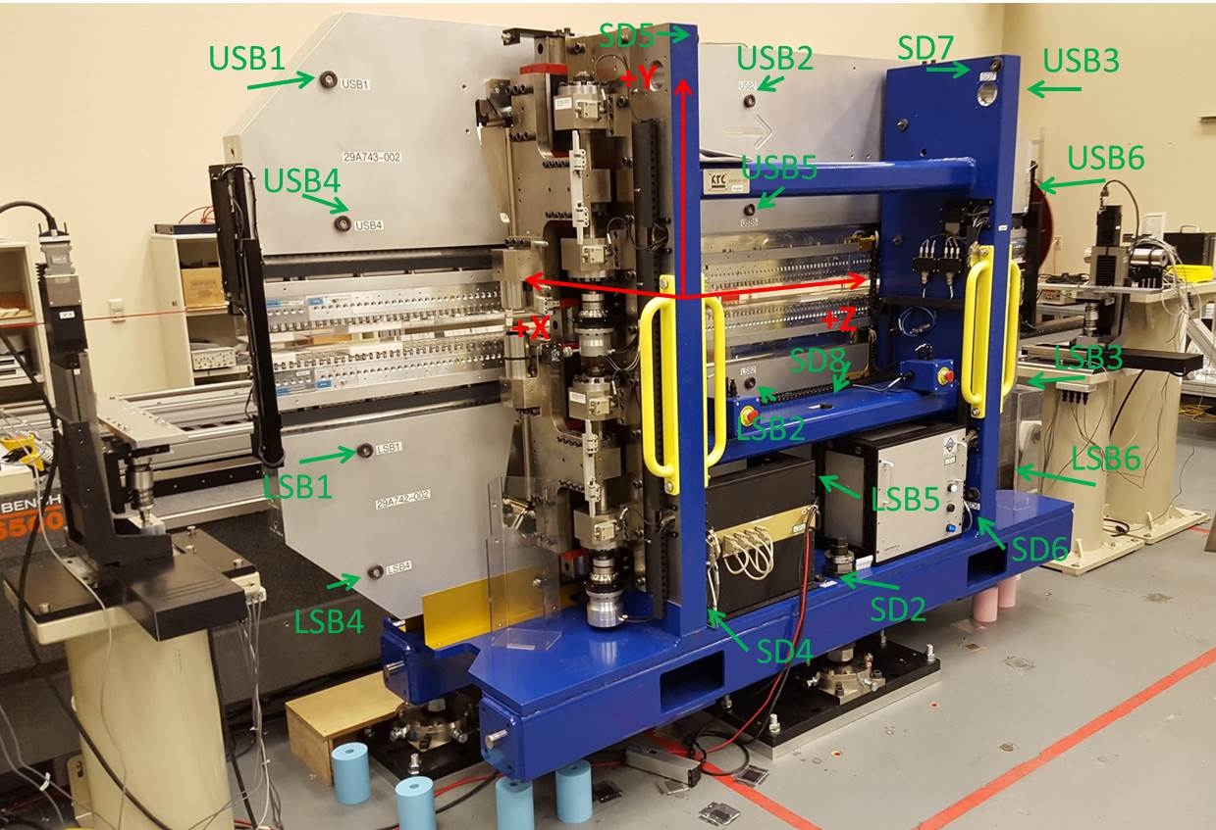

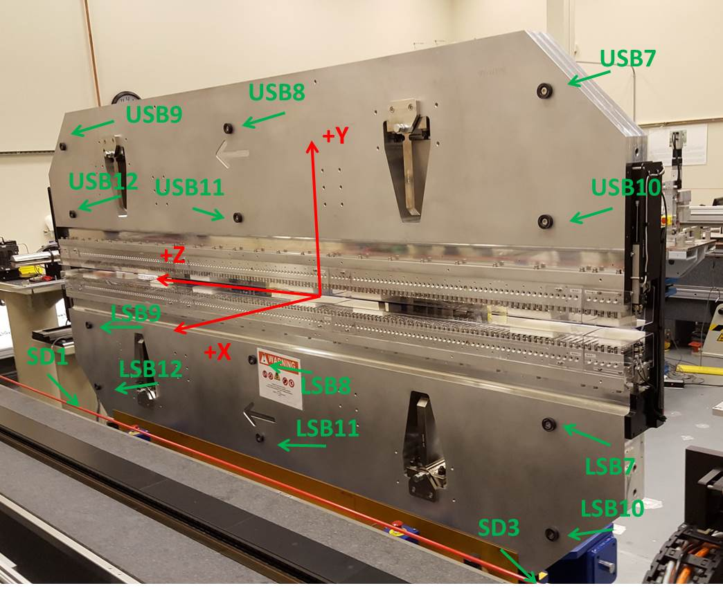

Tooling ball values to center of 1.5 inch sphere, all units are inches. Coordinates are to the SXR Undulator Magnetic Axis.
Tooling Ball | Z (in) | X (in) | Y (in)
LSB1 | -57.4788 | -3.4876 | -10.4854
LSB2 | 0.0100 | -3.4889 | -10.4693
LSB3 | 57.4681 | -3.4848 | -10.4825
LSB4 | -57.4783 | -3.4856 | -24.2604
LSB5 | -0.0013 | -3.4885 | -24.2491
LSB6 | 57.4736 | -3.4867 | -24.2563
LSB7 | -57.4898 | 3.4896 | -10.4687
LSB8 | -0.0038 | 3.4880 | -10.4764
LSB9 | 57.4728 | 3.4928 | -10.4751
LSB10 | -57.4741 | 3.4920 | -24.2511
LSB11 | -0.0007 | 3.4885 | -24.2683
LSB12 | 57.4692 | 3.4906 | -24.2612
SD1 | 50.9962 | 7.2641 | -34.6847
SD2 | -3.9232 | -19.5017 | -34.7327
SD3 | -50.9757 | 7.2587 | -34.6852
SD4 | -25.6095 | -21.6886 | -29.5855
SD5 | -25.6293 | -21.6539 | 29.4755
SD6 | 25.6668 | -21.6668 | -29.5876
SD7 | 25.6381 | -21.7227 | 29.4875
SD8 | -0.0052 | -17.0176 | -12.3464
USB1 | -57.4885 | -3.4840 | 24.2526
USB2 | 0.0035 | -3.4899 | 24.2574
USB3 | 57.4872 | -3.4835 | 24.2458
USB4 | -57.4650 | -3.4832 | 10.4719
USB5 | 0.0039 | -3.4923 | 10.4777
USB6 | 57.4897 | -3.4874 | 10.4688
USB7 | -57.4702 | 3.4948 | 24.2503
USB8 | -0.0027 | 3.4895 | 24.2541
USB9 | 57.4809 | 3.4941 | 24.2515
USB10 | -57.4769 | 3.4944 | 10.4701
USB11 | 0.0080 | 3.4874 | 10.4833
USB12 | 57.4741 | 3.4913 | 10.4670

Center | Z (m) | X (m) | Y (m) | Z (in) | X (in) | Y (in)
PM10M | -2.816106 | -0.026353 | 0.000659 | -110.8703 | -1.0375 | 0.0259
PM11M | 2.726025 | -0.026590 | 0.000417 | 107.3238 | -1.0469 | 0.0164
RFM | -2.671360 | 0.048617 | -0.000009 | -105.1717 | 1.9141 | -0.0004

PM10 and Granite coordinate system with Yurii shifts.
 |  | From Yurii |  |  | Measured
Device | Z (m) | X (m) | Y (m) | Z (m) | X (m) | Y (m) | dX (mm) | dY (mm)
PM10 | -0.368884 | -0.102492 | 0.000790 | -2.816106 | -0.102487 | 0.000798 | 0.005 | 0.008
PM11 | 5.173760 | -0.102718 | 0.000564 | 2.726025 | -0.102724 | 0.000556 | -0.006 | -0.008
RefBlock |  |  |  | -2.671360 | -0.027517 | 0.000130

