LCLS2 SXR Undulator

Alignment Engineering Group
L2?????
SN 29A804-019
February 05, 2019

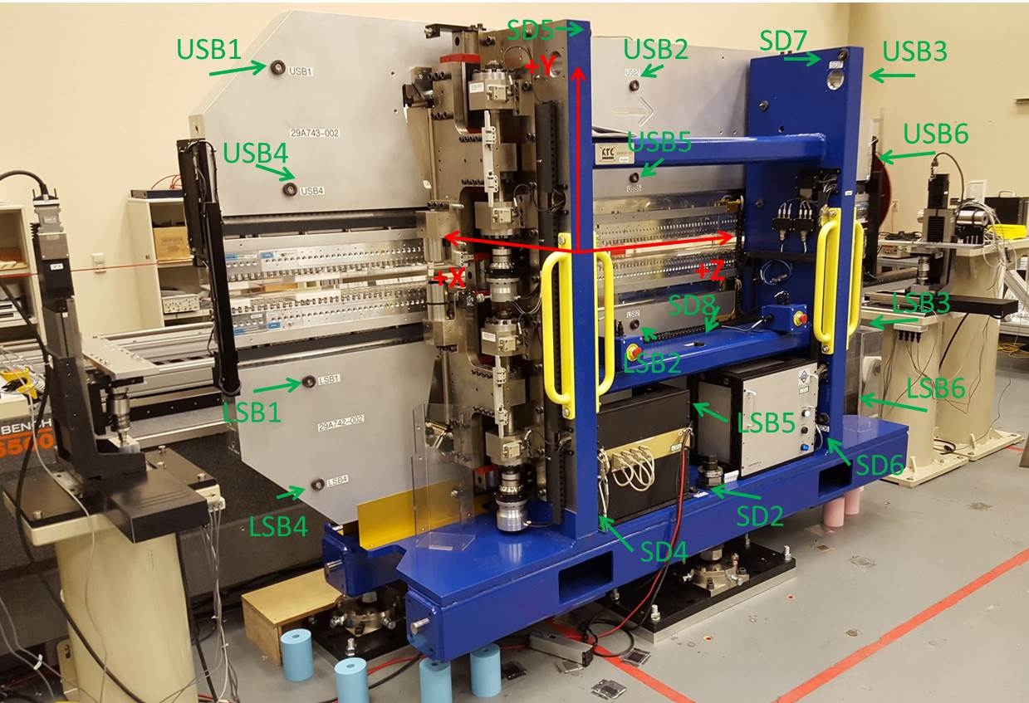

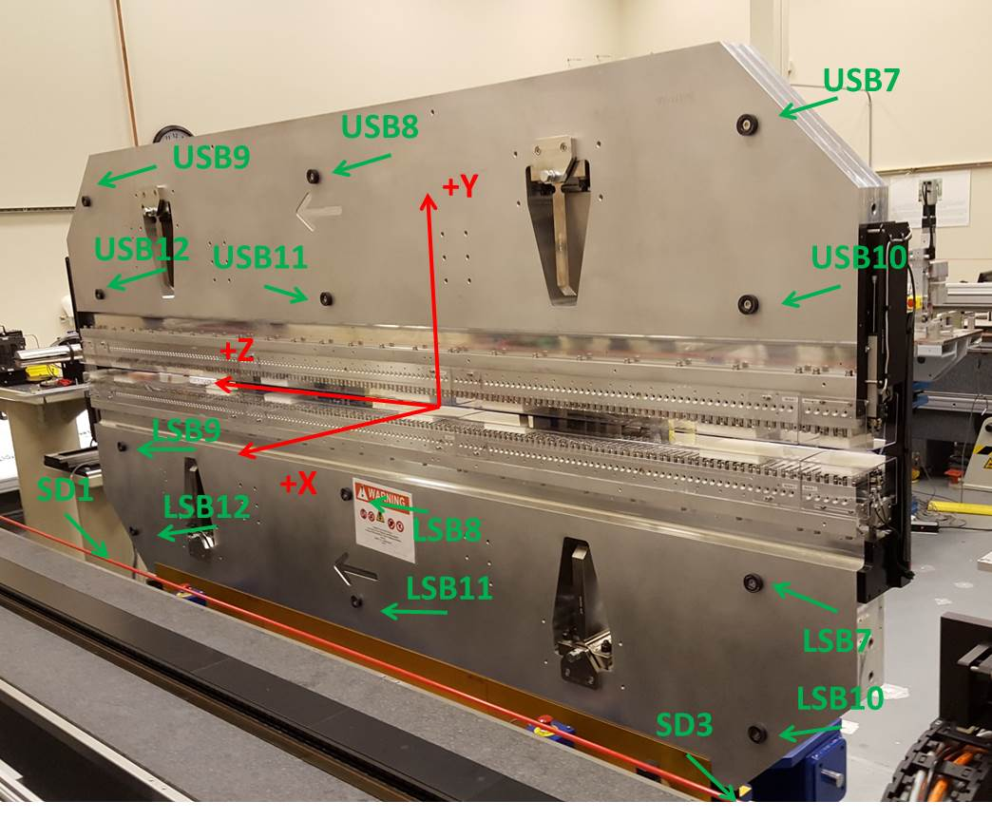

Tooling ball values to center of 1.5 inch sphere, all units are inches. Coordinates are to the SXR Undulator Magnetic Axis.
Tooling Ball | Z (in) | X (in) | Y (in)
LSB1 | -57.4680 | -3.4965 | -10.4730
LSB2 | 0.0045 | -3.4923 | -10.4681
LSB3 | 57.4609 | -3.4885 | -10.4768
LSB4 | -57.4776 | -3.4938 | -24.2481
LSB5 | 0.0038 | -3.4905 | -24.2417
LSB6 | 57.4850 | -3.4875 | -24.2550
LSB7 | -57.4937 | 3.4796 | -10.4747
LSB8 | 0.0001 | 3.4839 | -10.4787
LSB9 | 57.4801 | 3.4887 | -10.4722
LSB10 | -57.4847 | 3.4816 | -24.2608
LSB11 | -0.0061 | 3.4847 | -24.2531
LSB12 | 57.4802 | 3.4881 | -24.2528
SD1 | 50.9913 | 7.2409 | -34.6712
SD2 | -3.9294 | -19.5346 | -34.7100
SD3 | -50.9695 | 7.2394 | -34.6789
SD4 | -25.6624 | -21.6985 | -29.5630
SD5 | -25.6457 | -21.6732 | 29.4527
SD6 | 25.6272 | -21.6763 | -29.5558
SD7 | 25.6377 | -21.6812 | 29.4807
SD8 | -0.0579 | -17.0337 | -12.4141
USB1 | -57.4787 | -3.4791 | 24.2526
USB2 | 0.0075 | -3.4797 | 24.2563
USB3 | 57.4839 | -3.4830 | 24.2493
USB4 | -57.4693 | -3.4819 | 10.4807
USB5 | -0.0037 | -3.4838 | 10.4702
USB6 | 57.4747 | -3.4886 | 10.4730
USB7 | -57.4838 | 3.4979 | 24.2502
USB8 | -0.0074 | 3.4964 | 24.2546
USB9 | 57.4796 | 3.4937 | 24.2509
USB10 | -57.4783 | 3.4955 | 10.4683
USB11 | -0.0024 | 3.4938 | 10.4657
USB12 | 57.4811 | 3.4890 | 10.4631

Center | Z (m) | X (m) | Y (m) | Z (in) | X (in) | Y (in)
PM10M | -2.815811 | -0.026374 | 0.000627 | -110.8587 | -1.0383 | 0.0247
PM11M | 2.726358 | -0.026628 | 0.000351 | 107.3369 | -1.0483 | 0.0138
RFM | -2.671034 | 0.048594 | -0.000034 | -105.1588 | 1.9131 | -0.0013

PM10 and Granite coordinate system with Yurii shifts.
 |  | From Yurii |  |  | Measured
Device | Z (m) | X (m) | Y (m) | Z (m) | X (m) | Y (m) | dX (mm) | dY (mm)
PM10 | -0.368879 | -0.102490 | 0.000796 | -2.815811 | -0.102478 | 0.000798 | 0.012 | 0.002
PM11 | 5.173400 | -0.102720 | 0.000524 | 2.726358 | -0.102732 | 0.000522 | -0.012 | -0.002
RefBlock |  |  |  | -2.671034 | -0.027510 | 0.000137

