LCLS2 SXR Undulator

Alignment Engineering Group
L2?????
SN 29A804-016
November 7, 2018

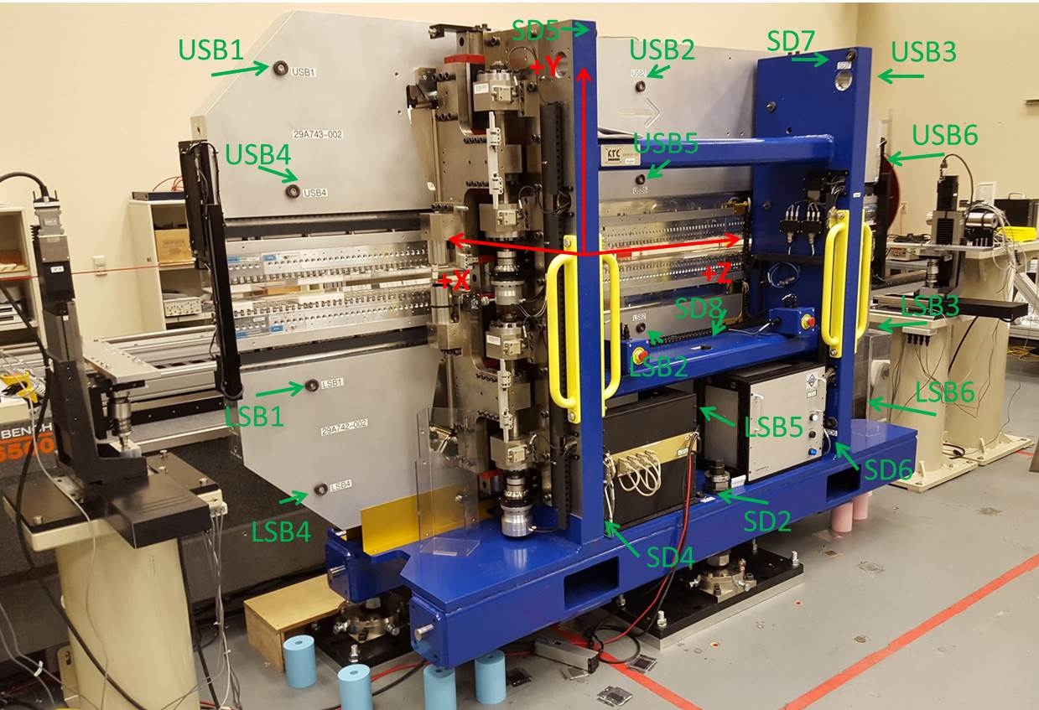

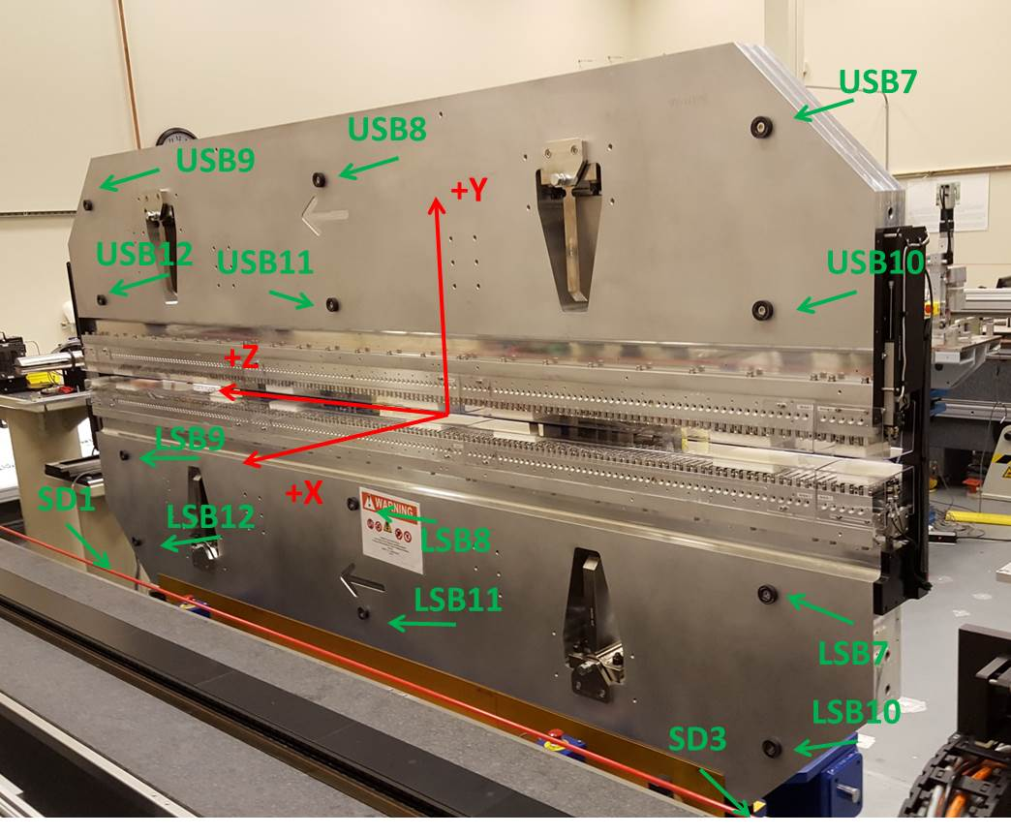

Tooling ball values to center of 1.5 inch sphere, all units are inches. Coordinates are to the SXR Undulator Magnetic Axis.
Tooling Ball | Z (in) | X (in) | Y (in)
LSB1 | -57.4777 | -3.4834 | -10.4835
LSB2 | -0.0056 | -3.4884 | -10.4805
LSB3 | 57.4745 | -3.4863 | -10.4812
LSB4 | -57.4898 | -3.4790 | -24.2469
LSB5 | 0.0075 | -3.4828 | -24.2627
LSB6 | 57.4651 | -3.4808 | -24.2641
LSB7 | -57.4791 | 3.4920 | -10.4652
LSB8 | -0.0049 | 3.4880 | -10.4797
LSB9 | 57.4805 | 3.4891 | -10.4693
LSB10 | -57.4802 | 3.4958 | -24.2458
LSB11 | -0.0008 | 3.4918 | -24.2487
LSB12 | 57.4691 | 3.4928 | -24.2593
SD1 | 50.9833 | 7.2437 | -34.6206
SD2 | -3.9297 | -19.5209 | -34.6829
SD3 | -50.9747 | 7.2570 | -34.6244
SD4 | -25.6767 | -21.6980 | -29.5220
SD5 | -25.6244 | -21.6735 | 29.5045
SD6 | 25.6375 | -21.6815 | -29.5372
SD7 | 25.6415 | -21.7044 | 29.5269
SD8 | -0.0409 | -17.0775 | -12.3439
USB1 | -57.4652 | -3.4889 | 24.2585
USB2 | 0.0011 | -3.4857 | 24.2621
USB3 | 57.4824 | -3.4787 | 24.2521
USB4 | -57.4608 | -3.4900 | 10.4703
USB5 | -0.0019 | -3.4866 | 10.4793
USB6 | 57.4851 | -3.4802 | 10.4832
USB7 | -57.4772 | 3.4844 | 24.2607
USB8 | 0.0015 | 3.4910 | 24.2590
USB9 | 57.4735 | 3.4949 | 24.2506
USB10 | -57.4642 | 3.4838 | 10.4825
USB11 | -0.0009 | 3.4907 | 10.4791
USB12 | 57.4707 | 3.4934 | 10.4715

Center | Z (m) | X (m) | Y (m) | Z (in) | X (in) | Y (in)
PM10M | -2.815704 | -0.026334 | 0.000611 | -110.8545 | -1.0368 | 0.0241
PM11M | 2.726518 | -0.026586 | 0.000375 | 107.3432 | -1.0467 | 0.0148
RFM | -2.670952 | 0.048640 | -0.000054 | -105.1556 | 1.9150 | -0.0021

PM10 and Granite coordinate system with Yurii shifts.
 |  | From Yurii |  |  | Measured
Device | Z (m) | X (m) | Y (m) | Z (m) | X (m) | Y (m) | dX (mm) | dY (mm)
PM10 | -0.368906 | -0.102507 | 0.000732 | -2.815704 | -0.102484 | 0.000740 | 0.023 | 0.008
PM11 | 5.173402 | -0.102712 | 0.000512 | 2.726518 | -0.102736 | 0.000504 | -0.024 | -0.008
RefBlock |  |  |  | -2.670952 | -0.027510 | 0.000075

