LCLS2 SXR Undulator

Alignment Engineering Group
L2?????
SN 29A804-015
October 19, 2018

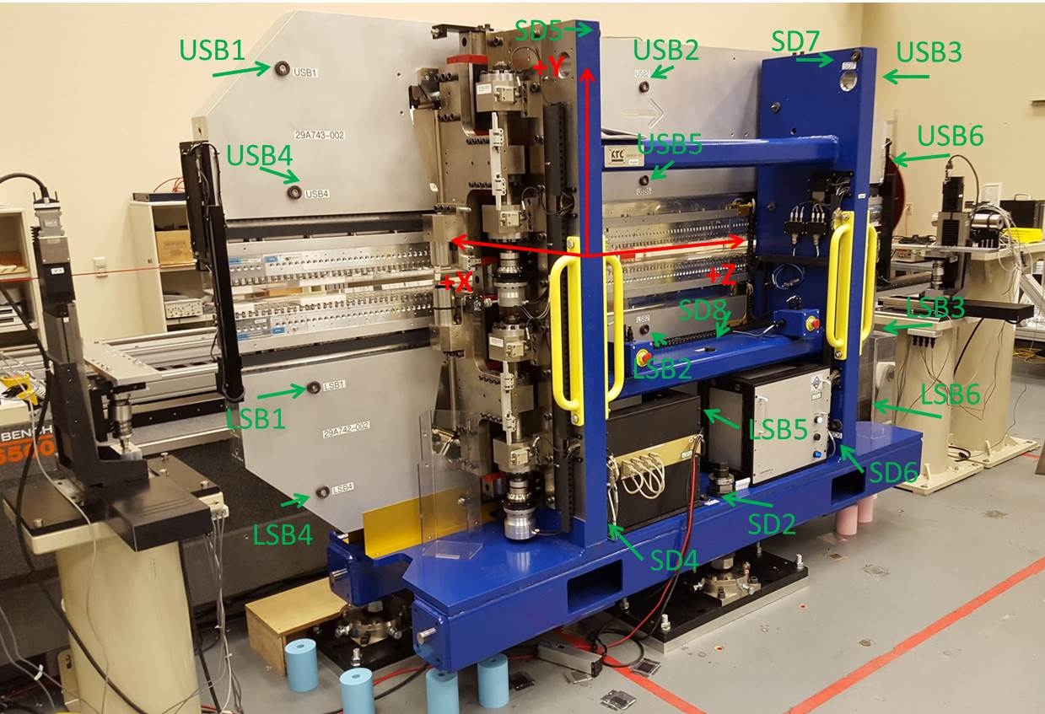

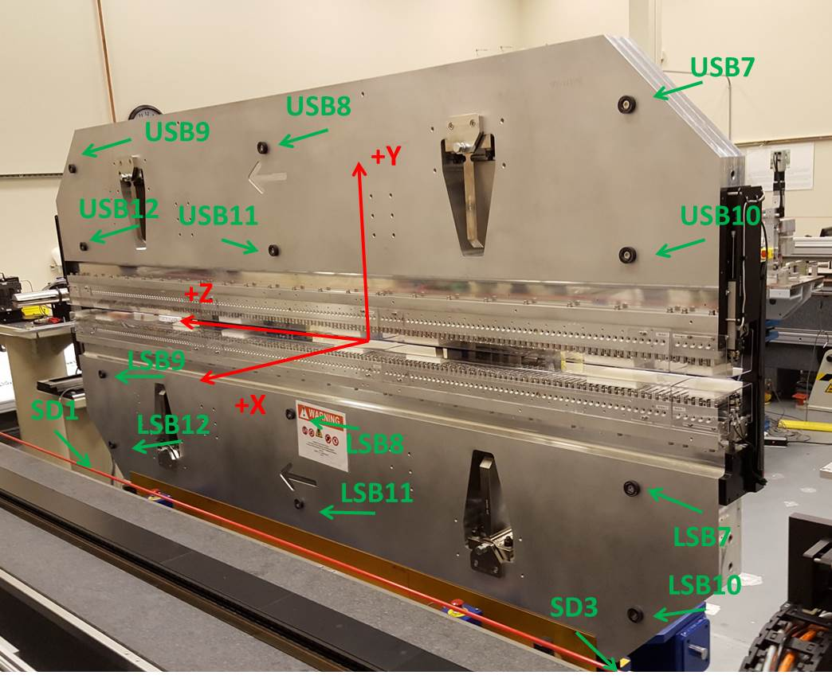

Tooling ball values to center of 1.5 inch sphere, all units are inches. Coordinates are to the SXR Undulator Magnetic Axis.
Tooling Ball | Z (in) | X (in) | Y (in)
LSB1 | -57.4735 | -3.4968 | -10.4647
LSB2 | -0.0011 | -3.4921 | -10.4729
LSB3 | 57.4751 | -3.4832 | -10.484
LSB4 | -57.4707 | -3.4956 | -24.2617
LSB5 | -0.0058 | -3.4926 | -24.2538
LSB6 | 57.4827 | -3.4831 | -24.2621
LSB7 | -57.4884 | 3.4772 | -10.4727
LSB8 | -0.0152 | 3.4821 | -10.4743
LSB9 | 57.4788 | 3.4915 | -10.4822
LSB10 | -57.4894 | 3.4778 | -24.2595
LSB11 | -0.0105 | 3.4831 | -24.2642
LSB12 | 57.4641 | 3.4913 | -24.26
SD1 | -50.9893 | 7.2506 | -34.6492
SD2 | -3.929 | -19.5351 | -34.7392
SD3 | 50.9721 | 7.2395 | -34.654
SD4 | -25.6374 | -21.5512 | -29.5252
SD5 | -25.5992 | -21.6839 | 29.4556
SD6 | 25.5993 | -21.5977 | -29.5707
SD7 | 25.6349 | -21.6905 | 29.4752
SD8 | -0.0212 | -17.0704 | -12.3806
USB1 | -57.4847 | -3.4832 | 24.2549
USB2 | -0.0001 | -3.4853 | 24.2509
USB3 | 57.4613 | -3.4875 | 24.2581
USB4 | -57.4828 | -3.4853 | 10.4793
USB5 | -0.0031 | -3.489 | 10.4793
USB6 | 57.4607 | -3.4904 | 10.4747
USB7 | -57.4952 | 3.4916 | 24.2529
USB8 | 0.0013 | 3.49 | 24.2419
USB9 | 57.4767 | 3.4893 | 24.2561
USB10 | -57.4844 | 3.4901 | 10.4824
USB11 | -0.0174 | 3.4866 | 10.4779
USB12 | 57.4684 | 3.4866 | 10.4856

Center | Z (m) | X (m) | Y (m) | Z (in) | X (in) | Y (in)
PM10M | -2.815902 | -0.026391 | 0.000605 | -110.8623 | -1.0390 | 0.0238
PM11M | 2.726347 | -0.026609 | 0.000386 | 107.3365 | -1.0476 | 0.0152
RFM | -2.671145 | 0.048588 | -0.000051 | -105.1632 | 1.9129 | -0.0020

PM10 and Granite coordinate system with Yurii shifts.
 |  | From Yurii |  |  | Measured
Device | Z (m) | X (m) | Y (m) | Z (m) | X (m) | Y (m) | dX (mm) | dY (mm)
PM10 | -0.368906 | -0.102520 | 0.000822 | -2.815597 | -0.102472 | 0.000800 | -0.010 | 0.001
PM11 | 5.173427 | -0.102716 | 0.000601 | 2.726651 | -0.102699 | 0.000565 | 0.012 | -0.001
RefBlock |  |  |  | -2.671145 | -0.027531 | 0.000165

