LCLS2 SXR Undulator

Alignment Engineering Group
L2?????
SN 29A804-011
August 15, 2018

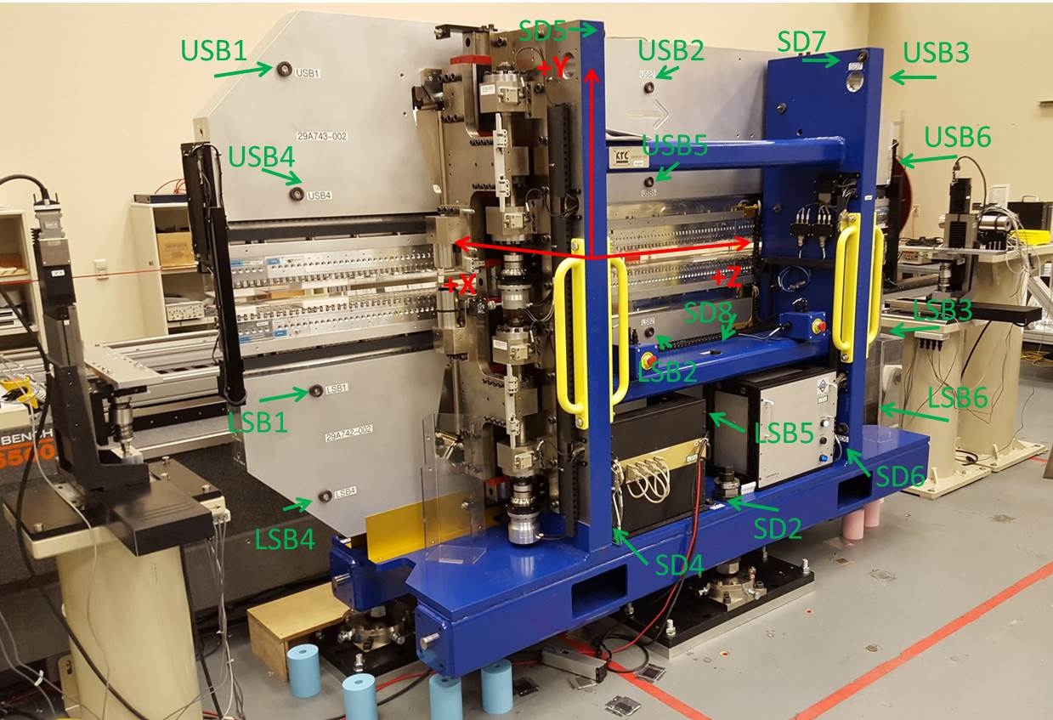

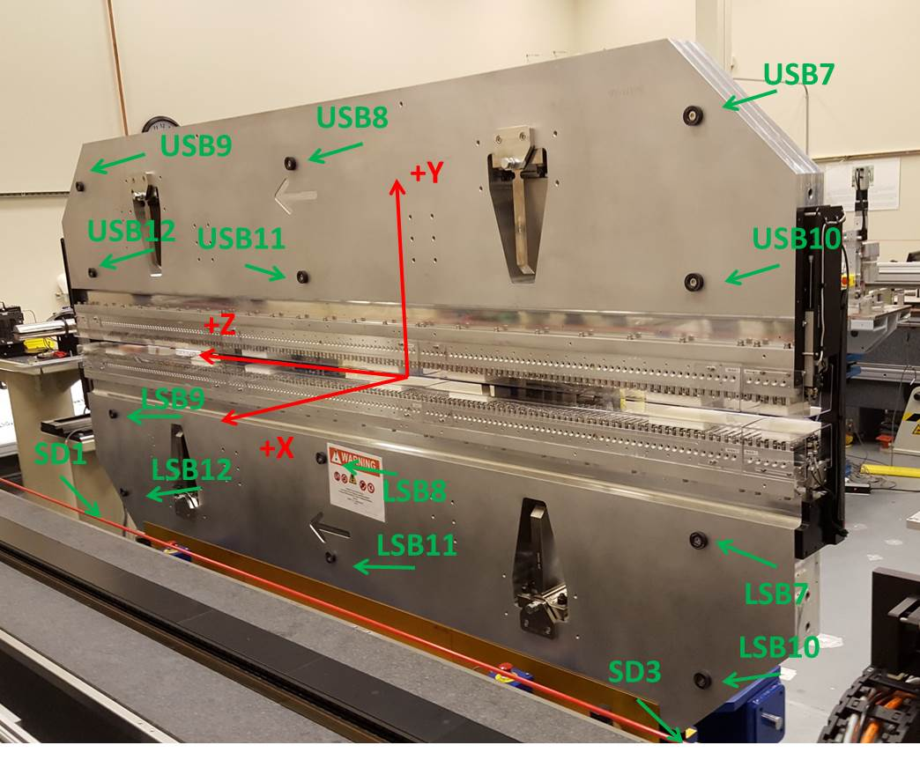

Tooling ball values to center of 1.5 inch sphere, all units are inches. Coordinates are to the SXR Undulator Magnetic Axis.
Tooling Ball | Z (in) | X (in) | Y (in)
LSB1 | -57.4863 | -3.4917 | -10.4771
LSB2 | -0.0081 | -3.4890 | -10.4775
LSB3 | 57.4726 | -3.4921 | -10.4747
LSB4 | -57.4861 | -3.4891 | -24.2558
LSB5 | -0.0072 | -3.4872 | -24.2554
LSB6 | 57.4745 | -3.4915 | -24.2559
LSB7 | -57.4862 | 3.4974 | -10.4737
LSB8 | -0.0051 | 3.5044 | -10.4741
LSB9 | 57.4758 | 3.4960 | -10.4784
LSB10 | -57.4861 | 3.5011 | -24.2518
LSB11 | -0.0043 | 3.5063 | -24.2524
LSB12 | 57.4735 | 3.4973 | -24.2565
SD1 | 50.9744 | 7.2493 | -34.7013
SD2 | -3.9246 | -19.5310 | -34.7560
SD3 | -50.9845 | 7.2228 | -34.6900
SD4 | -25.6504 | -21.6964 | -29.5927
SD5 | -25.6366 | -21.6820 | 29.4494
SD6 | 25.6180 | -21.6648 | -29.6187
SD7 | 25.6274 | -21.7035 | 29.4308
SD8 | -0.0186 | -16.9687 | -12.3656
USB1 | -57.4853 | -3.4857 | 24.2566
USB2 | -0.0033 | -3.4893 | 24.2575
USB3 | 57.4740 | -3.4831 | 24.2554
USB4 | -57.4845 | -3.4885 | 10.4755
USB5 | -0.0041 | -3.4933 | 10.4764
USB6 | 57.4733 | -3.4869 | 10.4738
USB7 | -57.4849 | 3.4912 | 24.2560
USB8 | -0.0074 | 3.4867 | 24.2557
USB9 | 57.4735 | 3.4934 | 24.2547
USB10 | -57.4855 | 3.4881 | 10.4760
USB11 | -0.0076 | 3.4837 | 10.4751
USB12 | 57.4744 | 3.4898 | 10.4771

Center | Z (m) | X (m) | Y (m) | Z (in) | X (in) | Y (in)
PM10M | -2.815396 | -0.026441 | 0.000741 | -110.8424 | -1.0410 | 0.0292
PM11M | 2.726865 | -0.026662 | 0.000501 | 107.3569 | -1.0497 | 0.0197
RFM | -2.670619 | 0.048535 | 0.000077 | -105.1425 | 1.9108 | 0.0030

PM10 and Granite coordinate system with Yurii shifts.
 |  | From Yurii |  |  | Measured
Device | Z (m) | X (m) | Y (m) | Z (m) | X (m) | Y (m) | dX (mm) | dY (mm)
PM10 | -0.369303 | -0.102477 | 0.000846 | -2.815396 | -0.102473 | 0.000847 | 0.004 | 0.001
PM11 | 5.173015 | -0.102690 | 0.000608 | 2.726865 | -0.102694 | 0.000607 | -0.004 | -0.001
RefBlock |  |  |  | -2.670619 | -0.027497 | 0.000183

Transformation results from 8/16/2018 measurements to 6/19/2018 measurements
 | dZ (m) | dX (m) | dY (m) | dRoll (mr) | dPitch (mr) | dYaw (mr)
UND | 0.000040 | 0.000005 | 0.000015 | -0.015 | 0.002 | -0.005

