LCLS2 SXR Undulator

Alignment Engineering Group
L2?????
SN 29A804-010
June 4, 2018

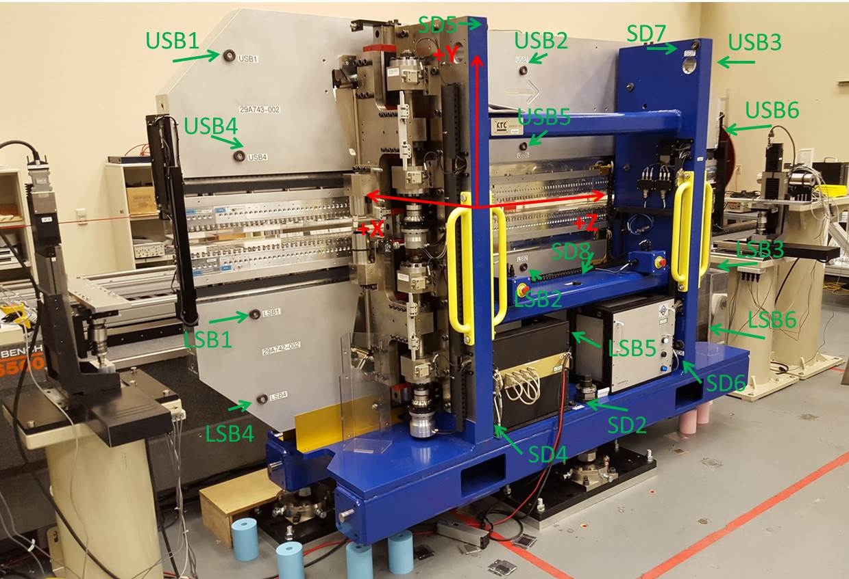

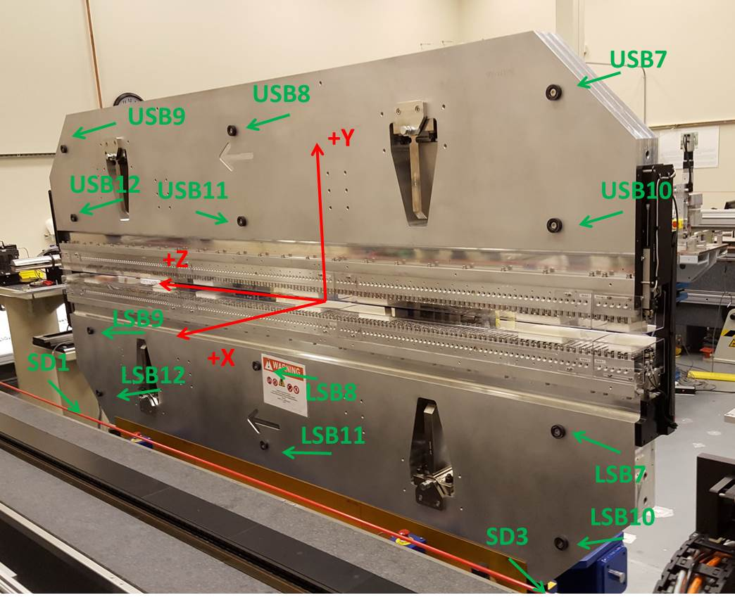

Tooling ball values to center of 1.5 inch sphere, all units are inches. Coordinates are to the SXR Undulator Magnetic Axis.
Tooling Ball | Z (in) | X (in) | Y (in)
LSB1 | -57.4804 | -3.4897 | -10.4735
LSB2 | 0.0002 | -3.4879 | -10.4761
LSB3 | 57.4819 | -3.4926 | -10.4751
LSB4 | -57.4788 | -3.4870 | -24.2491
LSB5 | 0.0013 | -3.4844 | -24.2525
LSB6 | 57.4822 | -3.4882 | -24.2520
LSB7 | -57.4903 | 3.4910 | -10.4752
LSB8 | -0.0070 | 3.4918 | -10.4757
LSB9 | 57.4704 | 3.4870 | -10.4756
LSB10 | -57.4892 | 3.4933 | -24.2549
LSB11 | -0.0092 | 3.4950 | -24.2556
LSB12 | 57.4727 | 3.4912 | -24.2559
SD1 | 50.9879 | 7.2377 | -34.6480
SD2 | -3.9464 | -19.5348 | -34.7021
SD3 | -50.9899 | 7.2283 | -34.6436
SD4 | -25.6873 | -21.7082 | -29.5596
SD5 | -25.7112 | -21.6799 | 29.4990
SD6 | 25.6673 | -21.6636 | -29.5501
SD7 | 25.6574 | -21.6908 | 29.4770
SD8 | 0.0335 | -16.9346 | -12.3408
USB1 | -57.4778 | -3.4898 | 24.2522
USB2 | 0.0020 | -3.4972 | 24.2543
USB3 | 57.4807 | -3.4969 | 24.2537
USB4 | -57.4791 | -3.4915 | 10.4750
USB5 | 0.0014 | -3.4985 | 10.4759
USB6 | 57.4806 | -3.4982 | 10.4755
USB7 | -57.4786 | 3.4900 | 24.2531
USB8 | -0.0026 | 3.4839 | 24.2533
USB9 | 57.4799 | 3.4843 | 24.2531
USB10 | -57.4774 | 3.4900 | 10.4765
USB11 | -0.0020 | 3.4822 | 10.4783
USB12 | 57.4768 | 3.4822 | 10.4772

Center | Z (m) | X (m) | Y (m) | Z (in) | X (in) | Y (in)
PM10M | -2.815242 | -0.026337 | 0.000613 | -110.8363 | -1.0369 | 0.0241
PM11M | 2.726965 | -0.026565 | 0.000386 | 107.3608 | -1.0459 | 0.0152
RFM | -2.670477 | 0.048643 | -0.000044 | -105.1369 | 1.9151 | -0.0017

PM10 and Granite coordinate system with Yurii shifts.
 |  | From Yurii |  |  | Measured
Device | Z (m) | X (m) | Y (m) | Z (m) | X (m) | Y (m) | dX (mm) | dY (mm)
PM10 | -0.368777 | -0.102548 | 0.000944 | -2.815242 | -0.102538 | 0.000936 | 0.010 | -0.008
PM11 | 5.173508 | -0.102756 | 0.000701 | 2.726965 | -0.102766 | 0.000709 | -0.010 | 0.008
Ref Block |  |  |  | -2.670477 | -0.027558 | 0.000279

