LCLS2 SXR Undulator

Alignment Engineering Group
L2?????
SN 29A804-003
April 26, 2019

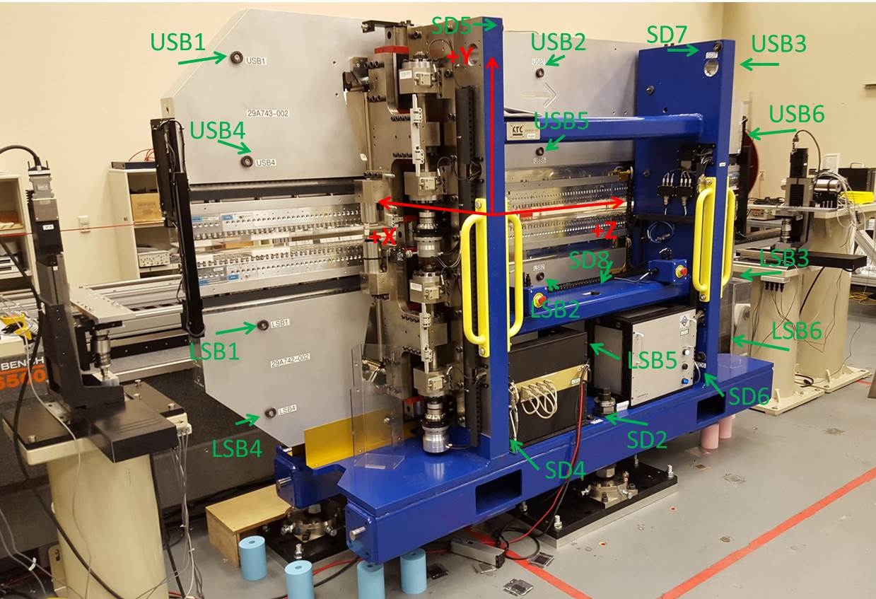

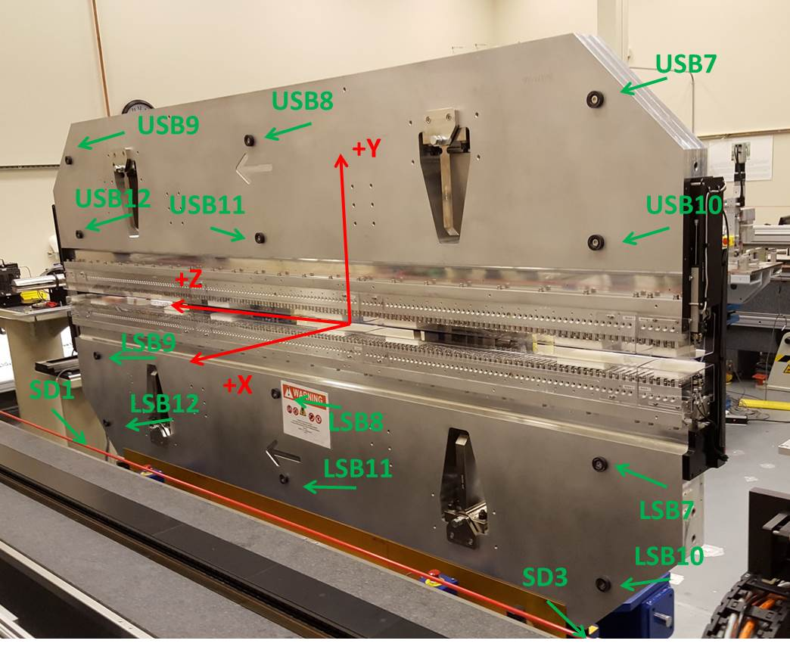

Tooling ball values to center of 1.5 inch sphere, all units are inches. Coordinates are to the SXR Undulator Magnetic Axis.
Tooling Ball | Z (in) | X (in) | Y (in)
LSB1 | -57.4472 | -3.4843 | -10.4828
LSB2 | 0.0312 | -3.4722 | -10.4863
LSB3 | 57.5218 | -3.4725 | -10.4829
LSB4 | -57.4409 | -3.4822 | -24.2605
LSB5 | 0.0277 | -3.4736 | -24.2514
LSB6 | 57.5083 | -3.4739 | -24.2467
LSB7 | -57.4399 | 3.4903 | -10.4738
LSB8 | 0.0337 | 3.5006 | -10.4679
LSB9 | 57.5173 | 3.4993 | -10.4708
LSB10 | -57.4426 | 3.4890 | -24.2510
LSB11 | 0.0355 | 3.5019 | -24.2543
LSB12 | 57.5026 | 3.4983 | -24.2559
SD1 | 51.0109 | 7.2420 | -34.6851
SD2 | -3.9165 | -19.5309 | -34.7513
SD3 | -50.9512 | 7.2415 | -34.6880
SD4 | -25.5837 | -21.6871 | -29.6016
SD5 | -25.6345 | -21.6615 | 29.4502
SD6 | 25.6751 | -21.6538 | -29.6071
SD7 | 25.6516 | -21.6951 | 29.4430
SD8 | 0.0321 | -16.9387 | -12.4048
USB1 | -57.4417 | -3.4911 | 24.2476
USB2 | 0.0287 | -3.4748 | 24.2561
USB3 | 57.4998 | -3.4922 | 24.2502
USB4 | -57.4358 | -3.4906 | 10.4813
USB5 | 0.0304 | -3.4739 | 10.4766
USB6 | 57.5027 | -3.4915 | 10.4711
USB7 | -57.4457 | 3.4877 | 24.2543
USB8 | 0.0315 | 3.5041 | 24.2446
USB9 | 57.5050 | 3.4863 | 24.2539
USB10 | -57.4384 | 3.4874 | 10.4756
USB11 | 0.0279 | 3.5054 | 10.4804
USB12 | 57.5156 | 3.4863 | 10.4699

Center | Z (m) | X (m) | Y (m) | Z (in) | X (in) | Y (in)
PM10M | -2.815807 | -0.026256 | 0.000732 | -110.8585 | -1.0337 | 0.0288
PM11M | 2.726345 | -0.026495 | 0.000482 | 107.3364 | -1.0431 | 0.0190
RFM | -2.671048 | 0.048722 | 0.000064 | -105.1594 | 1.9182 | 0.0025

PM10 and Granite coordinate system with Yurii shifts.
 |  | From Yurii |  |  | Measured
Device | Z (m) | X (m) | Y (m) | Z (m) | X (m) | Y (m) | dX (mm) | dY (mm)
PM10 | -0.369011 | -0.102535 | 0.000891 | -2.815807 | -0.102531 | 0.000884 | 0.004 | -0.007
PM11 | 5.173268 | -0.102766 | 0.000626 | 2.726345 | -0.102770 | 0.000634 | -0.004 | 0.008
RefBlock |  |  |  | -2.671048 | -0.027553 | 0.000216

