LCLS2 SXR Undulator

Alignment Engineering Group
L200112
SN 29A804-001 Repeat3
March 08, 2019

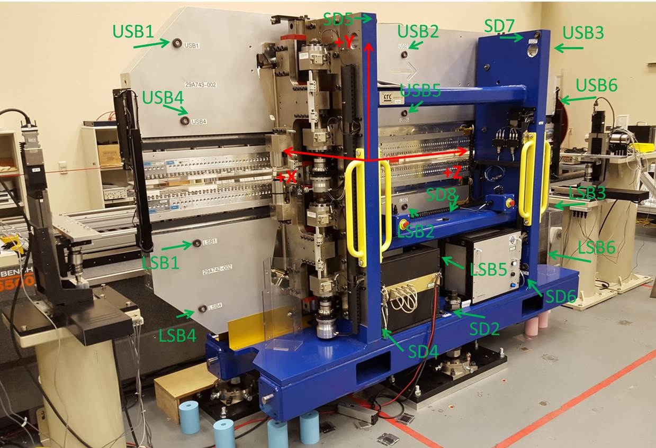

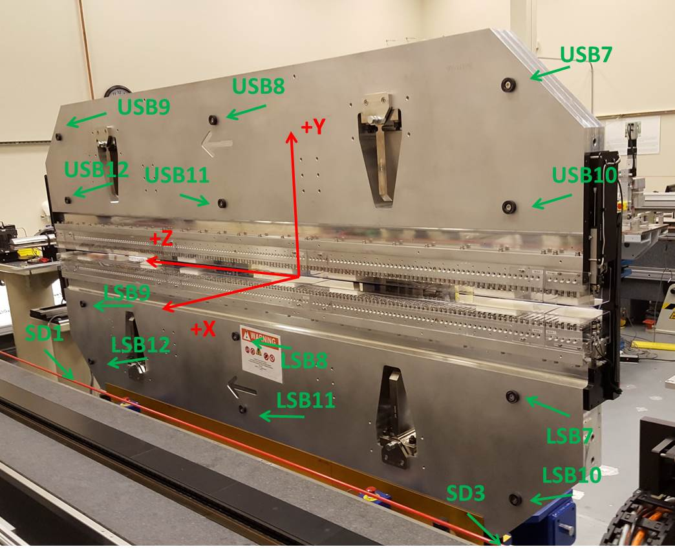

Tooling ball values to center of 1.5 inch sphere, all units are inches. Coordinates are to the SXR Undulator Magnetic Axis.
Tooling Ball | Z (in) | X (in) | Y (in)
LSB1 | -57.4787 | -3.4886 | -10.4701
LSB2 | 0.0032 | -3.5009 | -10.4737
LSB3 | 57.4861 | -3.4915 | -10.4748
LSB4 | -57.4828 | -3.4864 | -24.2567
LSB5 | -0.0033 | -3.4990 | -24.2453
LSB6 | 57.4884 | -3.4898 | -24.2503
LSB7 | -57.4683 | 3.4868 | -10.4724
LSB8 | 0.0086 | 3.4760 | -10.4746
LSB9 | 57.4854 | 3.4834 | -10.4778
LSB10 | -57.4697 | 3.4899 | -24.2528
LSB11 | 0.0044 | 3.4781 | -24.2569
LSB12 | 57.4850 | 3.4862 | -24.2554
SD1 | 50.9594 | 7.2252 | -34.7539
SD2 | -3.9673 | -19.5308 | -34.8203
SD3 | -51.0017 | 7.2366 | -34.7809
SD4 | -25.7452 | -21.7135 | -29.6728
SD5 | -25.7739 | -21.6994 | 29.3913
SD6 | 25.6069 | -21.6983 | -29.6599
SD7 | 25.6065 | -21.6985 | 29.3844
SD8 | 0.0073 | -16.9119 | -12.4389
USB1 | -57.4670 | -3.4856 | 24.2501
USB2 | 0.0082 | -3.4812 | 24.2539
USB3 | 57.4856 | -3.4933 | 24.2574
USB4 | -57.4654 | -3.4885 | 10.4728
USB5 | 0.0054 | -3.4848 | 10.4779
USB6 | 57.4857 | -3.4944 | 10.4745
USB7 | -57.4667 | 3.4899 | 24.2492
USB8 | 0.0076 | 3.4943 | 24.2452
USB9 | 57.4825 | 3.4836 | 24.2490
USB10 | -57.4662 | 3.4871 | 10.4698
USB11 | 0.0117 | 3.4916 | 10.4663
USB12 | 57.4828 | 3.4814 | 10.4716

Center | Z (m) | X (m) | Y (m) | Z (in) | X (in) | Y (in)
PM10M | -2.815936 | -0.026401 | 0.000595 | -110.8636 | -1.0394 | 0.0234
PM11M | 2.726207 | -0.026647 | 0.000353 | 107.3310 | -1.0491 | 0.0139
RFM | -2.671172 | 0.048572 | -0.000070 | -105.1643 | 1.9123 | -0.0028

PM10 and Granite coordinate system with Yurii shifts.
 |  | From Yurii |  |  | Measured
Device | Z (m) | X (m) | Y (m) | Z (m) | X (m) | Y (m) | dX (mm) | dY (mm)
PM10 | -0.368878 | -0.102493 | 0.000742 | -2.815936 | -0.102478 | 0.000726 | 0.015 | -0.016
PM11 | 5.173383 | -0.102708 | 0.000468 | 2.726207 | -0.102724 | 0.000484 | -0.016 | 0.016
RefBlock |  |  |  | -2.671172 | -0.027505 | 0.000061

