LCLS2 SXU 001

Alignment Engineering Group
L200112
SN 29A804-001
August 17, 2017

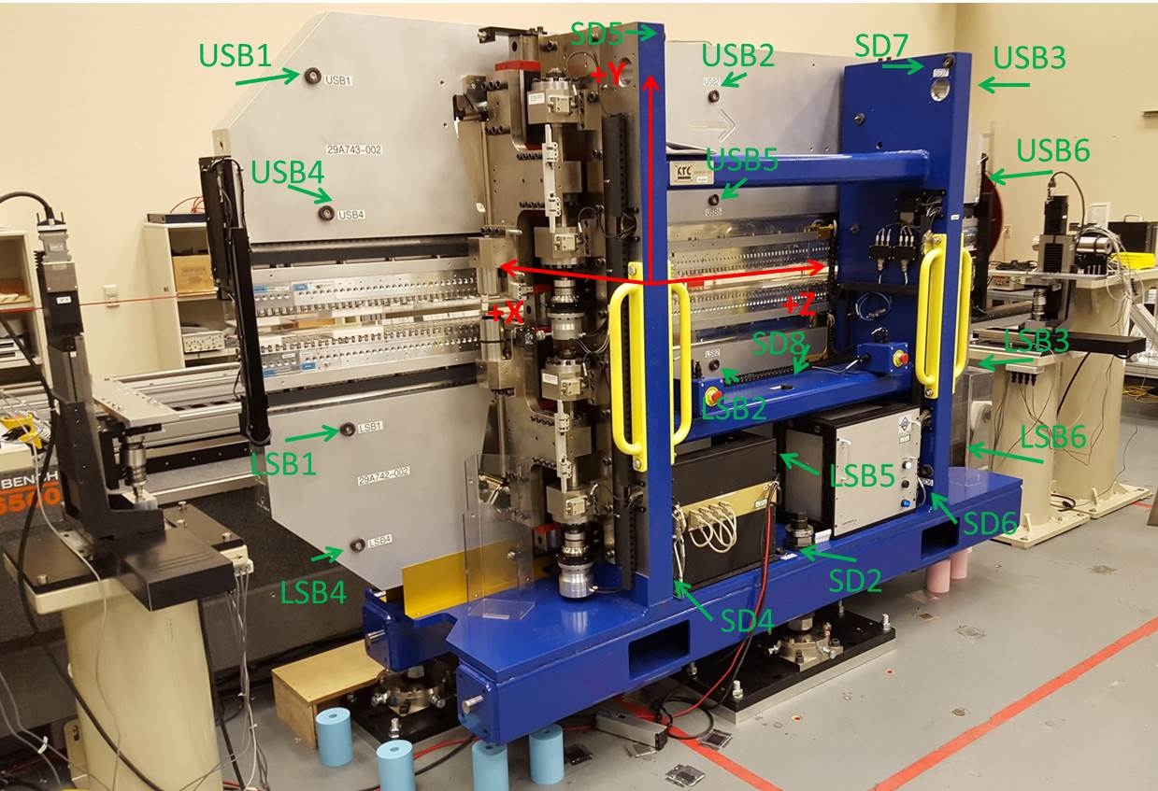

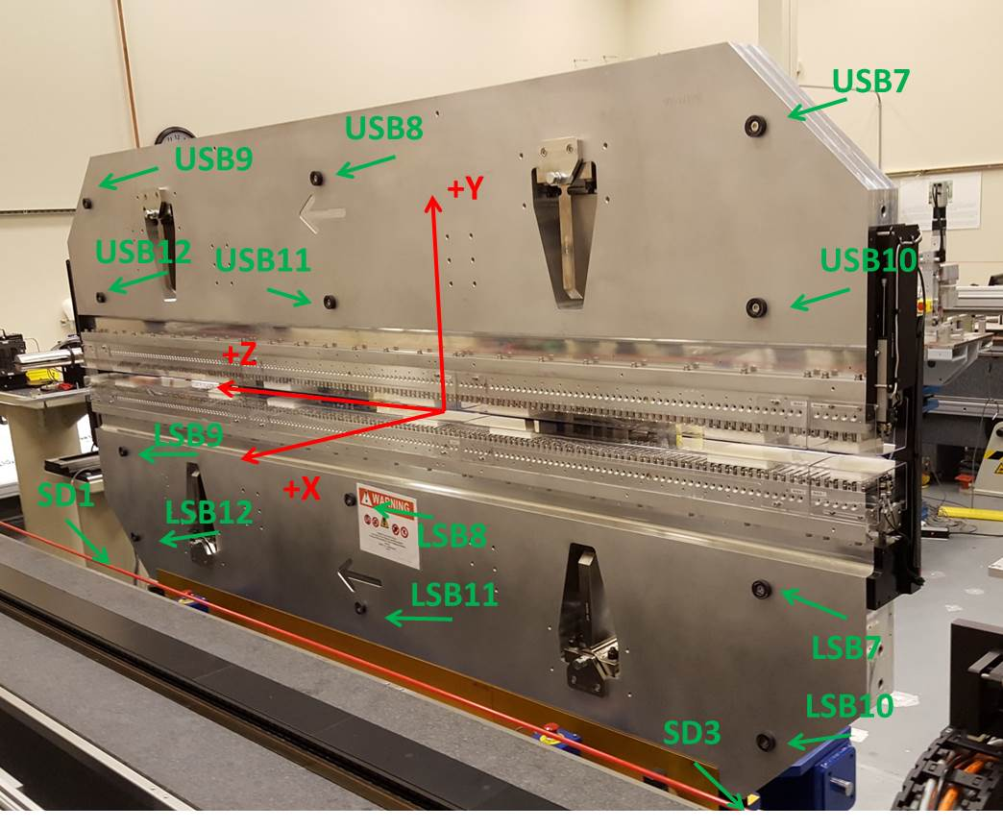

Tooling ball values to center of 1.5 inch sphere, all units are inches. Coordinates are to the SXU Magnetic Axis.
Tooling Ball | Z (in) | X (in) | Y (in)
LNB1 | -57.4708 | 3.4879 | -10.4702
LNB2 | 0.0065 | 3.4756 | -10.4722
LNB3 | 57.4832 | 3.4819 | -10.4759
LNB4 | -57.4724 | 3.4903 | -24.2502
LNB5 | 0.0020 | 3.4773 | -24.2549
LNB6 | 57.4828 | 3.4837 | -24.2537
LSB1 | -57.4808 | -3.4877 | -10.4679
LSB2 | 0.0008 | -3.5009 | -10.4720
LSB3 | 57.4839 | -3.4930 | -10.4734
LSB4 | -57.4850 | -3.4857 | -24.2540
LSB5 | -0.0057 | -3.4993 | -24.2428
LSB6 | 57.4861 | -3.4917 | -24.2486
SD1 | 50.9572 | 7.2226 | -34.7515
SD2 | -3.9700 | -19.5317 | -34.8161
SD3 | -51.0043 | 7.2371 | -34.7769
SD4 | -25.7480 | -21.7137 | -29.6689
SD5 | -25.7765 | -21.6979 | 29.3954
SD6 | 25.6041 | -21.6998 | -29.6560
SD7 | 25.6040 | -21.6975 | 29.3881
SD8 | 0.0050 | -16.9118 | -12.4351
UNB1 | -57.4689 | 3.4920 | 24.2517
UNB2 | 0.0058 | 3.4949 | 24.2476
UNB3 | 57.4807 | 3.4837 | 24.2509
UNB4 | -57.4687 | 3.4885 | 10.4724
UNB5 | 0.0096 | 3.4920 | 10.4683
UNB6 | 57.4809 | 3.4809 | 10.4736
USB1 | -57.4691 | -3.4836 | 24.2526
USB2 | 0.0060 | -3.4800 | 24.2561
USB3 | 57.4835 | -3.4932 | 24.2597
USB4 | -57.4675 | -3.4872 | 10.4755
USB5 | 0.0033 | -3.4841 | 10.4797
USB6 | 57.4834 | -3.4947 | 10.4765

Center | Z (m) | X (m) | Y (m) | Z (in) | X (in) | Y (in)
PM10M | -2.815583 | -0.026362 | 0.000790 | -110.8497 | -1.0379 | 0.0311
PM11M | 2.726777 | -0.026512 | 0.000941 | 107.3534 | -1.0438 | 0.0370

 | Z (m) | X (m) | Y (m) | Z (in) | X (in) | Y (in)
Mechanical Center | 0 | 0.000093 | 0.000125 | 0.0000 | 0.0037 | 0.0049

PM10 and Granite coordinate system with Yurii shifts.
 |  | From Yurii |  |  | Measured
Device | Z (m) | X (m) | Y (m) | Z (m) | X (m) | Y (m) | dX (mm) | dY (mm)
PM10 | -0.368922 | -0.102487 | 0.000910 | 0.000000 | -0.102487 | 0.000910 | 0.000 | 0.000
PM11 | 5.173467 | -0.102680 | 0.001056 | 5.542360 | -0.102637 | 0.001061 | 0.043 | 0.005

