SLAC Traveler for LCLS-II 0.79SD14.96, SA-375-150-01 HLAM Septum Magnet
(March 9, 2020)

This traveler is intended to cover mechanical fiducialization, and magnetic measurements of the 0.79SD14.96 HLAM septum magnet BLRDG0. This magnet is paired with a dipole BXDG0, which has the same length and gap. The septum has a round field free channel and a rectangular channel whose field will bend the beam horizontally.

Receiving:

MAD Name | Eng. Name | Drawing# | Barcode | Polarity | Bus Bars
BLRDG0 | 0.79SD14.96 | SA-375-150-01 | 4490 | N | Left Side
SPARE | 0.79SD14.96 | SA-375-150-01 | 4488 | N | Left Side

The following information is to be noted upon receipt of the magnets by the SLAC MM group:
Received by (initials): | SDA
Date placed on test stand (dd-mmm-yyyy): | 6/16/2020
SLAC barcode number: | 4488
Vendor serial number from magnet label: | 2
SLAC approved electrical safety covers? (Y or N): | Y
SLAC drawing number (enter number): | SA-375-150-01

Preparation:
A beam direction arrow, with text “beam direction”, is to be applied to the top and/or connector side of the magnet with a sticker supplied by LCLS-II. The terminals shall be oriented down beam.
Beam-direction arrow in place (initials): | SDA

Fiducialization:
Fiducialization will be done before magnetic measurements by the CMM or Alignment group. This will require the installation of removable tooling balls, location of the geometric axis of the field producing poles of the magnet, and location of tooling balls with respect to the center of the field free region axis when the poles are aligned precisely horizontal. The upstream and downstream pole gap should also be measured and recorded and record file made. The nominal beam center in the field-free region circular hole is 4 mm above the hole’s axis; the nominal beam center in the bending channel (at the septum entrance face) is 6 mm above the bottom of the channel. The upstream kicker(s) separate the kicked and non-kicked beams by 15 mm at the septum’s entrance face. Since the field-free hole is 20 mm in diameter, putting the beam 4 mm above the hole’s axis means that it is 6 mm below the top of the hole. The “blade” between the hole and bending channel is 3 mm thick. So the beams (kicked and non-kicked) are 15 mm apart at the septum’s entrance face. The kicked beam is also pointing slightly upward w.r.t. the bending channel, but we decided to measure in the channel parallel to its floor. The beam in x, is centered on the center of the field free axis.

CMM technician (initials): | BR

URL of on-line CMM fiducialization data (please modify or correct if necessary):
https://www-group.slac.stanford.edu/met/MagMeas/MAGDATA/LCLS-II/Fiducial%20Reports/4488%20Septum%200.79SD14.96_SN02%20Bending%20(mm).txt
https://www-group.slac.stanford.edu/met/MagMeas/MAGDATA/LCLS-II/Fiducial%20Reports/4488%20Septum%200.79SD14.96%20SN02%20Field%20Free%20(mm).txt

Magnetic Measurements:
Enter URL of on-line magnetic measurements data (please modify or correct if necessary):
http://www-group.slac.stanford.edu/met/MagMeas/MAGDATA/LCLS-II/Septum/4488

- Mark the magnet as BLRDG0 or SPARE 0.79SD14.96. BLRDG0 and SPARE 0.79SD14.96 are negative horizontal bends in polarity (bending electrons right). Determine the main-coil connection polarity (with main supply outputting positive current) which produces a negative horizontal dipole field polarity, as shown below, in the rectangular bending field channel and mark the polarity near the magnet leads with clear “+” and “-” labels.

Magnet marked as (BLRDG0 or SPARE 0.79SD14.96): | SPARE 0.79SD14.96
Polarity is marked according to Fig. 1 (initials): | SDA

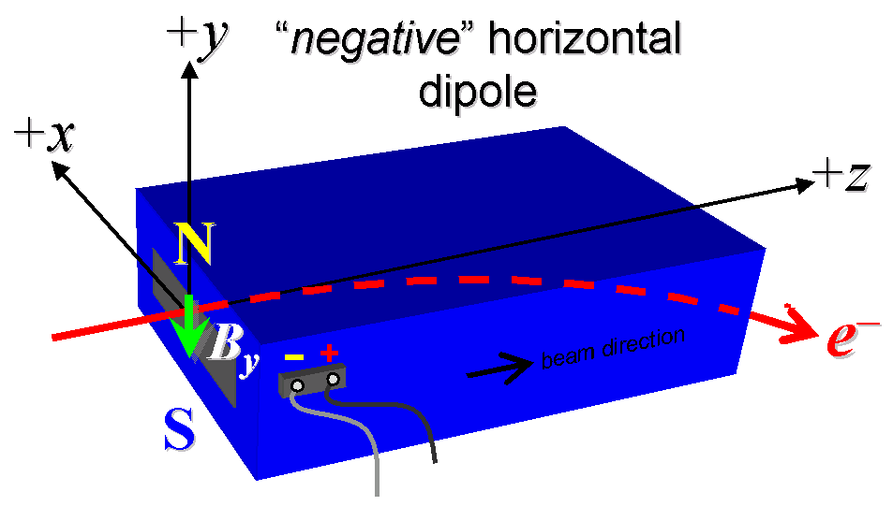

Figure 1. BLRDG0 is a “negative” horizontal polarity dipole (bending electrons to the right).

- Measure the inductance and resistance of the main magnet coils:
Inductance of main coil (mH): | 0.18397 mH
Resistance of main coil (Ohms): | 0.298 Ohm

- Connect the magnet terminals, in the correct polarity as established above, to a unipolar (or bipolar) power supply with maximum current I ≥ 130 A.

- Connect magnet to LCW supply. Adjust supply pressure to a delta P of ~51 psi to achieve a flow rate of 0.21 gpm. Run the magnet up to 130 A for ~1 hour to warm it up (record, delta P, flow rate, and magnet coil and steel temperature).
LCW delta P (psi) | 80 psi
LCW flow rate (gpm) | 0.25 gpm
LCW delta T (°C) | 5.16 °C
Ambient temperature (°C): | 24.1 °C
Final magnet steel temperature (°C): | 24.8 °C

- Ramp the main of the magnet to 130 A and measure the pole tip field. It should be close to 0.1333 Tesla.
Pole Tip Field and Current | 0.1581 T at 130.02724 A

- Standardize the magnet, starting from 0 to 130 A and back to zero, through three full cycles, finally ending at zero, with a flat-top pause time (at both 0 and 130 A) of 10 seconds. Use a cosine ramp rate of 10 A/sec, record the ramp rate used.
Standardization complete (initials): | SDA
Ramp rate used (A/sec): | 10 A/s

- Align the stretched wire in the rectangular bending field channel (See Fiducialization Section). Measure the length-integrated vertical dipole field, ∫B_{y}dl, from 0 to 130 A in the rectangular bending field channel in 10-A steps, including zero (14 ‘up’ measurements). Then, still maintaining the cycle history, measure ∫B_{y}dl back down from 130 A to 0 in 10-A steps, including zero (13 ‘down’ measurements).
Filename & run number of ∫B_{y}dl up & down data: | Wiredat.ru1, wireplt.ru1

- With the main coil at 130 A, measure the length-integrated vertical field at multiple x positions in the rectangular bending field channel. With the wire located at the 6 mm above the bottom of the channel (See Fiducialization section), measure the vertical length-integrated field at each 3-mm step of horizontal wire position, from x = −21 mm to +21 mm, with x = 0 centered at the magnet’s field free region center. Record data file name:
Filename of ∫B_{y}dl vs x data at 130 A: | wirevsx.ru1, wirevsxplt.ru1

- Align the stretched wire into field free round channel (See Fiducialization Section). Standardize the magnet and measure ∫B_{y}dl in the field free channel as a function of main coil current at 0, 50, 100 and 130 A steps. Also measure the ∫B_{y}dl in the field free channel with the main power supply off. The field in the field free channel should be less than 2 G-m length integrated field.
Filename of ∫B_{y}dl vs main current in field free region: | Wiredat.ru2, Wiredat.ru4 (PS off)

- With the stretched wire into field free round channel. Standardize the magnet and measure ∫B_{x}dl in the field free channel as a function of main coil current at 0, 50, 100 and 130 A steps. Also measure the ∫B_{x}dl in the field free channel with the main power supply off. The field in the field free channel should be less than 5 Gauss, or 2 G-m length integrated field.
Filename of ∫B_{x}dl vs main current in field free region: | Wiredat.ru3, Wiredat.ru5 (PS off)

- If possible, use a rotating coil to measure the harmonics in the field free channel. Align the rotating coil into field free round channel. Standardize the magnet and measure the harmonics with the main coil current at 50, 100 and 130 Amps.
Filename of Field Free Channel Rotating Coil Harmonics | Not done, field below tolerance

- Upon completion of tests, send data link to Mark Woodley who will produce a data analysis file. Place data analysis file in magnetic measurements data directory
Magnet data accepted and data analysis file produced | SDA

Enter URL of on-line magnetic measurements analysis data :
http://www-group.slac.stanford.edu/met/MagMeas/MAGDATA/LCLS-II/Septum/4488/4488.pptx

