LCLS2 SX Phase Shifter

Alignment Engineering Group
L200388
SN SXPS-16353
Jan 23, 2018

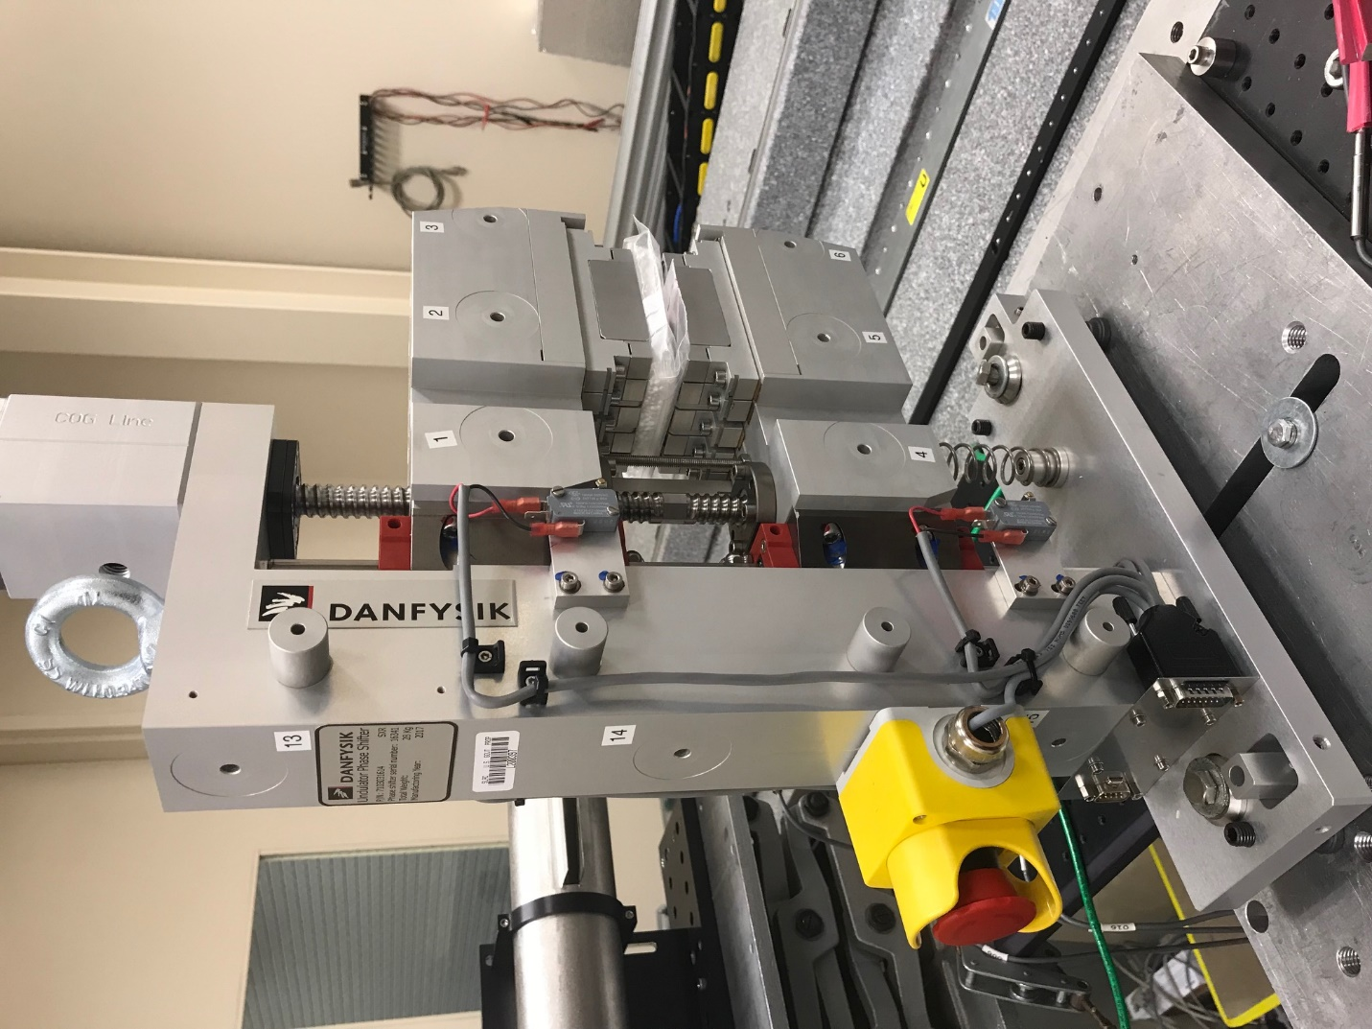
TB1
TB2
TB3
TB6
TB5
TB4
TB13
TB14
TB15
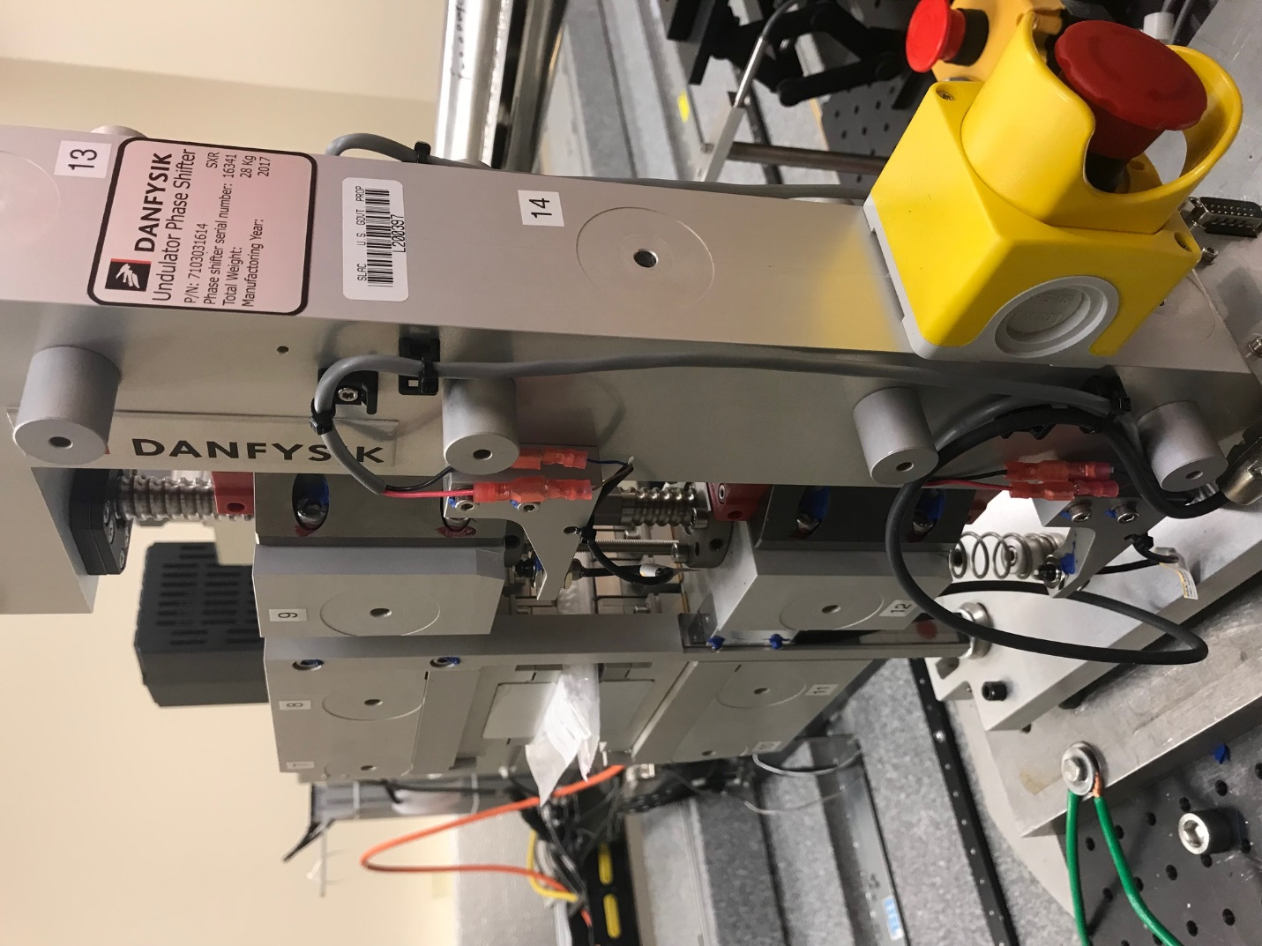
TB6
TB7
TB8
TB12

TB11
TB10
TB13
TB14
TB15

Tooling ball values to center of 1.5 inch sphere, all units are meter. Coordinates are to the HX Phase Shifter Magnetic Axis.
Tooling Ball | Z [m] | X [m] | Y [m]
TB1 | 0.070078 | -0.109093 | 0.083225
TB2 | 0.070043 | -0.026598 | 0.083300
TB3 | 0.070007 | 0.055914 | 0.083354
TB4 | 0.070136 | -0.108930 | -0.083544
TB5 | 0.070130 | -0.026391 | -0.083400
TB6 | 0.070119 | 0.056047 | -0.083196
TB7 | -0.070292 | 0.055829 | 0.083168
TB8 | -0.070273 | -0.026691 | 0.083142
TB9 | -0.070244 | -0.109173 | 0.083091
TB10 | -0.070209 | 0.056094 | -0.083181
TB11 | -0.070216 | -0.026402 | -0.083357
TB12 | -0.070219 | -0.108942 | -0.083528
TB13 | -0.000188 | -0.268515 | 0.186754
TB14 | -0.000170 | -0.268267 | 0.016730
TB15 | -0.000045 | -0.268024 | -0.153203

