LCLS2 SX Phase Shifter

Alignment Engineering Group
L200387
SN SXPS-16351
Jan 19, 2018

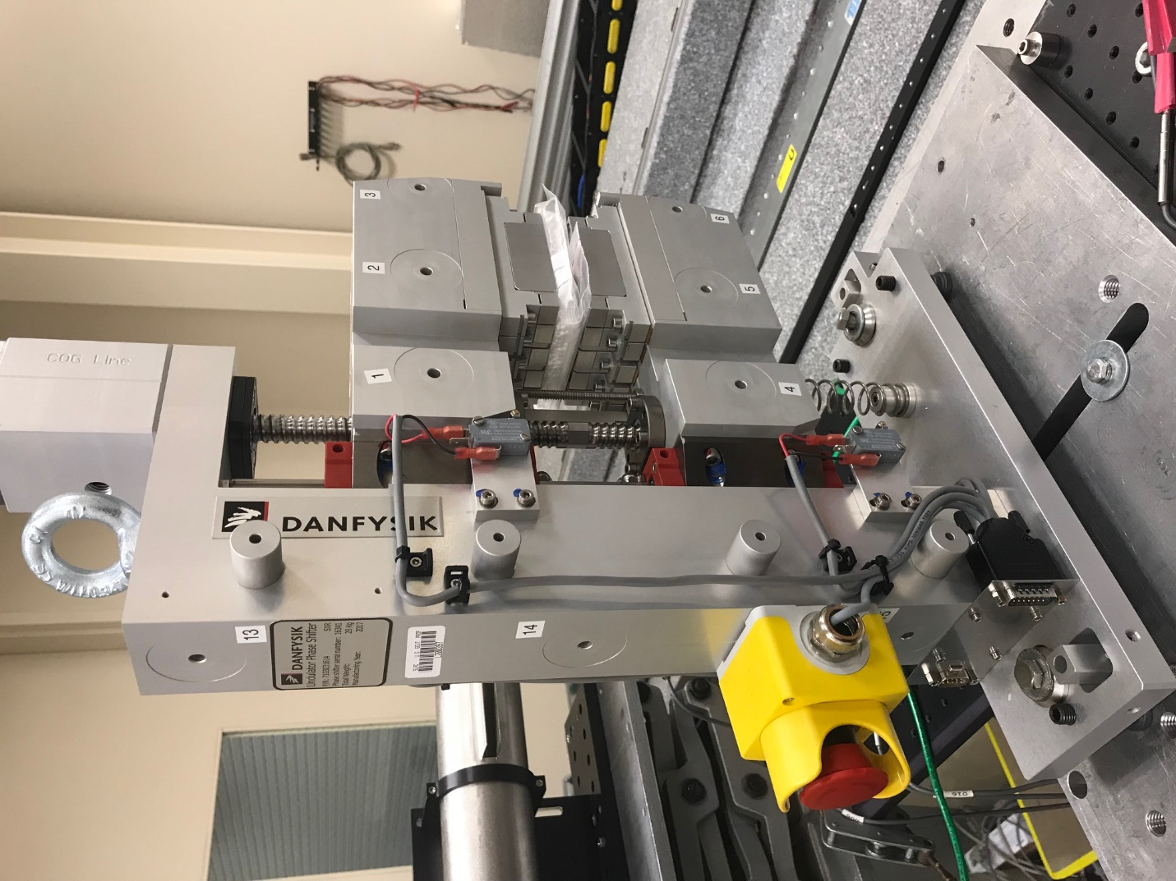
TB1
TB2
TB3
TB6
TB5
TB4
TB13
TB14
TB15
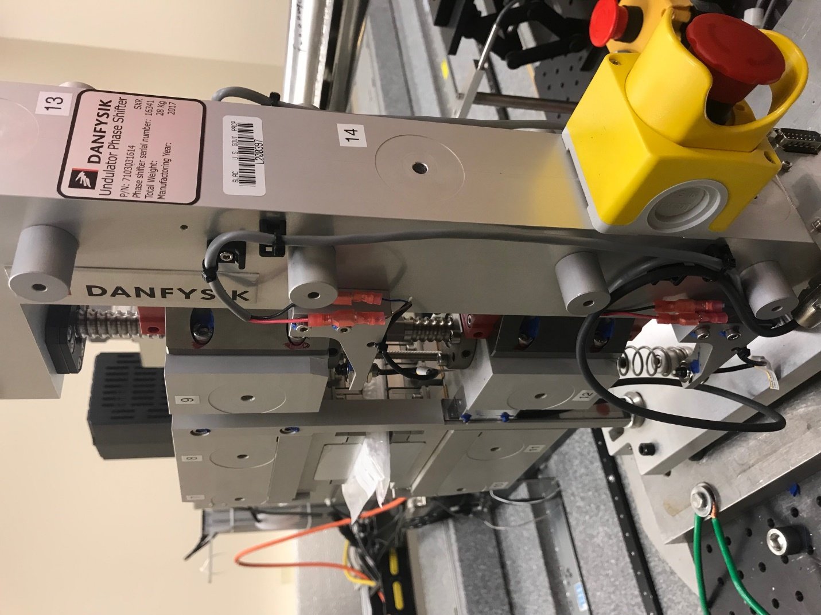
TB6
TB7
TB8
TB12

TB11
TB10
TB13
TB14
TB15

Tooling ball values to center of 1.5 inch sphere, all units are meter. Coordinates are to the HX Phase Shifter Magnetic Axis.
Tooling Ball | Z [m] | X [m] | Y [m]
TB1 | 0.070130 | -0.108750 | 0.085224
TB2 | 0.070071 | -0.026277 | 0.085254
TB3 | 0.070011 | 0.056239 | 0.085273
TB4 | 0.070114 | -0.108770 | -0.085266
TB5 | 0.070094 | -0.026264 | -0.085209
TB6 | 0.070105 | 0.056347 | -0.085187
TB7 | -0.070338 | 0.056142 | 0.085186
TB8 | -0.070298 | -0.026381 | 0.085192
TB9 | -0.070288 | -0.108994 | 0.085032
TB10 | -0.070242 | 0.056237 | -0.085151
TB11 | -0.070236 | -0.026257 | -0.085243
TB12 | -0.070244 | -0.108842 | -0.085317
TB13 | -0.000122 | -0.268076 | 0.187080
TB14 | -0.000141 | -0.268015 | 0.017127
TB15 | -0.000158 | -0.267961 | -0.152821

