LCLS2 SX Phase Shifter

Alignment Engineering Group
L200386
SN SXPS-16350
Jan 17, 2018

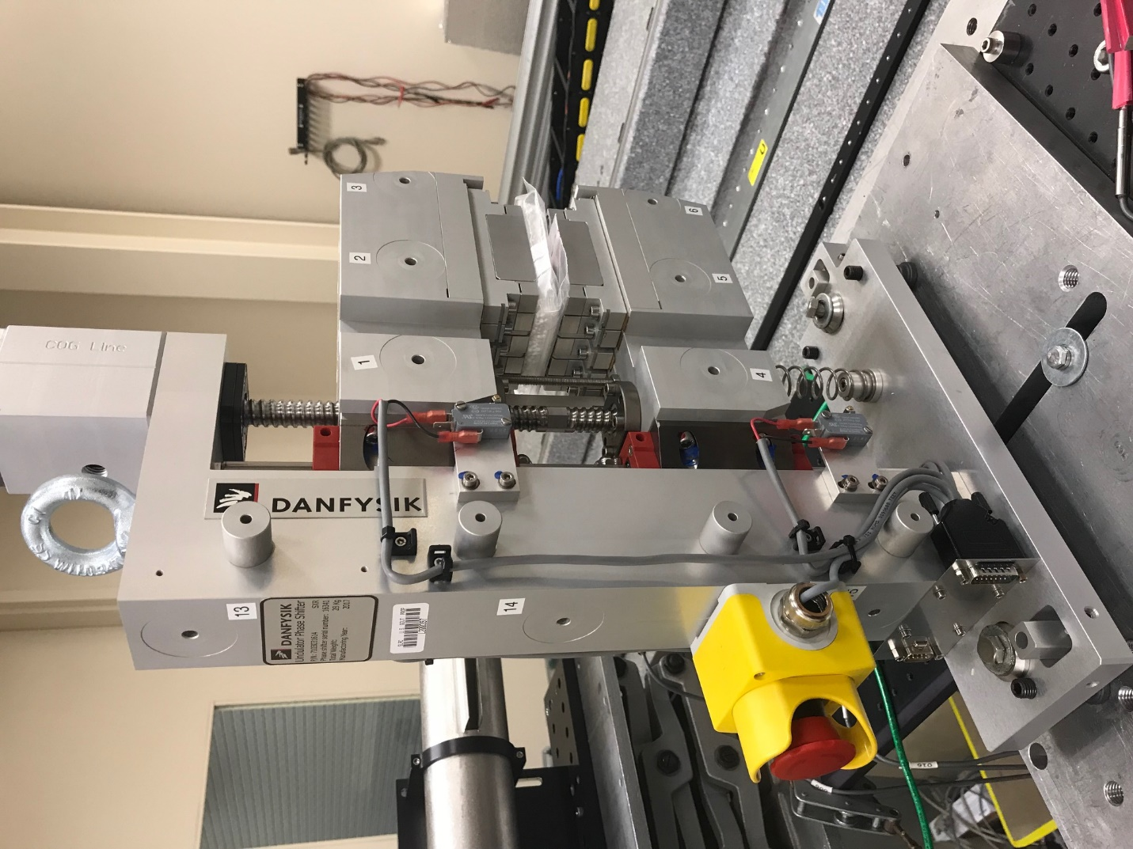
TB1
TB2
TB3
TB6
TB5
TB4
TB13
TB14
TB15
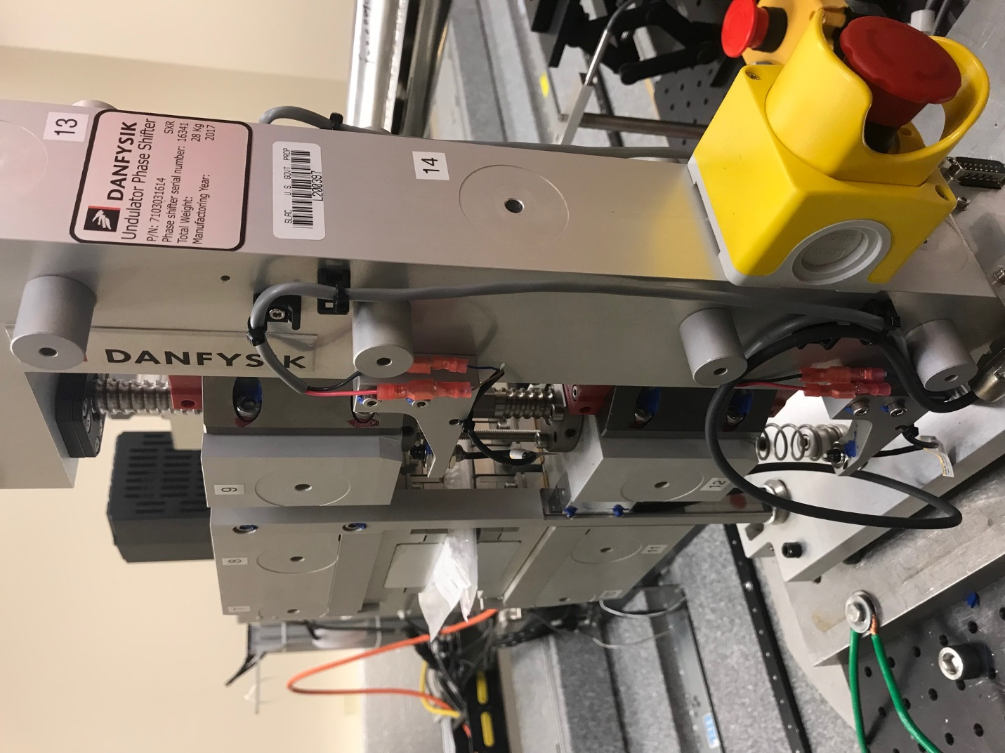
TB6
TB7
TB8
TB12

TB11
TB10
TB13
TB14
TB15

Tooling ball values to center of 1.5 inch sphere, all units are meter. Coordinates are to the HX Phase Shifter Magnetic Axis.
Tooling Ball | Z [m] | X [m] | Y [m]
TB1 | 0.070011 | -0.109204 | 0.084520
TB2 | 0.070056 | -0.026666 | 0.084603
TB3 | 0.070089 | 0.055831 | 0.084662
TB4 | 0.070061 | -0.108954 | -0.084817
TB5 | 0.070120 | -0.026450 | -0.084672
TB6 | 0.070155 | 0.056056 | -0.084446
TB7 | -0.070232 | 0.055882 | 0.084689
TB8 | -0.070282 | -0.026626 | 0.084630
TB9 | -0.070332 | -0.109146 | 0.084542
TB10 | -0.070134 | 0.056163 | -0.084669
TB11 | -0.070225 | -0.026385 | -0.084868
TB12 | -0.070281 | -0.108817 | -0.084956
TB13 | -0.000386 | -0.268465 | 0.186587
TB14 | -0.000350 | -0.268233 | 0.016618
TB15 | -0.000381 | -0.268002 | -0.153364

