LCLS2 SX Phase Shifter

Alignment Engineering Group
L200385
SN SXPS-16349
Feb 1, 2018

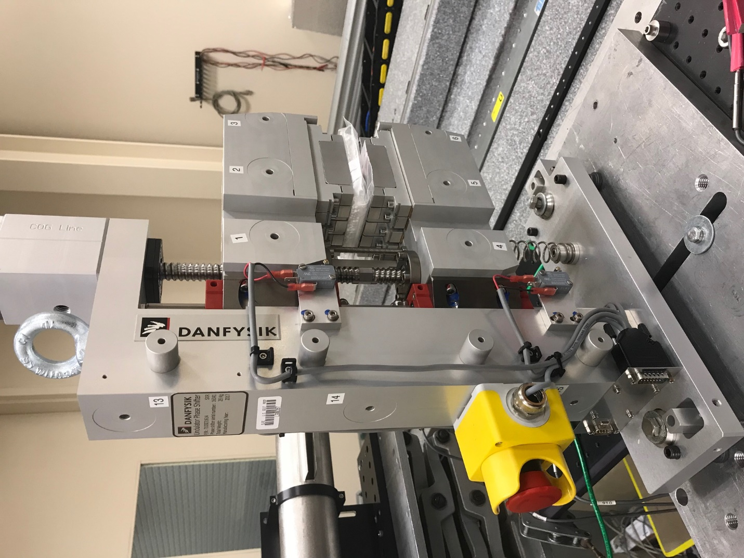
TB1
TB2
TB3
TB6
TB5
TB4
TB13
TB14
TB15
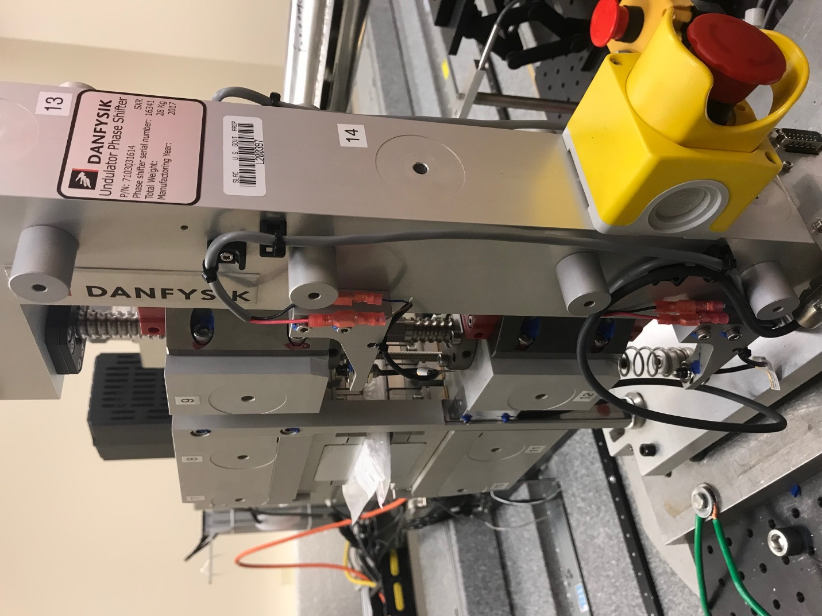
TB6
TB7
TB8
TB12

TB11
TB10
TB13
TB14
TB15

Tooling ball values to center of 1.5 inch sphere, all units are meter. Coordinates are to the HX Phase Shifter Magnetic Axis.
Tooling Ball | Z [m] | X [m] | Y [m]
TB1 | 0.070139 | -0.109042 | 0.083260
TB2 | 0.070039 | -0.026626 | 0.083313
TB3 | 0.069971 | 0.055869 | 0.083255
TB4 | 0.070252 | -0.109198 | -0.083206
TB5 | 0.070268 | -0.026697 | -0.083143
TB6 | 0.070289 | 0.055809 | -0.083066
TB7 | -0.070322 | 0.055728 | 0.083254
TB8 | -0.070272 | -0.026865 | 0.083293
TB9 | -0.070209 | -0.109289 | 0.083357
TB10 | -0.070046 | 0.055873 | -0.083307
TB11 | -0.070077 | -0.026639 | -0.083384
TB12 | -0.070110 | -0.109145 | -0.083450
TB13 | 0.000065 | -0.268444 | 0.186676
TB14 | 0.000011 | -0.268394 | 0.016872
TB15 | 0.000100 | -0.268402 | -0.153107

