LCLS2 SX Phase Shifter

Alignment Engineering Group
L200382
SN SXPS-16346
Dec 15, 2017

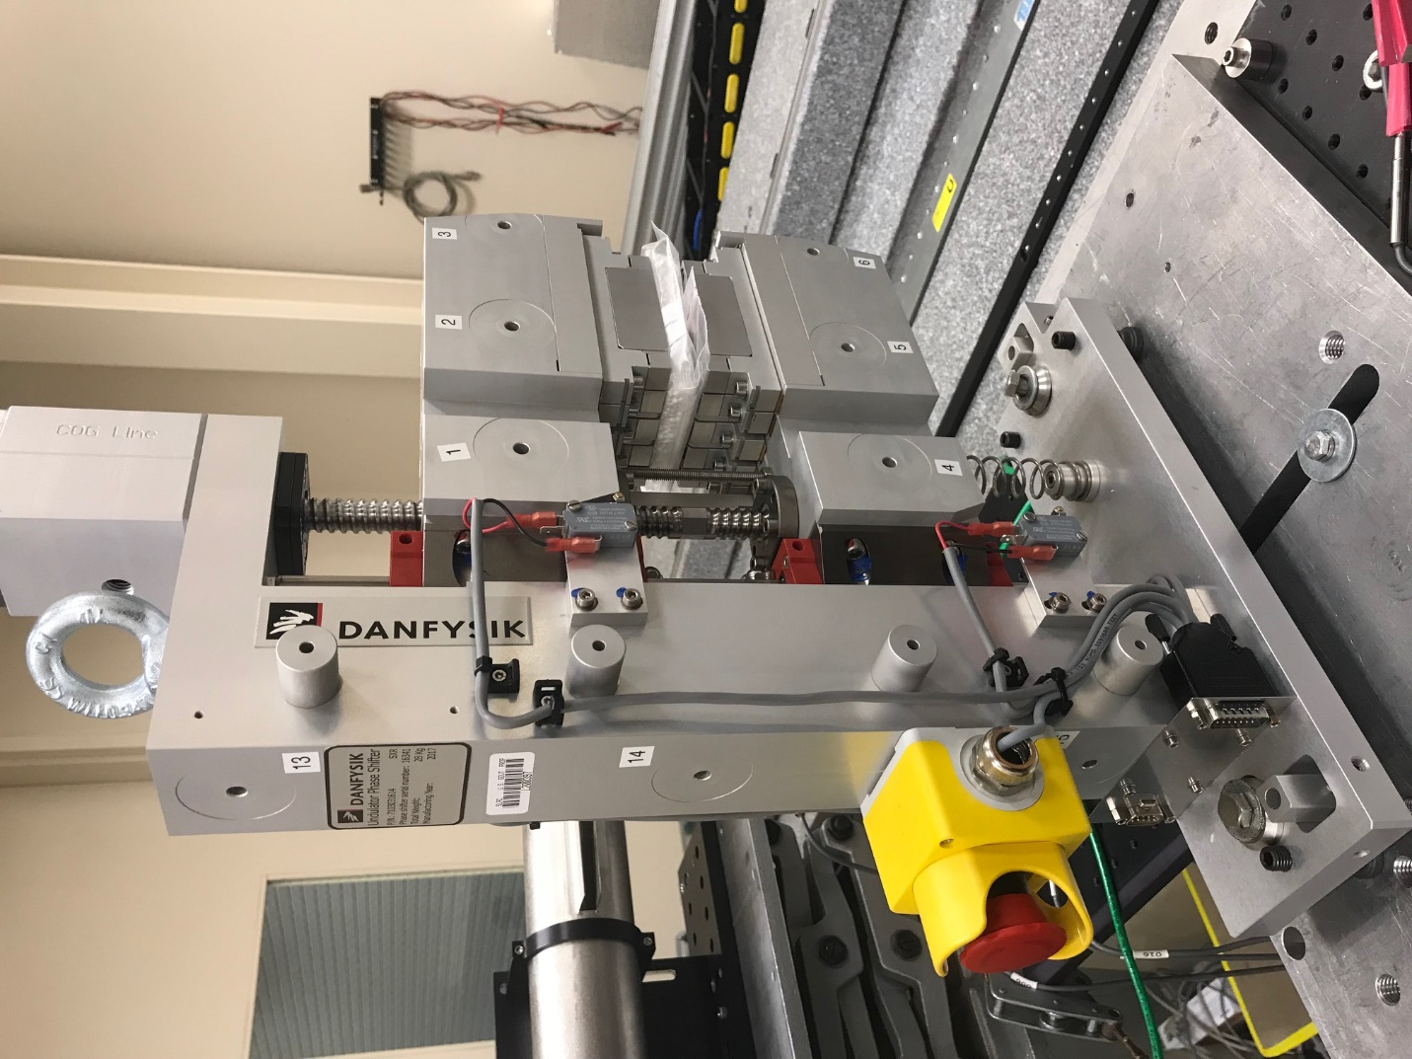
TB1
TB2
TB3
TB6
TB5
TB4
TB13
TB14
TB15
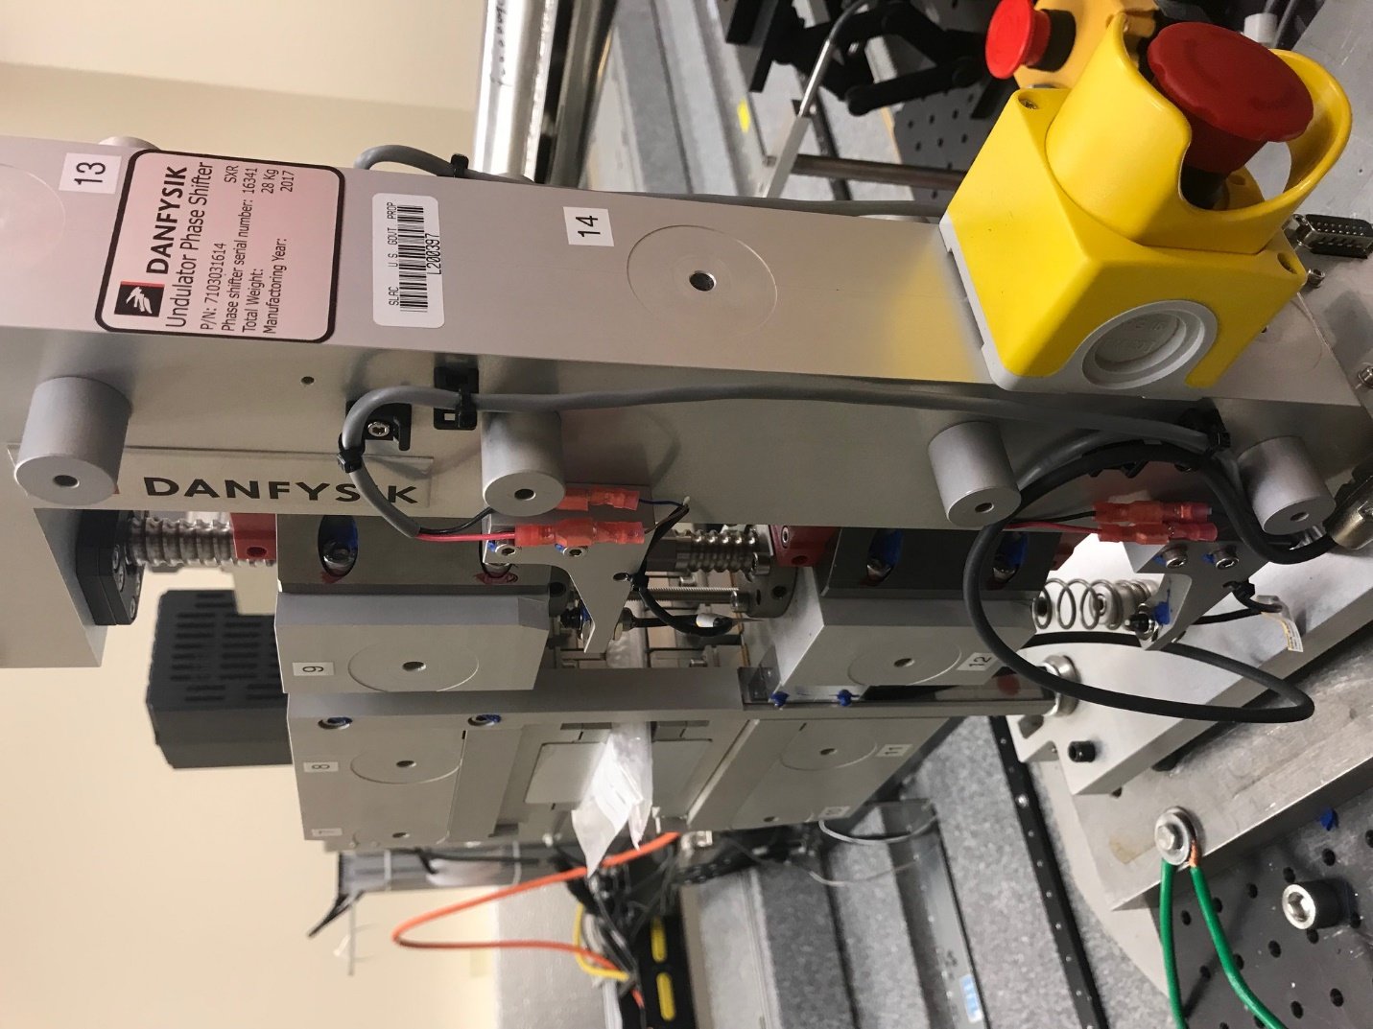
TB6
TB7
TB8
TB12

TB11
TB10
TB13
TB14
TB15

Tooling ball values to center of 1.5 inch sphere, all units are meter. Coordinates are to the HX Phase Shifter Magnetic Axis.
Tooling Ball | Z [m] | X [m] | Y [m]
TB1 | 0.070161 | -0.108946 | 0.083365
TB2 | 0.070171 | -0.026452 | 0.083387
TB3 | 0.070188 | 0.056039 | 0.083356
TB4 | 0.070049 | -0.108841 | -0.083280
TB5 | 0.070104 | -0.026358 | -0.083173
TB6 | 0.070152 | 0.056159 | -0.083036
TB7 | -0.070157 | 0.056037 | 0.083414
TB8 | -0.070184 | -0.026454 | 0.083438
TB9 | -0.070215 | -0.108955 | 0.083424
TB10 | -0.070194 | 0.056258 | -0.083046
TB11 | -0.070264 | -0.026260 | -0.083202
TB12 | -0.070330 | -0.108754 | -0.083304
TB13 | -0.000181 | -0.268222 | 0.186324
TB14 | -0.000263 | -0.268087 | 0.016330
TB15 | -0.000376 | -0.267957 | -0.153660

