LCLS2 SX Phase Shifter

Alignment Engineering Group
L200394
SN SXPS-16338
Jan 26, 2018

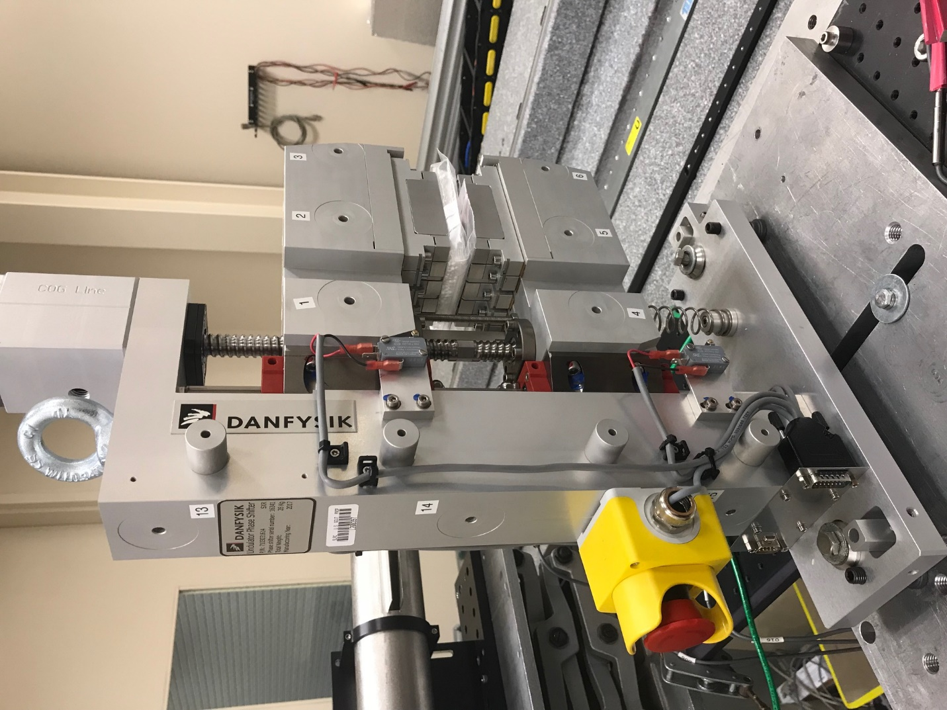
TB1
TB2
TB3
TB6
TB5
TB4
TB13
TB14
TB15
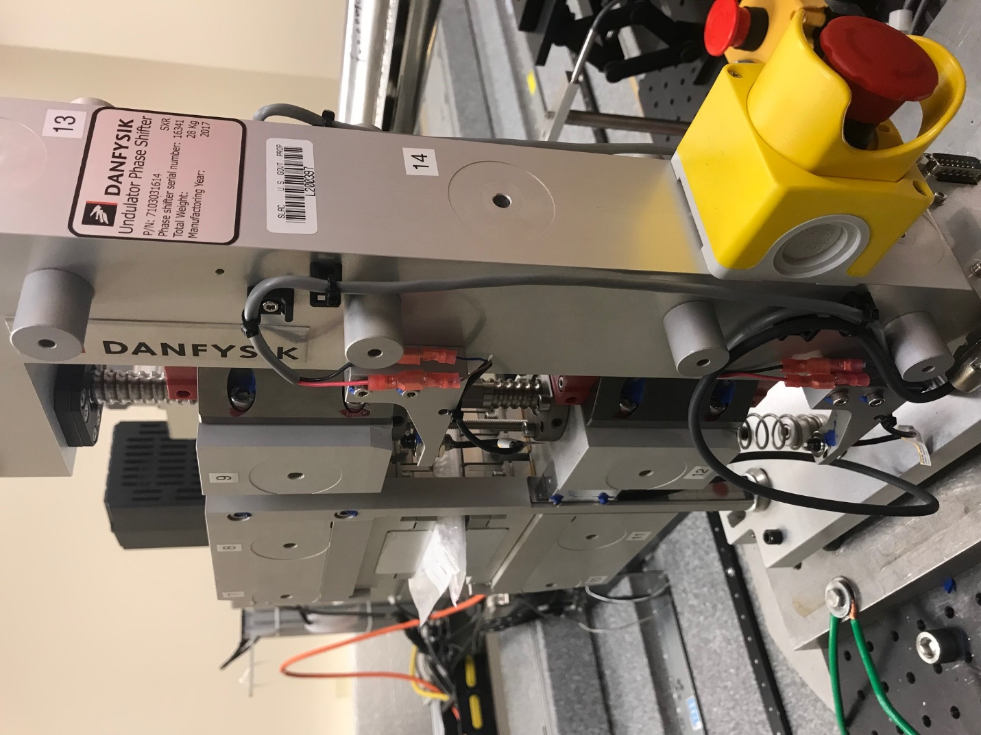
TB6
TB7
TB8
TB12

TB11
TB10
TB13
TB14
TB15

Tooling ball values to center of 1.5 inch sphere, all units are meter. Coordinates are to the HX Phase Shifter Magnetic Axis.
Tooling Ball | Z [m] | X [m] | Y [m]
TB1 | 0.069916 | -0.109065 | 0.083302
TB2 | 0.070011 | -0.026575 | 0.083306
TB3 | 0.070121 | 0.055958 | 0.083245
TB4 | 0.069990 | -0.109064 | -0.083369
TB5 | 0.070100 | -0.026577 | -0.083305
TB6 | 0.070234 | 0.055684 | -0.083271
TB7 | -0.070221 | 0.056072 | 0.083235
TB8 | -0.070336 | -0.026412 | 0.083287
TB9 | -0.070450 | -0.108930 | 0.083300
TB10 | -0.070138 | 0.056119 | -0.083239
TB11 | -0.070255 | -0.026369 | -0.083305
TB12 | -0.070372 | -0.108858 | -0.083385
TB13 | -0.000635 | -0.268195 | 0.187178
TB14 | -0.000536 | -0.268145 | 0.017224
TB15 | -0.000460 | -0.268099 | -0.152796

