LCLS2 SX Phase Shifter

Alignment Engineering Group
L200391
SN SXPS-16336
Feb 7, 2018

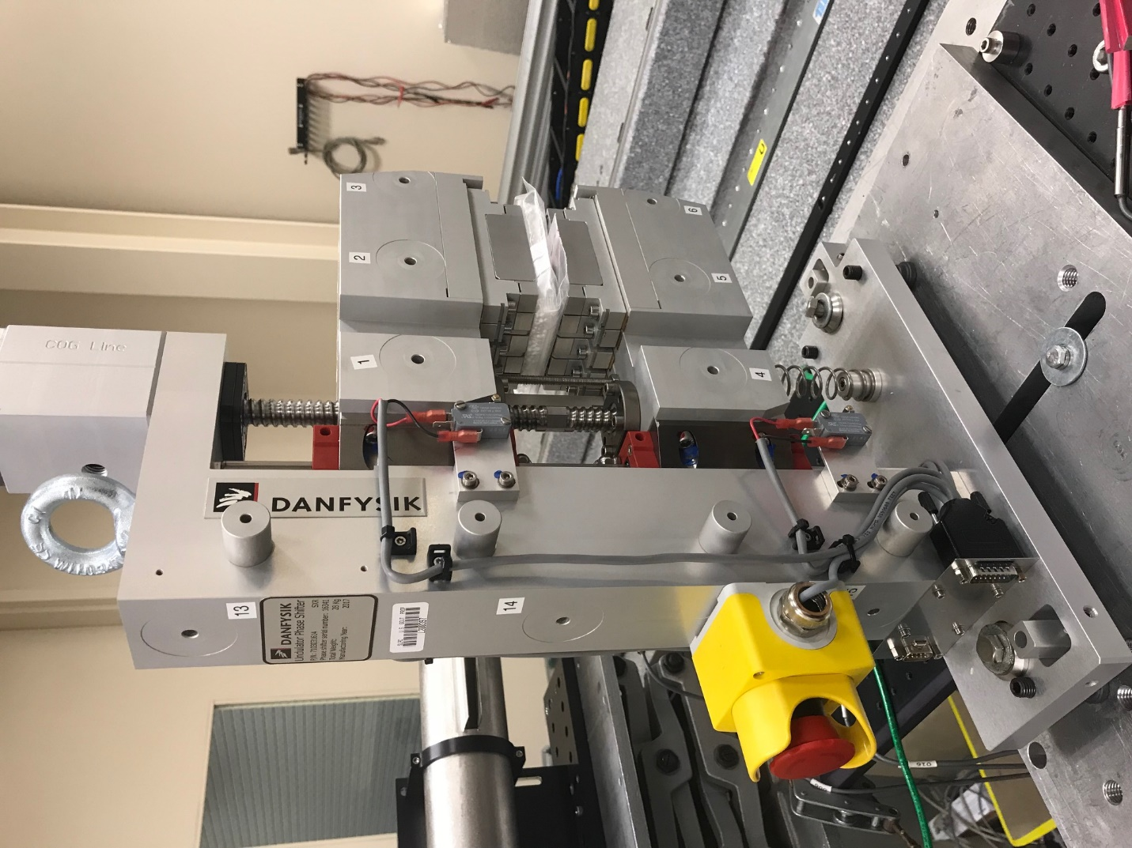
TB1
TB2
TB3
TB6
TB5
TB4
TB13
TB14
TB15
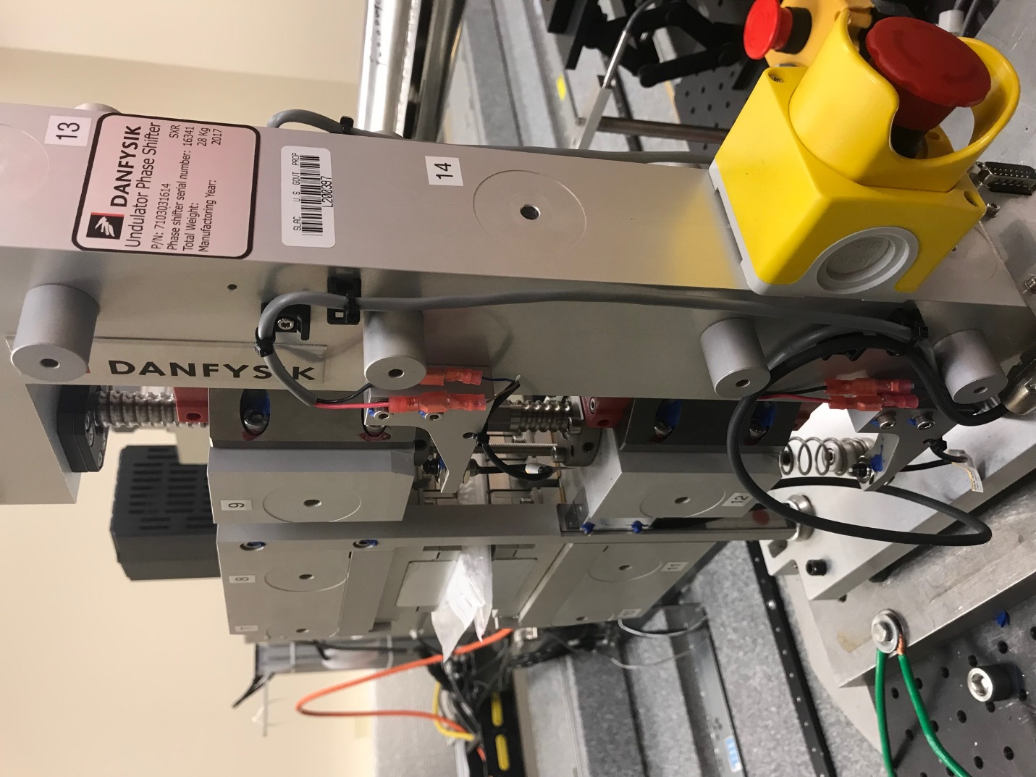
TB6
TB7
TB8
TB12

TB11
TB10
TB13
TB14
TB15

Tooling ball values to center of 1.5 inch sphere, all units are meter. Coordinates are to the HX Phase Shifter Magnetic Axis.
Tooling Ball | Z [m] | X [m] | Y [m]
TB1 | 0.070443 | -0.108738 | 0.094612
TB2 | 0.070238 | -0.026217 | 0.094652
TB3 | 0.070046 | 0.056273 | 0.094614
TB4 | 0.070422 | -0.108677 | -0.094589
TB5 | 0.070205 | -0.026184 | -0.094551
TB6 | 0.070006 | 0.056313 | -0.094469
TB7 | -0.070245 | 0.055891 | 0.094579
TB8 | -0.070062 | -0.026607 | 0.094602
TB9 | -0.069883 | -0.109105 | 0.094591
TB10 | -0.070322 | 0.055983 | -0.094616
TB11 | -0.070124 | -0.026526 | -0.094689
TB12 | -0.069937 | -0.108999 | -0.094757
TB13 | 0.000505 | -0.268134 | 0.186981
TB14 | 0.000571 | -0.268068 | 0.017057
TB15 | 0.000730 | -0.268036 | -0.153080

