LCLS2 HX Phase Shifter

Alignment Engineering Group
L201261
SN HXPS-16322
July 18, 2018

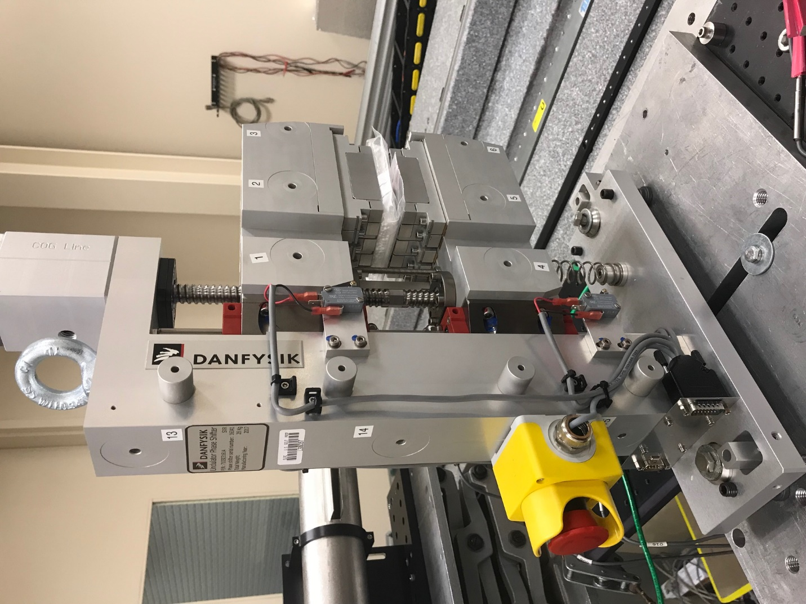
TB1
TB2
TB3
TB6
TB5
TB4
TB13
TB14
TB15
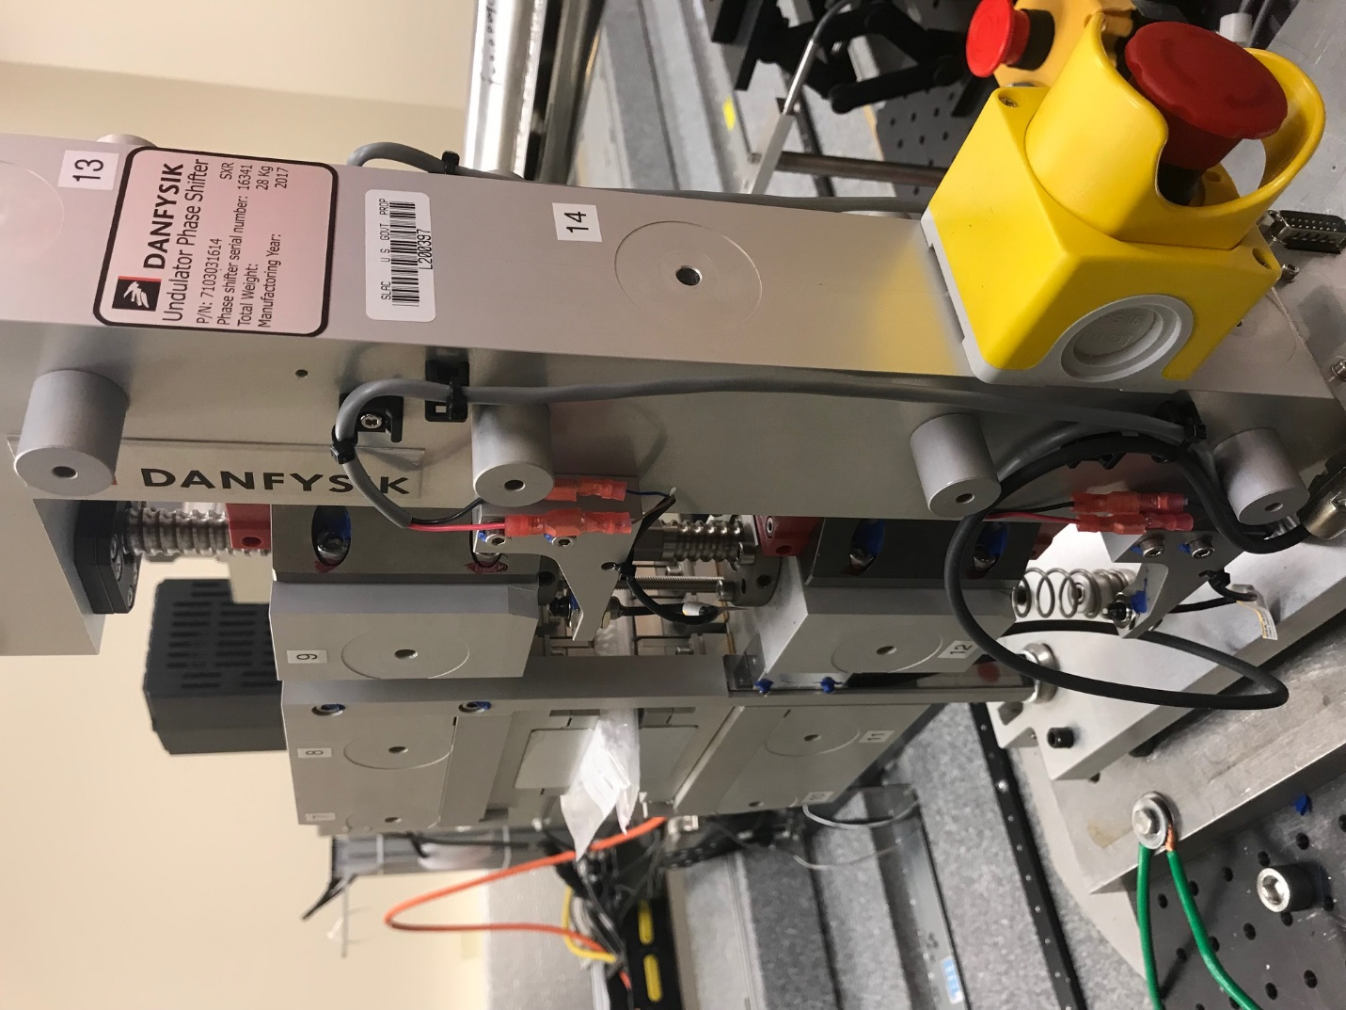
TB6
TB7
TB8
TB12

TB11
TB10
TB13
TB14
TB15

Tooling ball values to center of 1.5 inch sphere, all units are meter. Coordinates are to the HX Phase Shifter Magnetic Axis.
Tooling Ball | Z [m] | X [m] | Y [m]
TB1 | -0.070068 | 0.108904 | 0.083055
TB2 | -0.070084 | 0.026397 | 0.083054
TB3 | -0.070101 | -0.056115 | 0.082992
TB4 | -0.070054 | 0.108869 | -0.083087
TB5 | -0.070093 | 0.026386 | -0.083071
TB6 | -0.070129 | -0.056128 | -0.082968
TB7 | 0.070178 | -0.056109 | 0.083031
TB8 | 0.070204 | 0.026391 | 0.083074
TB9 | 0.070235 | 0.108898 | 0.083059
TB10 | 0.070167 | -0.056192 | -0.083079
TB11 | 0.070210 | 0.026304 | -0.083133
TB12 | 0.070260 | 0.108812 | -0.083127
TB13 | 0.000164 | 0.268078 | 0.186767
TB14 | 0.000172 | 0.268037 | 0.016762
TB15 | 0.000207 | 0.267990 | -0.153178

