LCLS2 HX Phase Shifter

Alignment Engineering Group
L201260
SN HXPS-16321
July 17, 2018

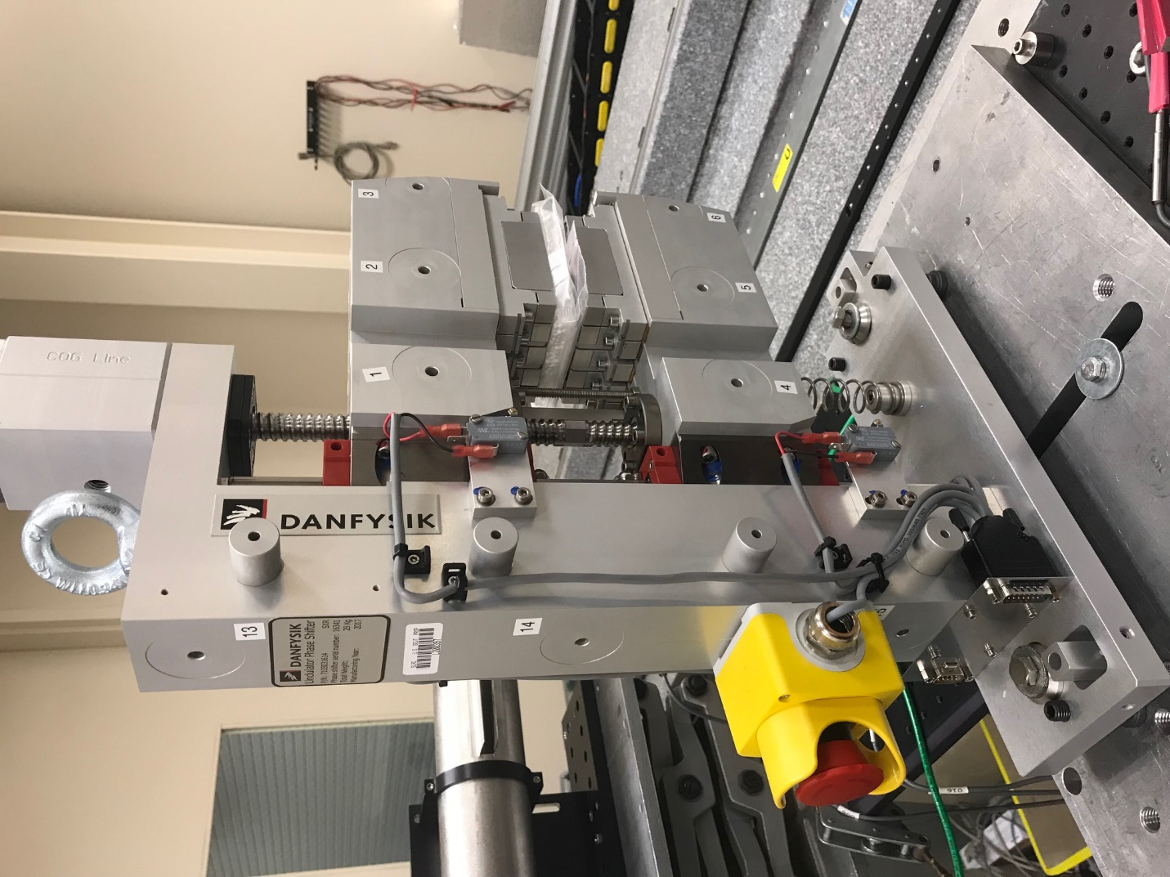
TB1
TB2
TB3
TB6
TB5
TB4
TB13
TB14
TB15
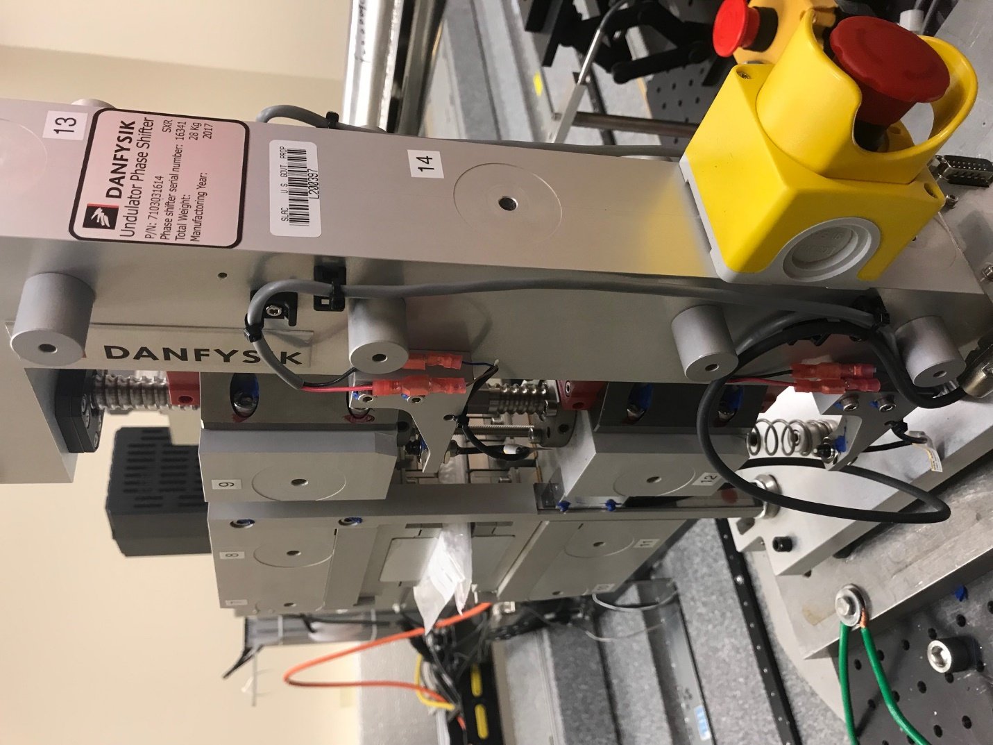
TB6
TB7
TB8
TB12

TB11
TB10
TB13
TB14
TB15

Tooling ball values to center of 1.5 inch sphere, all units are meter. Coordinates are to the HX Phase Shifter Magnetic Axis.
Tooling Ball | Z [m] | X [m] | Y [m]
TB1 | -0.069946 | 0.108521 | 0.083172
TB2 | -0.069983 | 0.026014 | 0.083192
TB3 | -0.070015 | -0.056487 | 0.083175
TB4 | -0.070165 | 0.108581 | -0.083068
TB5 | -0.070219 | 0.026093 | -0.083028
TB6 | -0.070277 | -0.056402 | -0.082980
TB7 | 0.070264 | -0.056502 | 0.082902
TB8 | 0.070297 | 0.026002 | 0.082923
TB9 | 0.070345 | 0.108491 | 0.082921
TB10 | 0.070034 | -0.056551 | -0.083166
TB11 | 0.070107 | 0.025969 | -0.083222
TB12 | 0.070145 | 0.108481 | -0.083192
TB13 | 0.000536 | 0.267649 | 0.186085
TB14 | 0.000246 | 0.267605 | 0.016075
TB15 | 0.000059 | 0.267623 | -0.153897

