LCLS2 HX Phase Shifter

Alignment Engineering Group
L201254
SN HXPS-16314
June 24, 2018

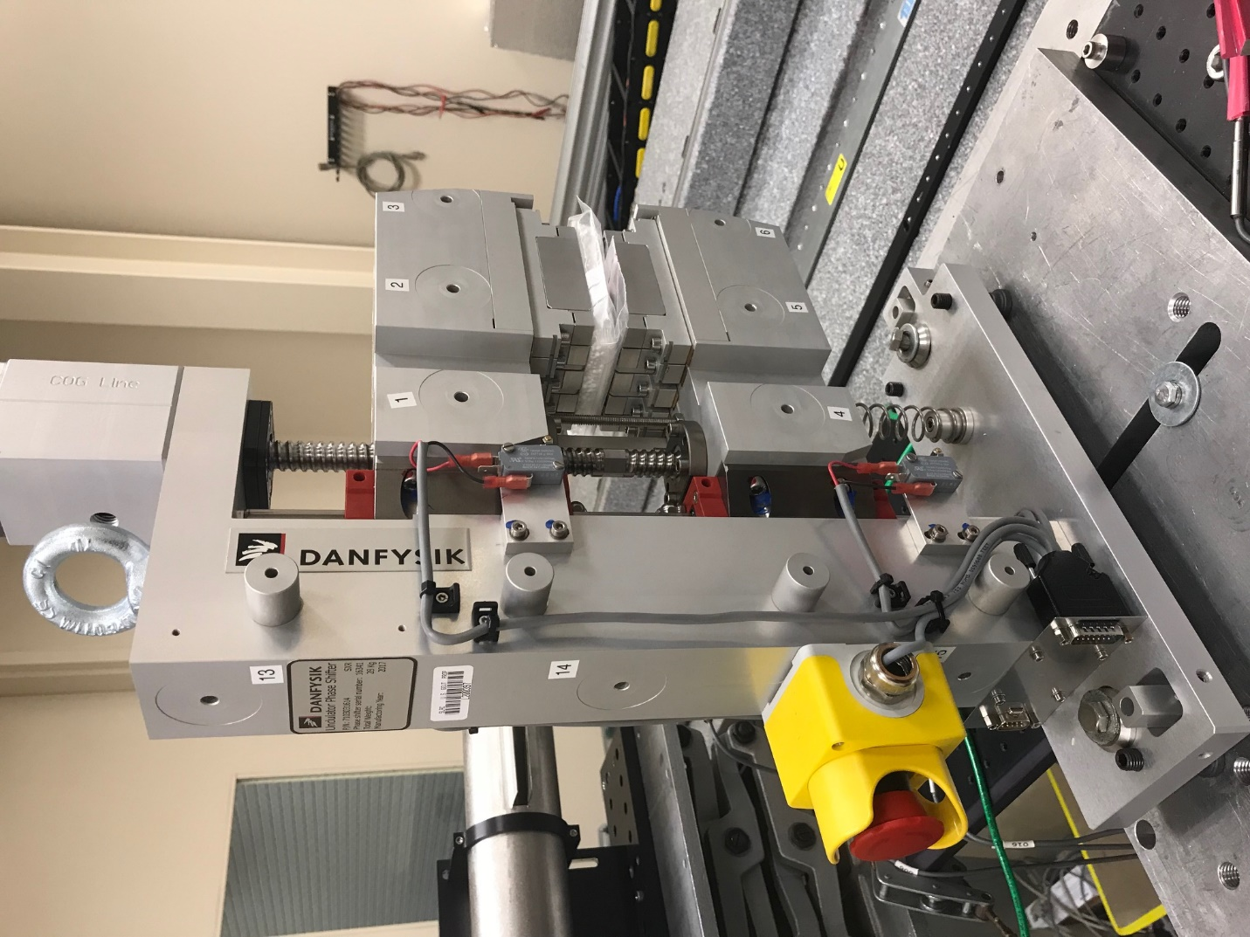
TB1
TB2
TB3
TB6
TB5
TB4
TB13
TB14
TB15
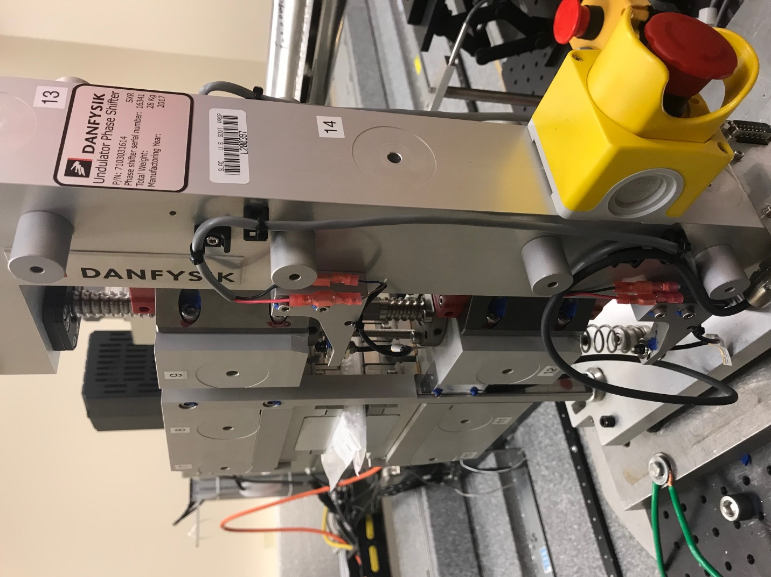
TB6
TB7
TB8
TB12

TB11
TB10
TB13
TB14
TB15

Tooling ball values to center of 1.5 inch sphere, all units are meter. Coordinates are to the HX Phase Shifter Magnetic Axis.
Tooling Ball | Z [m] | X [m] | Y [m]
TB1 | -0.070000 | 0.109135 | 0.083370
TB2 | -0.070025 | 0.026626 | 0.083400
TB3 | -0.070077 | -0.055860 | 0.083252
TB4 | -0.070047 | 0.109104 | -0.083384
TB5 | -0.070100 | 0.026620 | -0.083333
TB6 | -0.070155 | -0.055880 | -0.083250
TB7 | 0.070247 | -0.055894 | 0.083258
TB8 | 0.070278 | 0.026602 | 0.083261
TB9 | 0.070317 | 0.109106 | 0.083242
TB10 | 0.070139 | -0.055996 | -0.083347
TB11 | 0.070206 | 0.026497 | -0.083433
TB12 | 0.070260 | 0.109027 | -0.083427
TB13 | 0.000359 | 0.268387 | 0.186864
TB14 | 0.000247 | 0.268297 | 0.016898
TB15 | 0.000234 | 0.268236 | -0.153204

