LCLS2 HX Phase Shifter

Alignment Engineering Group
L201249
SN HXPS-16309
May 18, 2018

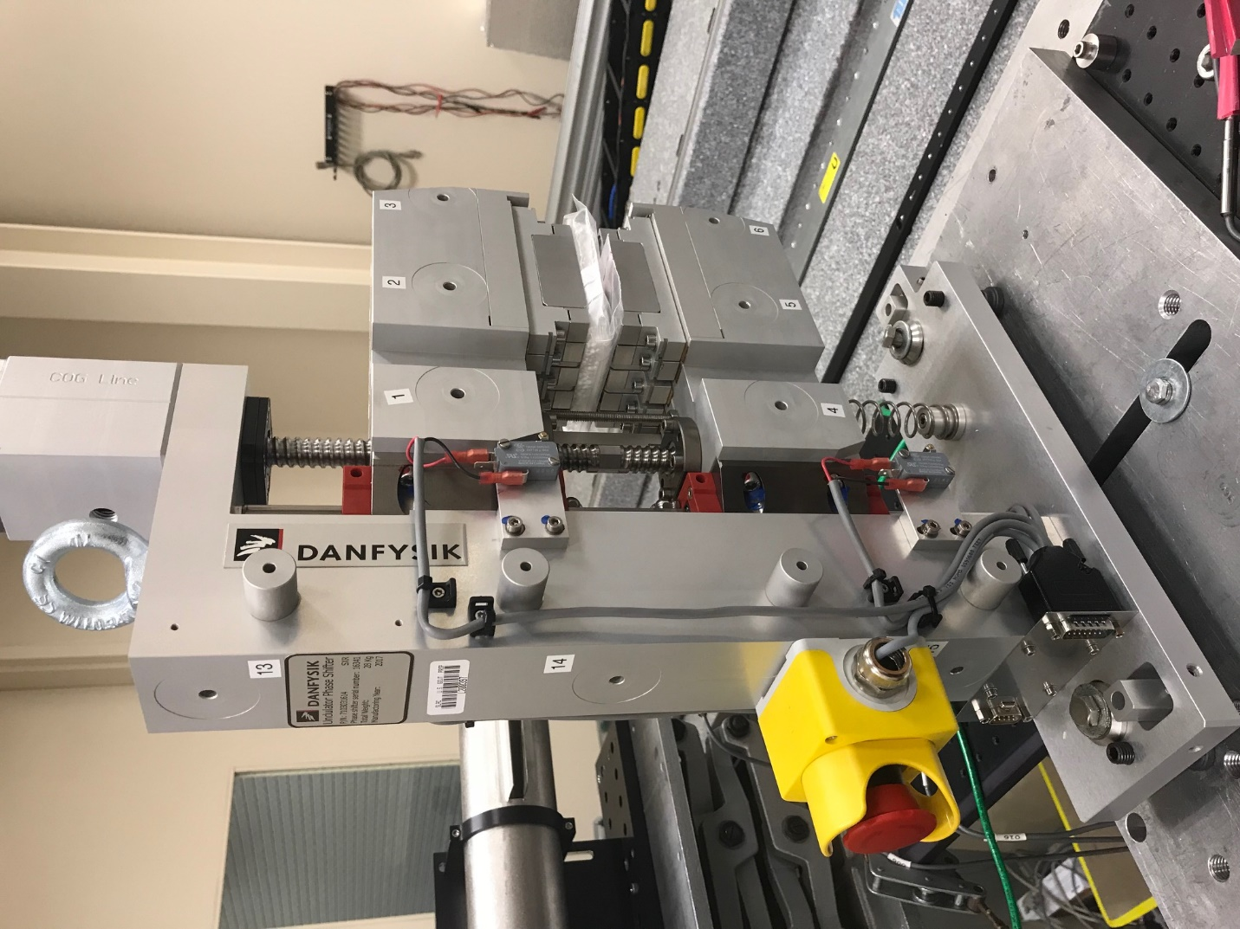
TB1
TB2
TB3
TB6
TB5
TB4
TB13
TB14
TB15
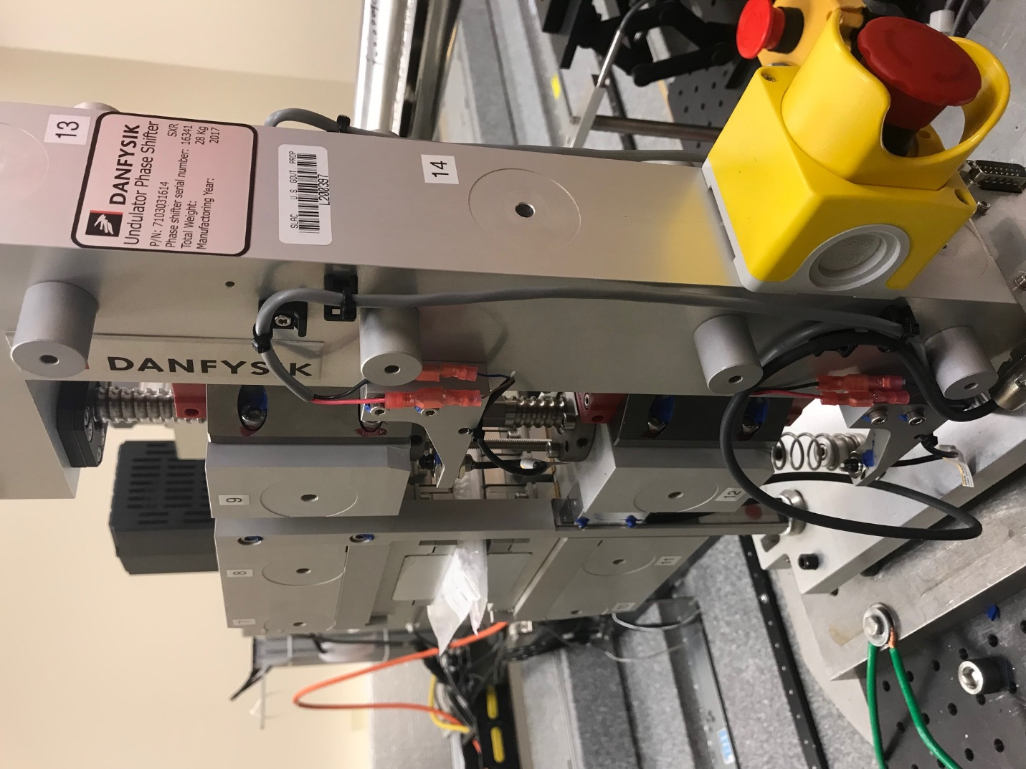
TB6
TB7
TB8
TB12

TB11
TB10
TB13
TB14
TB15

Tooling ball values to center of 1.5 inch sphere, all units are meter. Coordinates are to the HX Phase Shifter Magnetic Axis.
Tooling Ball | Z [m] | X [m] | Y [m]
TB1 | -0.070148 | 0.109177 | 0.083332
TB2 | -0.070124 | 0.026671 | 0.083339
TB3 | -0.070098 | -0.055840 | 0.083370
TB4 | -0.070437 | 0.109095 | -0.083185
TB5 | -0.070425 | 0.026610 | -0.083100
TB6 | -0.070426 | -0.055899 | -0.083026
TB7 | 0.070205 | -0.055776 | 0.083151
TB8 | 0.070191 | 0.026733 | 0.083141
TB9 | 0.070175 | 0.109244 | 0.083104
TB10 | 0.069912 | -0.055874 | -0.083412
TB11 | 0.069917 | 0.026609 | -0.083503
TB12 | 0.069918 | 0.109126 | -0.083547
TB13 | 0.000302 | 0.268417 | 0.186069
TB14 | 0.000022 | 0.268310 | 0.016091
TB15 | -0.000266 | 0.268226 | -0.153941

