LCLS2 HX Phase Shifter

Alignment Engineering Group
L201248
SN HXPS-16308
May 17, 2018

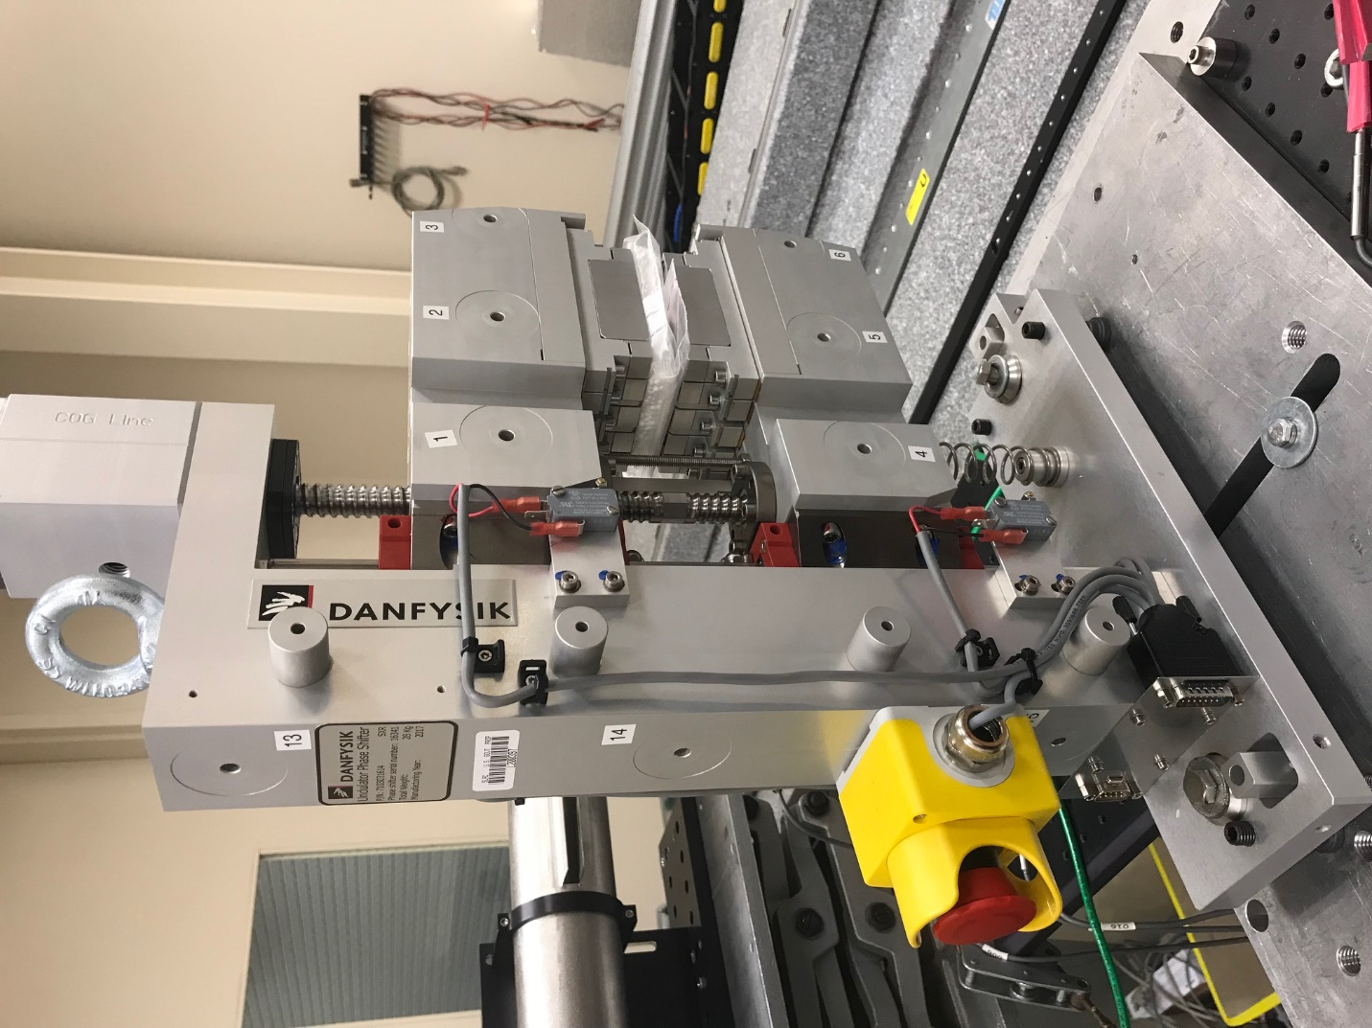
TB1
TB2
TB3
TB6
TB5
TB4
TB13
TB14
TB15
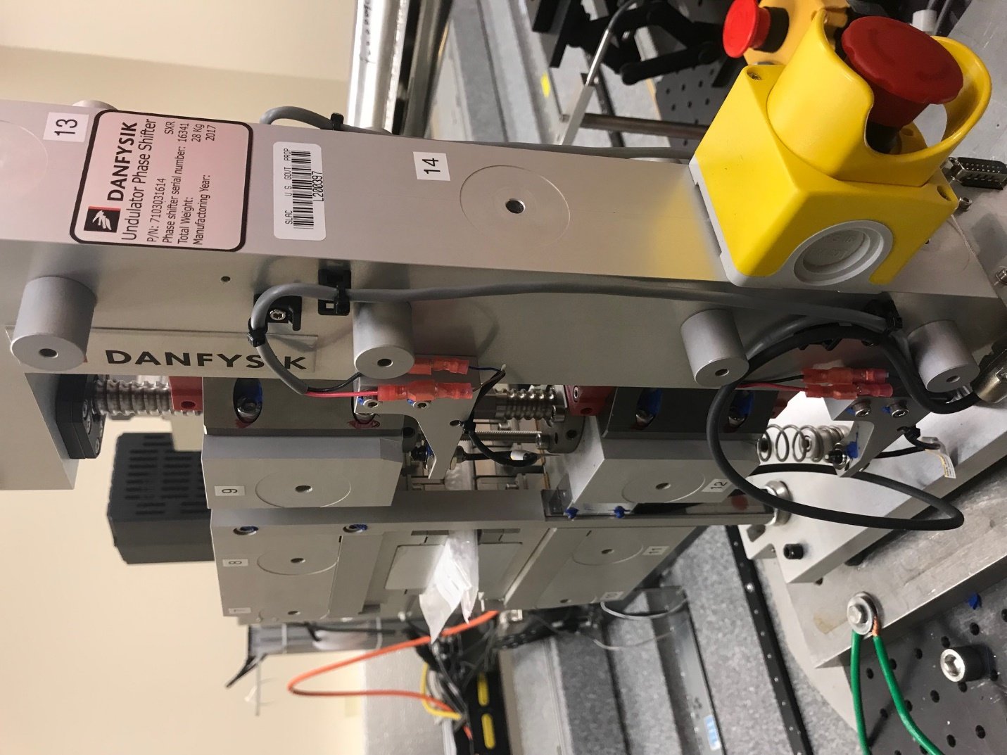
TB6
TB7
TB8
TB12

TB11
TB10
TB13
TB14
TB15

Tooling ball values to center of 1.5 inch sphere, all units are meter. Coordinates are to the HX Phase Shifter Magnetic Axis.
Tooling Ball | Z [m] | X [m] | Y [m]
TB1 | -0.070147 | 0.108714 | 0.083205
TB2 | -0.070181 | 0.026239 | 0.083283
TB3 | -0.070229 | -0.056289 | 0.083298
TB4 | -0.070348 | 0.108537 | -0.083331
TB5 | -0.070371 | 0.026066 | -0.083222
TB6 | -0.070404 | -0.056423 | -0.083123
TB7 | 0.070071 | -0.056308 | 0.083236
TB8 | 0.070122 | 0.026192 | 0.083213
TB9 | 0.070171 | 0.108688 | 0.083154
TB10 | 0.069935 | -0.056506 | -0.083324
TB11 | 0.069975 | 0.026010 | -0.083411
TB12 | 0.070001 | 0.108513 | -0.083464
TB13 | 0.000338 | 0.267965 | 0.186330
TB14 | 0.000088 | 0.267801 | 0.016317
TB15 | -0.000039 | 0.267636 | -0.153659

