LCLS2 HX Phase Shifter

Alignment Engineering Group
L201247
SN HXPS-16307
June 20, 2018

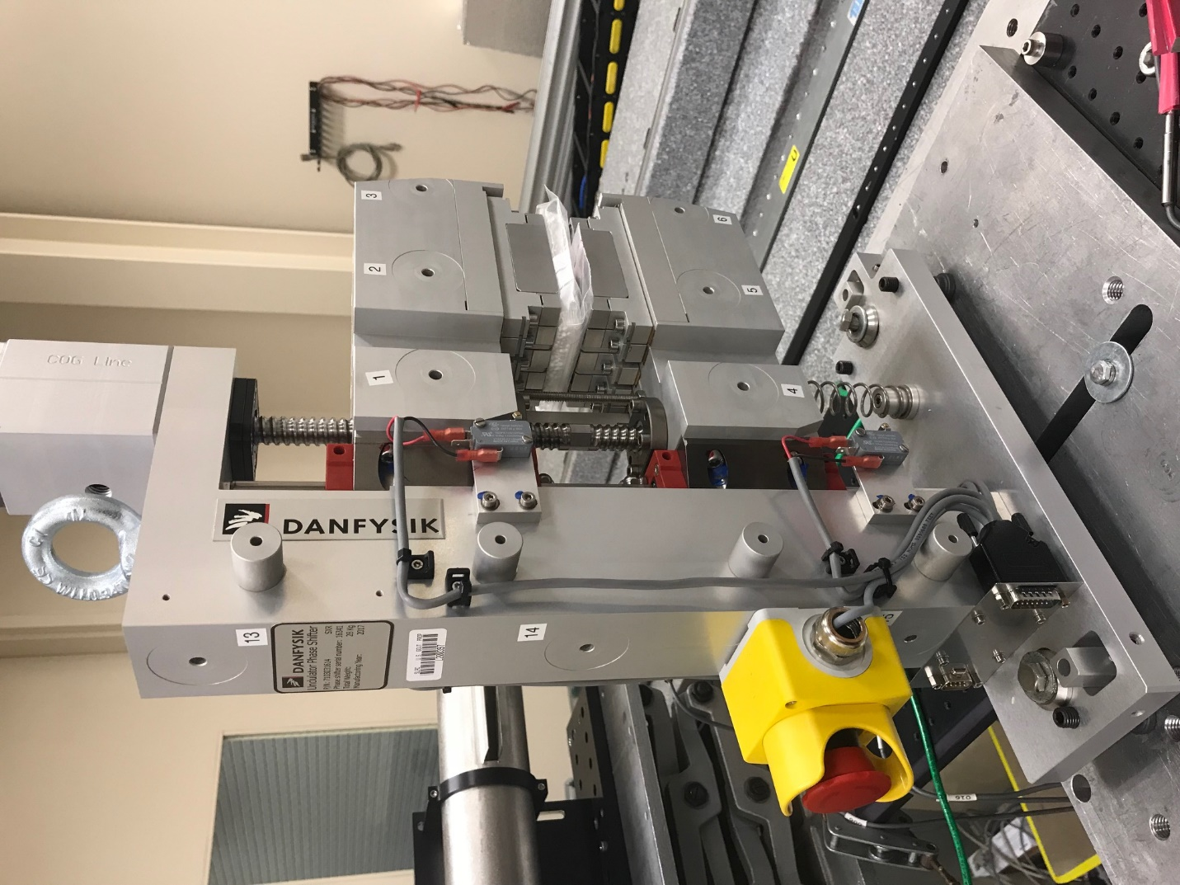
TB1
TB2
TB3
TB6
TB5
TB4
TB13
TB14
TB15
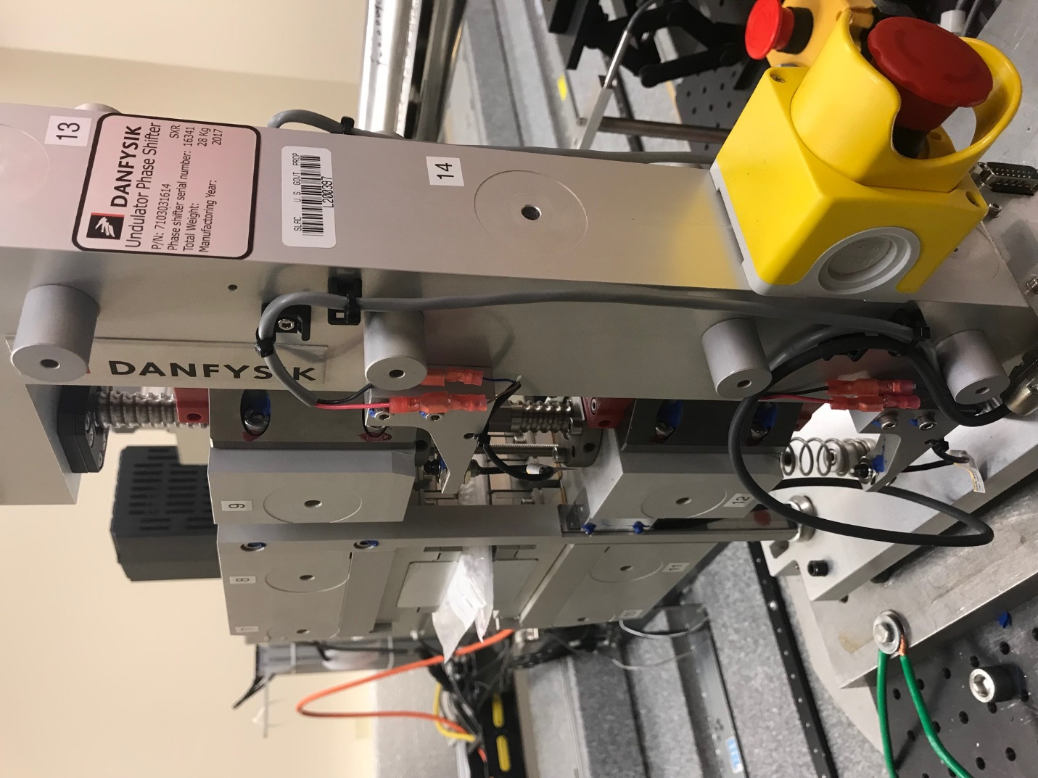
TB6
TB7
TB8
TB12

TB11
TB10
TB13
TB14
TB15

Tooling ball values to center of 1.5 inch sphere, all units are meter. Coordinates are to the HX Phase Shifter Magnetic Axis.
Tooling Ball | Z [m] | X [m] | Y [m]
TB1 | -0.069805 | 0.109270 | 0.105730
TB2 | -0.069891 | 0.026776 | 0.105763
TB3 | -0.069991 | -0.055722 | 0.105749
TB4 | -0.069995 | 0.109208 | -0.105632
TB5 | -0.070106 | 0.026722 | -0.105587
TB6 | -0.070224 | -0.055779 | -0.105529
TB7 | 0.070305 | -0.055884 | 0.105606
TB8 | 0.070409 | 0.026628 | 0.105606
TB9 | 0.070511 | 0.109126 | 0.105603
TB10 | 0.070058 | -0.056016 | -0.105653
TB11 | 0.070192 | 0.026496 | -0.105717
TB12 | 0.070367 | 0.109035 | -0.105757
TB13 | 0.000666 | 0.268401 | 0.186065
TB14 | 0.000523 | 0.268324 | 0.016062
TB15 | 0.000438 | 0.268262 | -0.153935

