LCLS2 HX Phase Shifter

Alignment Engineering Group
L201246
SN HXPS-16306
May 16, 2018

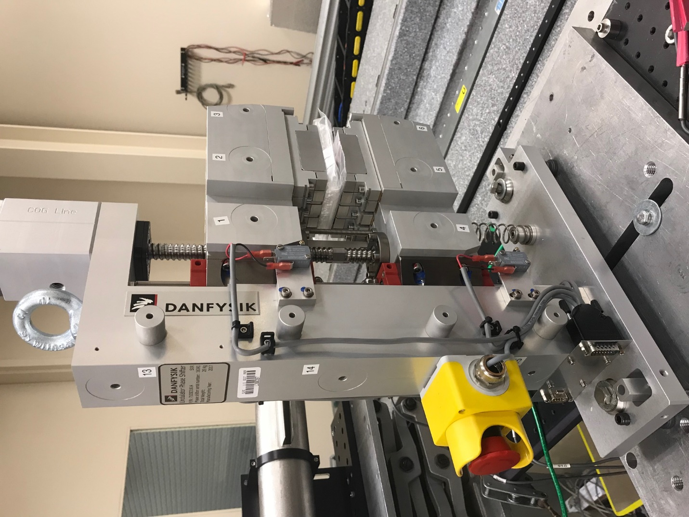
TB1
TB2
TB3
TB6
TB5
TB4
TB13
TB14
TB15
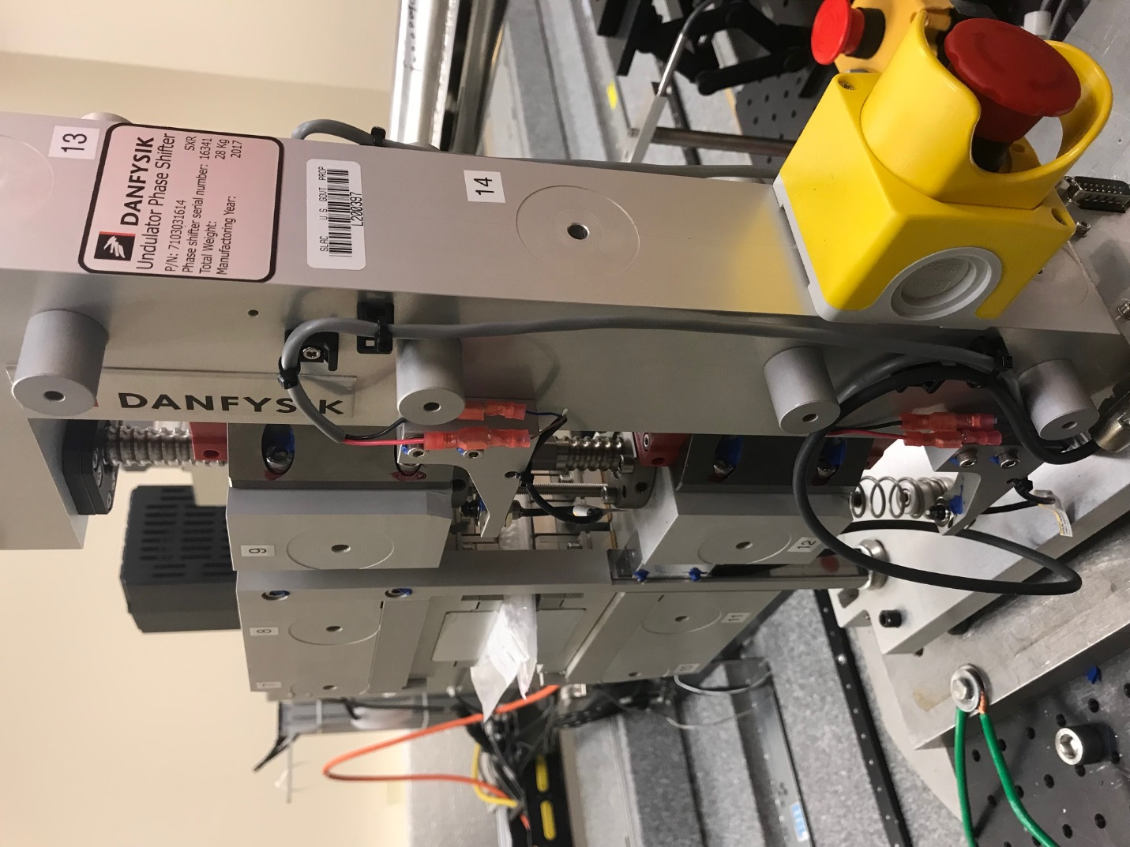
TB6
TB7
TB8
TB12

TB11
TB10
TB13
TB14
TB15

Tooling ball values to center of 1.5 inch sphere, all units are meter. Coordinates are to the HX Phase Shifter Magnetic Axis.
Tooling Ball | Z [m] | X [m] | Y [m]
TB1 | -0.070290 | 0.109197 | 0.080517
TB2 | -0.070291 | 0.026700 | 0.080579
TB3 | -0.070290 | -0.055818 | 0.080604
TB4 | -0.070261 | 0.109075 | -0.080730
TB5 | -0.070263 | 0.026579 | -0.080640
TB6 | -0.070267 | -0.055905 | -0.080509
TB7 | 0.069997 | -0.055755 | 0.080523
TB8 | 0.070006 | 0.026751 | 0.080492
TB9 | 0.070020 | 0.109266 | 0.080449
TB10 | 0.070116 | -0.055925 | -0.080462
TB11 | 0.070072 | 0.026576 | -0.080580
TB12 | 0.070089 | 0.109054 | -0.080638
TB13 | -0.000003 | 0.268511 | 0.187169
TB14 | 0.000009 | 0.268336 | 0.017151
TB15 | 0.000043 | 0.268182 | -0.152912

