Item | Text | Result | Sign
1 | Mechanical test |  | N/A
1.1 | Initial dimension check without magnets |  | N/A
1.1.1 | Parallelism of girders  Measure the parallelism of each girder by measuring the distance in 6 points (10mm from transverse edges (Z=±35mm), 10mm (X=-59mm), 69mm (X=0) and 100mm (X=31) from longitudinal edge). Enter the measured values.  Measure at 3 gaps, 10mm (121mm without magnets), 50mm (161mm without magnets) and 100mm (211mm without magnets).  Accept criteria: Maximum deviation between measures at one gap setting 0.1mm.  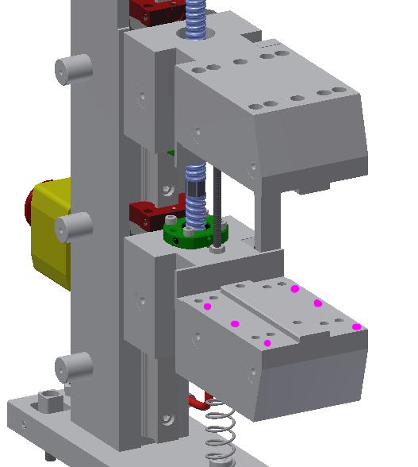 | 10mm gap (121mm):  Z=-35:  X=-59: 211,02 mm  X=0: 210,99 mm  X=31: 210,97 mm  Z=35:  X=-59: 211,07 mm  X=0: 211,05 mm  X=31: 211,00 mm  50mm gap (161mm):  Z=-35:  X=-59: 161,01 mm  X=0: 160,99 mm  X=31: 160,96 mm  Z=35:  X=-59: 161,06 mm  X=0: 161,03 mm  X=31: 161,00 mm  100mm gap (211mm):  Z=-35:  X=-59: 211,04 mm  X=0: 211,01 mm  X=31: 210,97 mm  Z=35:  X=-59: 211,06 mm  X=0: 211,04 mm  X=31: 211,00 mm  (Meas. Equip. No:__ ______) | BGR  01/03-  2017
1.1.2 | Position of lower girder  Measure the distance between the lower girder and top of base plate, as shown:  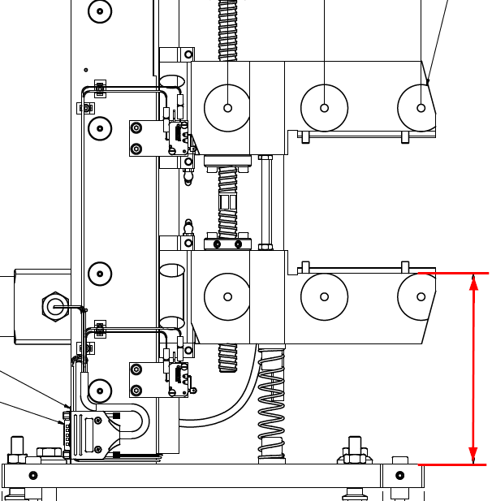  Accept criteria:162,5±1 | 10mm gap (121mm):  Distance measured: 163,2 mm | BGR  01/03-  2017
1.2 | Gap tests with magnets |  | N/A
1.2.0 | Securing Encoder head and ruler positions  After checking that encoder head and ruler distance is correct in full range:  Tighten M5 bolts for ruler bracket to 5 Nm. Tighten M2.5 bolts holding encoder head to 0.5 Nm.  Apply Loctite 7414 on the 4 boltheads.  Accept criteria: YES | Has Loctite 7414 been applied to the bolts? (4 pcs.)  YES / NO | CGPE 2017-08-14
1.2.1 | Adjust the gap to 10mm.  Draw a 10.00 mm ceramic block through the magnet gap and check that it can be pulled through the entire gap.  Set offset parameters in motor and encoder software.  Accept criteria: Yes | Can the 10.00 mm block be pulled through the entire gap?  YES / NO  (Meas. Equip. No:__276 ______)  Encoder raw value: 3133027 _ | CGPE 2017-08-14
1.2.2 | Set the gap to 100mm as indicated by the motor.  Draw a 100.00 mm ceramic block through the magnet gap and check that it can be pulled through the entire gap.  Accept criteria: Yes | Can the 100.00mm block be pulled through the entire gap?  YES / NO  (Meas. Equip. No:__ _276_____)  Encoder raw value: 2772970 _ | CGPE 2017-08-14
1.2.3 | Set the gap to 10mm. Open the gap to 15mm. Reset a dial gauge installed between the girders to zero. Close the gap to 10mm. Open the gap to 15mm and read the dial gauge. Repeat the measurements 3 times.  Accept criteria: Maximum allowable difference between measurements 1 to 3 is 16µm. | Distance between girders (opening):  Initial dial setting: 0 µm  Measurement 1: 0 µm  Measurement 2: 0 µm  Measurement 3: 0 µm  Max. difference: 0 µm | CGPE 2017-08-14
1.2.4 | Set the gap to 15mm. Close the gap to 10mm. Reset a dial gauge installed between the girders to zero. Open the gap to 15mm. Close the gap to 10mm and read the dial gauge. Repeat the measurements 3 times.  Accept criteria: Maximum allowable difference between measurements 1 to 3 is 16µm. | Distance between girders (opening):  Initial dial setting: 0 µm  Measurement 1: 1 µm  Measurement 2: 1 µm  Measurement 3: 1 µm  Max. difference: 1 µm | CGPE 2017-08-14
1.3 | Fiducialization (performed after magnetic measurement) |  | N/A
1.3.1 | Target holder positions. Set the gap to 10 mm. Measure the distance (X, Y, Z) from beam center to the 15 target holder centers (center of reference hole at reference face). Use laser tracker or measuring arm to measure the positions.  Accept Criteria: The target points has been checked and the file is correct. | Save the positions in file “<Phase Shifter No.> Target Positions.pdf”.  Is the target points checked and file  correct YES / NO  (Meas. Equip. No: 1686-S )  Encoder raw value: 3133023 _ | CGPE 2017-08-16
1.4 | Stop and switch settings |  | N/A
1.4.1 | Hard stop.  Hard stop setting (encoder read gap where the hard stop is reached)  Accept criteria:  9.8mm < “Hard stop setting” < 9.9mm  Note: Attempt to bring to Hard stop setting as close to 9.8mm as possible to increase adjustment range for limit and abort switches. | Hard stop setting: 9.807 mm | CGPE 2017-08-14
1.4.2 | Abort switches (Honeywell).  Abort switch setting (encoder read gap where the switch activates)  Accept Criteria  @ Closed Gap:  “Hard stop setting” ≤ “Honeywell Closed gap activation” <9.9 mm or “Omron Closed gap activation”  @ Open Gap:  100.5 mm or “Omron Open gap activation”  ≤ “Honeywell Open gap activation” < 101mm | Closed Gap activation: 9.917 mm  Open Gap activation: 100.563 mm | CGPE 2017-08-14
1.4.3 | Limit switches (Omron).  Limit switch setting (encoder read gap where the switch activates)  Approach closed gap from 30 mm gap with 5 mm/s. Back off to 10.1 mm. Approach with 0.01 mm/s. Repeat. Record value for second slow approach.  Approach open gap from 90 mm gap with 5 mm/s. Back off to 99.9 mm. Approach with 0.01 mm/s. Repeat. Record value for second slow approach.  Accept Criteria:  @Closed Gap:  9.9mm ≤ “Omron Closed gap activation” < 10mm  @Open Gap:  100.1mm ≤ “Omron Open gap activation” < 100.5mm | Closed Gap activation: 9.988 mm  Encoder raw value:  3133061  Open Gap activation: 100.124 mm  Encoder raw value:  2772516 | CGPE 2017-08-14
1.4.4 | Securing limit switch positions  Tighten M4 bolts holding limit switch brackets to 3.5 Nm.  Apply Loctite 7414 on 4 bracket bolt heads and on limit switch top nut (both on bracket side and on limit switch side).  Accept criteria: Yes | Has Loctite 7414 been applied to the bolts? (4 pcs.)  YES / NO  Has Loctite 7414 been applied to the limit switch upper nuts?  YES / NO | CGPE 2017-08-14
1.5 | Brake test  Set the gap to 10.5mm. Note the exact encoder reading. Turn off the power supply for the brake and the motor controller. Read the gap.  Accept criteria: The gap shall not change by more than 0.05mm. | Gap initial setting: 10.507 mm  Encoder raw value:  3131006  Gap after power off: 10.497 mm  Encoder raw value:  3131026 | CGPE 2017-08-14
2 | Magnetic Test |  | N/A
2.1 | Magnetic measurements
2.2.1 | Stretch wire measurements at all gaps in x=-10 through x=10 in 2 mm steps.  At all gaps shall both 1st and 2nd integral scans be performed  - 10.0 mm gap  - 15.0 mm gap  - 20.0 mm gap  - 30.0 mm gap  - 100.0 mm gap | Enter results in separate report  (Meas. Equip. No: 1784-D SW DVM) | CGPE 2017-08-15
2.2.2 | Hall probe measurements at intermediate gaps.  Before and after each measurement series, reference magnetic field and magnet array temperature must be logged in order to perform temperature correction.  600 mm scans.  - 10.0 mm gap (x=0)  - 12.0 mm gap (x=0)  - 15.0 mm gap (x=0)  - 20.0 mm gap (x=0)  - 30.0 mm gap (x=0)  - 100.0 mm gap (x=0)) | Enter results in separate report  (Meas. Equip. No: 1718 Hall DVM X)  (Meas. Equip. No:1720 Hall DVM S)  (Meas. Equip. No:1719 Hall DVM Z)  (Meas. Equip. No:1279-S Temp DVM) | CGPE 2017-08-16
2.2.3 | Hall probe off-center measurements.  Before and after each measurement series, reference magnetic field and magnet array temperature must be logged in order to perform temperature correction.  600 mm scans.  - 10.0 mm gap (x=-2)  - 10.0 mm gap (x=-1)  - 10.0 mm gap (x=1)  - 10.0 mm gap (x=2)  - 30.0 mm gap (x=-2)  - 30.0 mm gap (x=-1)  - 30.0 mm gap (x=1)  - 30-0 mm gap (x=2) | Enter results in separate report  (Meas. Equip. No: 1718 Hall DVM X)  (Meas. Equip. No:1720 Hall DVM S)  (Meas. Equip. No:1719 Hall DVM Z)  (Meas. Equip. No:1279-S Temp DVM) | CGPE 2017-08-16

3 | General appearance |  | N/A
3.1 | Visual check  Accept criteria: Yes | Is the visual appearance acceptable?  YES / NO  Are both screens installed as per drawing?  YES / NO  Are all labels installed as per drawing?  YES / NO  Has Varnistop been applied to the bolts? (8 pcs.)  YES / NO | CGPE 2017-08-16
3.2 | Corrosion protection  Accept criteria: Yes | Are all surfaces corrosion protected?  YES / NO | CGPE 2017-08-16

