Bend 1.26D103.3T
SN 16102
LCLS2 Barcode 4510
Alignment Engineering Group
August 22, 2016
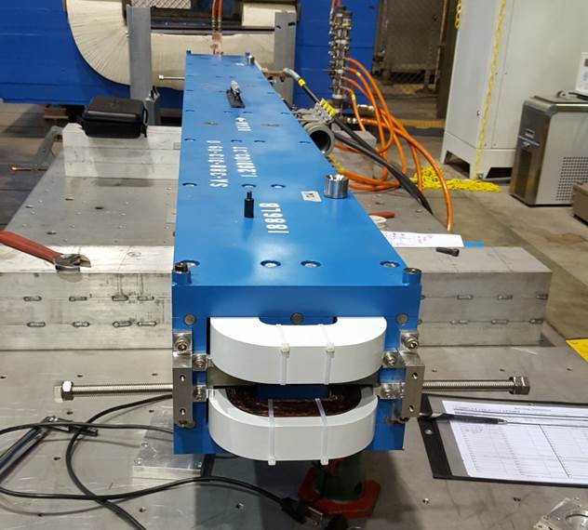
Beam Line
TB4 & D
TB3 & C
TB2 & B
TB1 & A

Tooling ball values 1 to 4 to center of 1.0000 inch tooling ball, A to D to center of 0.3125 inch tooling ball, all units are inches.

Tooling Ball | Z (in) | X (in) | Y (in)
TB1 | -51.2874 | -4.6753 | 5.4046
TB2 | -51.2861 | 4.6673 | 5.4054
TB3 | 51.2923 | 4.6691 | 5.4078
TB4 | 51.2932 | -4.6764 | 5.4098
TBA | -51.2864 | -4.6733 | 4.7170
TBB | -51.2851 | 4.6691 | 4.7179
TBC | 51.2947 | 4.6692 | 4.7200
TBD | 51.2942 | -4.6766 | 4.7222

-Constructed 6 planes, top pole, bottom pole, +X side top and bottom pole, -X side top and bottom pole, upstream end of steep and downstream end of steel.
-Bisected two Y planes for Y = 0 plane , two X planes for X = 0 plane, and two Z planes for Z = 0 plane.
-Origin is the intersection of three planes. Used the Y = 0 as primary plane, and X = 0 plane to clock the yaw angle.
-Measured both 1.0000 inch and 0.3125 inch tooling balls.
-Used AT401 for overall control. Used 9 foot Edge Arm on each end of magnet tied to tracker control to measure upstream and downstream poles.
-Computed the distances from the origin to the top and bottom pole planes along the Z axis. +/- 0.6304” for a total gap of 1.2608”.

