SLAC Traveler for LCLS-II BX31b/BX32b Dipole Magnets (1.26D103.3T)
(Aug. 16, 2016)

This traveler is intended to cover reception, preparation, mechanical fiducialization, and magnetic measurements of the two LTUS dog-leg dipole magnets. These magnets are 2.656 m long and have MAD designations of: BX31b and BX32b. Each magnet has trim coils (but only the BX31b trim is powered). Magnet requirements are listed in LCLS-II-2.4-PR-0081.

Receiving:
The following information is to be noted upon receipt of the magnets by the SLAC MFD group:
Received by (initials): | SDA
Date received (dd-mmm-yyyy):
SLAC barcode number: | 4509
Vendor serial number from magnet label: | 16101
SLAC approved electrical safety covers? (Y or N): | N
SLAC approved lifting eyes? (Y or N): | N
Shipping Damage? (Y or N): | N
Vendor tests passed on magnet label? (Y or N):
SLAC drawing number (enter number): | SA-388-313-09

Place a barcode sticker on the magnet and
also duplicate the barcode sticker here →

Preparation:
A beam direction arrow, with text “beam direction”, is to be applied to the top and/or tunnel aisle side of the magnet with a sticker supplied by LCLS II. The beam direction should point toward the end without the terminals.
Beam-direction arrow in place (initials): | SDA

Fiducialization:
Fiducialization may be done before or after magnetic measurements. The magnet is to be fiducialized by the CMM group. This will require the installation of removable tooling balls, location of the geometric axis of the poles of the magnet, and location of tooling balls with respect to the center of this geometric axis when the poles are aligned precisely horizontal.

CMM technician (initials): | FG

URL of on-line CMM fiducialization data (please modify or correct if necessary):
http://www-group.slac.stanford.edu/met/MagMeas/MAGDATA/LCLS-II/Dipole/BX31b/1.26D103.3T_sn16101_Bar4509 Fiducial Report.docx

Magnetic Measurements:
- Verify that the magnets are complete and undamaged, including wiring connections.
Incoming inspection OK (initials): | SDA
Date of arrival to mag. meas.(mm-dd-yyyy): | 9-26-2016

Enter URL of on-line magnetic measurements data (please modify or correct if necessary):
http://www-group.slac.stanford.edu/met/MagMeas/MAGDATA/LCLS-II/Dipole/BX32b/

- Mark each magnet as BX31b or BX32b. By choosing the magnet location initially, they will be tested in their proper polarities; since one is “positive” and the other is “negative” (see below for definition).
Magnet marked as (BX31b or BX32b): | BX32b

- Determine the main-coil connection polarity (with main supply outputting positive current) which produces a “positive” field polarity for BX31b (below left), but a “negative” field polarity for BX32b (below right), as shown below:

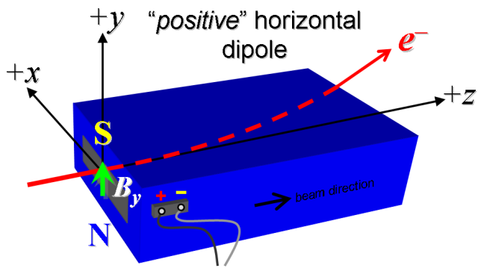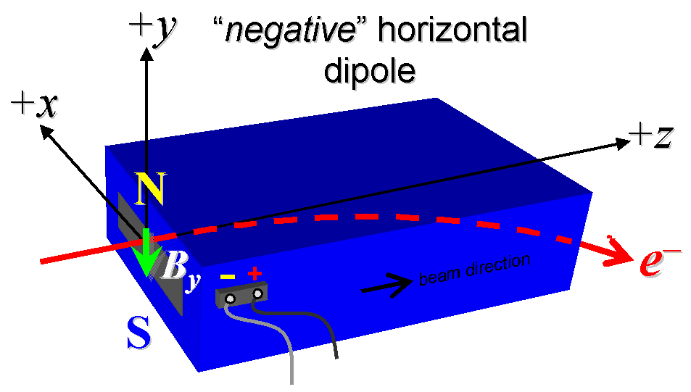
Figure 1. BX31b is “positive” (left), while BX32b is “negative” (right).

- Mark the polarity near the main magnet leads with clear “+” and “−” labels as shown above.
Main coil polarity chosen from Fig. 1 is (P or N): | N

- Also mark the trim leads with clear “+” and “−” labels such that, with the trim supply outputting positive current, the trim coil increases the absolute value of the magnetic field established by the main coil. This will set the trim polarity as “positive” for BX31b, and “negative” for BX32b, as described in LCLS-II-2.4-PR-0064 (https://docs.slac.stanford.edu/sites/pub/Publications/Polarity.pdf).
Trim coil polarity chosen from Fig. 1 is (P or N): | N

- Connect the main magnet terminals (not the trims), in the correct polarity as established above, to a unipolar power supply with maximum current I ≥ 165 A (assuming this current produces about 6.8 kG-m as the maximum required integrated field). Leave the trim coil disconnected for now.

- Connect magnet to LCW supply. Adjust supply pressure to a delta P of ~100 psi to achieve a flow rate of 1.76 gpm. Run the magnet up to 165 A for ~1 hour to warm it up (record, delta P, flow rate, and temperature).
LCW delta P (psi) | 108.5 psi
LCW flow rate (gpm) | 1.64 gpm
LCW delta T (°C) | 4.1 °C
Ambient temperature (°C): | 31.53 °C
Final magnet temperature (°C): | 31.09 °C

- Standardize the magnet, starting from zero to 170 A and back to zero, through three full cycles, finally ending at zero, with a flat-top pause time (at both 0 and 170 A) of 10 seconds. Use a ramp rate of 10 A/sec, if possible, and record the ramp rate used.
Standardization complete (initials): | SDA
Ramp rate used (A/sec): | 10 A/sec Three Linear

- Maintaining this cycle history, measure the length-integrated vertical dipole field, ∫B_{y}dl, from 0 to 170 A in 15-A steps, including zero (12 ‘up’ measurements). Please record (below) the current necessary to achieve 6.80 kG-m (maximum required). Then, still maintaining the cycle history, measure ∫B_{y}dl back down from 165 A to 0 in 15-A steps, including zero (12 ‘down’ measurements).
Main coil excitation current at 6.80 kG-m: | 164.275 Amps
Filename & run number of ∫B_{y}dl up & down data: | wiredat.ru1/wireplt.ru1

- With the main coils still hooked up, connect the trim coil to a bipolar 6-A (MCOR6) supply with proper trim polarity as determined above.

- Set the main coil to 0 current by ramping first up to 165 A, then down to zero at the same ramp rate used in the standardization cycle. Measure ∫B_{y}dl as a function of trim coil current from 0 to −6 in 1-A steps, including zero (7 ‘down’ measurements), and again from −6 to +6 A in 1-A steps (13 ‘up’ measurements). Finally, set the trim current to 0.
Filename & run # of ∫B_{y}dl trim data at I_{main} = 0: | Wiredat.ru2/wireplt.ru2

- For each magnet, with stretched wire, measure the vertical length-integrated field component over a horizontal span of ±30 mm (±1.181 inches), at each 2-mm interval, at the following main and trim coil current settings.
- I_{main} = 165 A, and I_{trim} = 0
- I_{main} = 60 A, and I_{trim} = 6 A
Filename & run # of ∫B_{y}dl vs. x data at 165, 0 A: | Wirevsx.ru3/wirevsxplt.ru3
Filename & run # of ∫B_{y}dl vs. x data at 60, 6 A: | Wirevsx.ru4/wirevsxplt.ru4

- For the BX31b magnet only, and at a main current of 60 A, with trim current at zero, measure the vertical magnetic fringe field component, B_{y}, at x = y = 0, as a function of the longitudinal beam-direction coordinate, z (from −10 cm to +30 cm in 1-cm steps, where z = 0 is defined at the iron edge), at the downstream end of this one magnet. Please also measure the background field at z = +30 cm with magnet switched off (separate file).
Filename of B_{y} vs. z data for BX31b exit edge: | N/A
Background filename of B_{y}(z = 30 cm), magnet OFF: | N/A

- For the BX31b magnet only, perform this final thermal test. Run the main current up to 170 A, and with trim also set at its maximum operating current of +6 A, measure the magnet temperature after it stabilizes (~1 hour). Record the temperature below.
Ambient temperature (°C): | N/A
Final BX31b magnet coil temperature at 170 A (°C): | N/A
Final BX31b magnet steel temperature at 170 A (°C): | N/A

- Measure the inductance and resistance of the main and trim magnet coils for each magnet:
Inductance of main coil (mH): | 0.655 mH
Resistance of main coil (Ohms): | 0.0728 Ohm
Inductance of trim coil (mH): | 1.11 mH
Resistance of trim coil (Ohms): | 0.764 Ohm

- Measure pole tip field of the main at 165 amps
Pole Tip Field and Current | 0.252 T at 165.063 amps

- Upon completion of tests, send traveler to Mark Woodley at mailstop 54.

This section is to be completed by M. Woodley.
Magnet accepted (signed):
Assigned beamline location (MAD-deck name):

