Bend 1.26D103.3T
SN 16101
LCLS2 Barcode 4509
Alignment Engineering Group
Sept.26, 2016
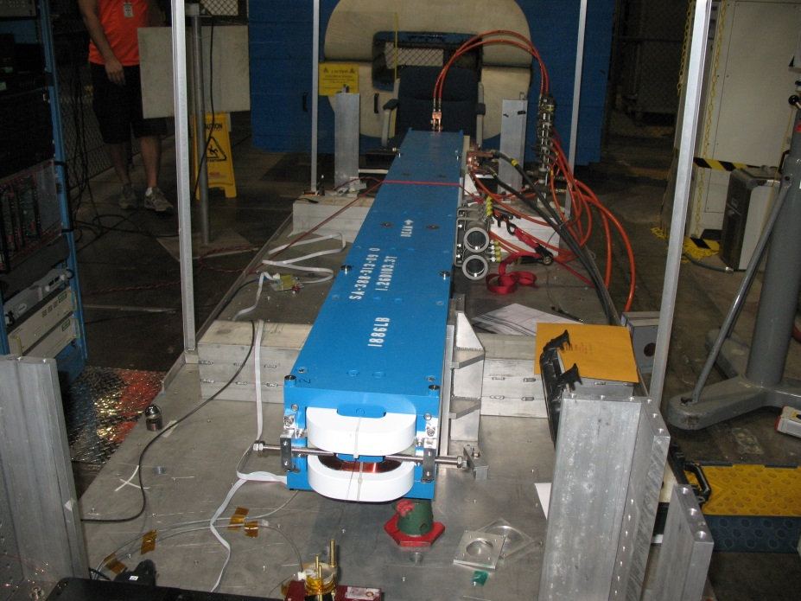
TB4 & D
TB3 & C
Beam Line
TB1 & A
TB2 & B

Tooling ball values 1 to 4 to center of 1.0000 inch tooling ball, A to D to center of 0.3125 inch tooling ball, all units are inches.

Tooling Ball | Z (in) | X (in) | Y (in)
TB1 | -51.2902 | -4.6818 | 5.3989
TB2 | -51.292 | 4.6632 | 5.4082
TB3 | 51.2865 | 4.6724 | 5.4056
TB4 | 51.2884 | -4.6688 | 5.4044
TBA | -51.2886 | -4.6797 | 4.7126
TBB | -51.2878 | 4.6647 | 4.7195
TBC | 51.2852 | 4.6723 | 4.7178
TBD | 51.2881 | -4.6696 | 4.7164

-Constructed 6 planes, top pole, bottom pole, +X side top and bottom pole, -X side top and bottom pole, upstream end of steel and downstream end of steel.
-Bisected two Y planes for Y = 0 plane , two X planes for X = 0 plane, and two Z planes for Z = 0 plane.
-Origin is the intersection of three planes. Used the Y = 0 as primary plane, and X = 0 plane to clock the yaw angle.
-Measured both 1.0000 inch and 0.3125 inch tooling balls.
-Used AT401 for overall control. Used 9 foot Edge Arm on each end of magnet tied to tracker control to measure upstream and downstream poles.
-Average distance from the top and bottom pole planes or a total gap of 1.2631”.

