FACET-II Laser Heater Undulator (LHU) re-measurement report.
The FACET-II LHU (S/N LHU-0003), see picture 1, has been taken out of the tunnel, re-measured, top plate removed, and 2.5” machined off the width of the plate.
The LHU was re-assembled, re-calibrated, and re-fiducialized at SLAC MMF.
The undulator gap was adjusted using ceramic blocks. The placement of the ceramic blocks and the new gap value are marked on the lower jaw.

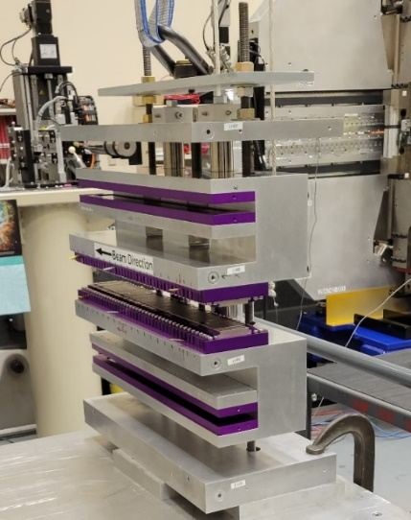
Gap value marked here
Top plate
Picture 1. Laser Heater Undulator.
All measurement data could be found at:
V:\MET\MagServe\MagData\LCLS-II-HE\Undulator\LHU-0003\DATASET0001\Tuning\....
For K=1.17 the gap should be set to 36.985mm at the first magnet.
For K=1.18 the gap should be set to 36.910mm at the first magnet. The K is set to higher value intentionally to compensate for the temperature difference between the vault (29°C) and the MMF (20°C). The final Hall probe scan and all wire measurements were done at gap = 36.910mm.
The summary of the measurements is shown in the table:
 | Initial | Back from tunnel * | Top plate re-installed | Final
K | 1.16802 | 1.16978 | 1.15875 | 1.17892
I1X(µTm) | 5.5 | 4.5 | 7.0 | 7.1
I1Y(µTm) | -3.1 | -1.0 | 0.1 | 0.5
I2X(µTm²) | -1.1 | 0.9 | 2.7 | 0.7
I2Y(µTm²) | 1.4 | 2.4 | 0.6 | 1.1
* LHU temperature was 19.3°C. All other measurements were done at 20.0°C.

Prepared by: Yurii Levashov
12/7/2022

