FACET-II Laser Heater Undulator (LHU) measurements report.

The FACET-II LHU (S/N LHU-0003), see picture 1, has been assembled, measured, tuned, and calibrated at SLAC MMF.
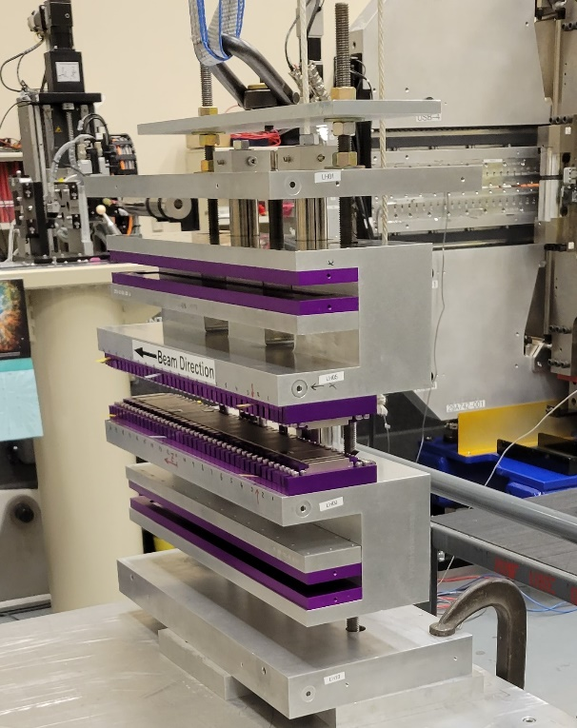
Picture 1. Laser Heater Undulator.
The LHU is a 9 period PPM device based on Roger Carr’s design, with counterforce magnet arrays.
The magnets were sorted initially to minimize the field errors.
The LHU was measured following the “SLAC Magnetic Measurement Plan and Traveler for FACET-II Injector Laser Heater Undulator, Rev.2”. The document and the other data could be found at: V:\MET\MagServe\MagData\LCLS-II-HE\Undulator\LHU-0003\....
The coordinate system is the right-handed system with z-axis following the beam direction, y-axis is up, and x-axis makes the right-hand system.
The 2-D calibrated Sentron Hall probe was used for the field measurements. The bench set-up was so that the bench coordinate system was flipped around Y-axis. Difference in coordinate systems was taken into account during the data processing.
The field integrals were measured with 92cm long single stretched wire. The ambient fields were subtracted from all the measurements.
The undulator temperature was measured by 2 thermistors attached to upstream faces of the upper and the lower jaws.
All measurement data could be found at:
V:\MET\MagServe\MagData\LCLS-II-HE\Undulator\LHU-0003\DATASET0001\Tuning\....
The “Z Scans” folder contains all Hall probe measurements. Explanations to the individual runs could be found in the”index.txt” file. The “Stretched wire” folder contains the field integrals’ measurements. In addition, the final measurements at magnetic axis are summarized in the “Final Results” folder.
The undulator gap was set using ceramic blocks, as in the picture 2. The placement of the ceramic blocks and the gap value are marked on the lower jaw.
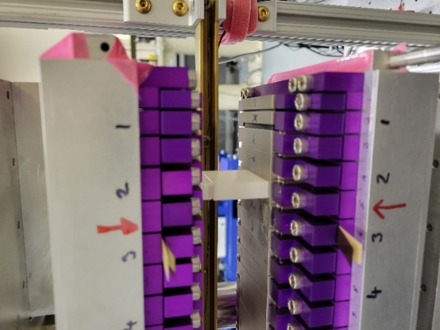
Picture 2. Ceramic block position on undulator jaw.
After the initial measurements and tuning to tolerances, the Hall probe measurement were done at 5 different gap settings and the undulator K was calculated for each gap. The K data were fit with 3-rd order polynomial to find the required gap. For K=1.17 the gap should be set to 36.985mm. The final Hall probe scan and all wire measurements were done at this gap.
The off-axis field integral measurements are shown in figure 1.

Figure 1. Field integrals vs. X-position
The following was performed on the LHU after the final measurement:
- Gap fixing plate was attached to the backs of the undulator jaws.
- Lifting fixture was attached to the undulator.
- The transportation test. The LHU was taken off the measurement bench, put on a cart, rolled outside the building, as in picture 3, brought back and installed on the measurement bench, aligned and re-measured. The results of K measurements are summarized in table 1.
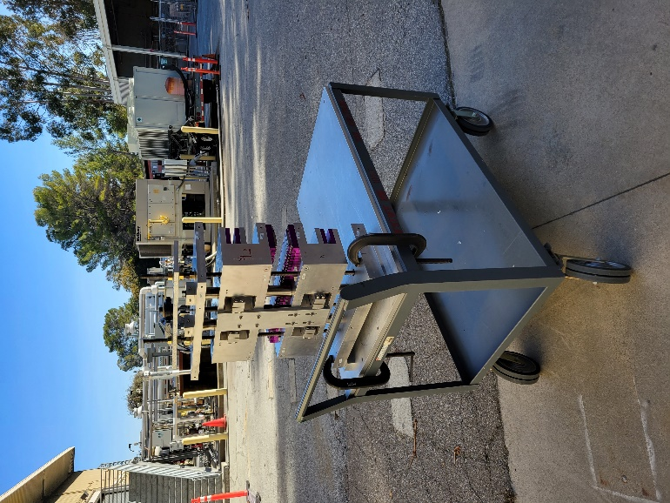
Picture 3. The LHU Transportation test set-up.
Table 1.
 | Initial | Plate | Before test | After test | Max diff.
K | 1.170803 | 1.168020 | 1.168370 | 1.168685 | 0.002783

Attaching the gap fixing plate has changed the gap a little bit (canting the jaws) but the K difference is in tolerance (+-0.003). The vertical rods of the lifting fixture have a small effect on the K. The field integral’s change was small also. Therefore, the lifting fixture could be left on the LHU when installed. The K change after the transportation test is small also.

Prepared by: Yurii Levashov
12/7/2022

