LCLS2 HE SXR Undulator

Alignment Engineering Group
L2?????
SN 29A804-031
March 17, 2025

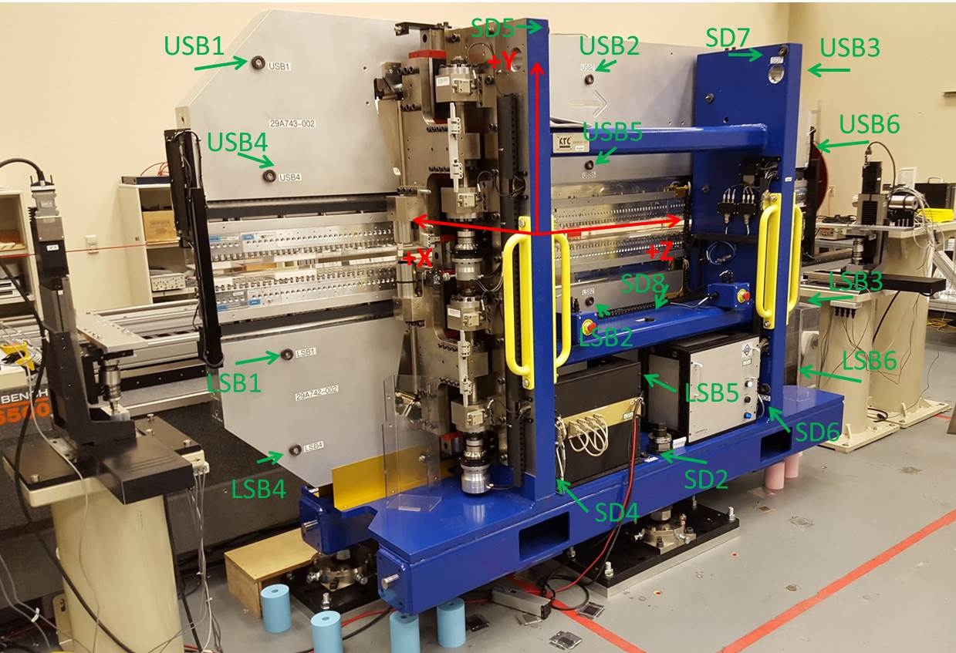

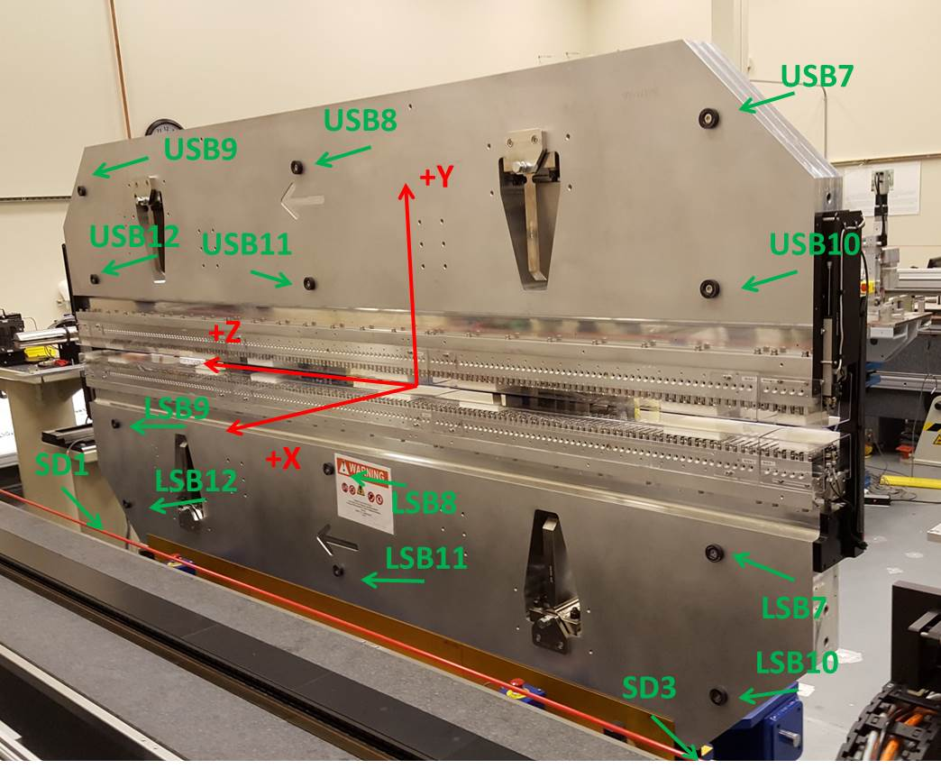

Tooling ball values to center of 1.5 inch sphere, all units are inches. Coordinates are to the SXR Undulator Magnetic Axis.
Tooling Ball | Z (in) | X (in) | Y (in)
LSB1 | -57.4945 | -3.4818 | -10.4986
LSB2 | -0.0077 | -3.4769 | -10.4839
LSB3 | 57.4599 | -3.4870 | -10.4921
LSB4 | -57.4951 | -3.4767 | -24.2759
LSB5 | -0.0121 | -3.4712 | -24.2790
LSB6 | 57.4685 | -3.4841 | -24.2785
LSB7 | -57.4844 | 3.4939 | -10.4951
LSB8 | -0.0064 | 3.4993 | -10.4872
LSB9 | 57.4611 | 3.4880 | -10.4981
LSB10 | -57.4849 | 3.5008 | -24.2646
LSB11 | -0.0145 | 3.5045 | -24.2749
LSB12 | 57.4700 | 3.4930 | -24.2688
SD1 | 50.9704 | 7.2565 | -34.7141
SD2 | -3.9428 | -19.5463 | -34.7573
SD3 | -50.9867 | 7.2204 | -34.7106
SD4 | -25.6062 | -21.6478 | -29.6805
SD5 | -25.6176 | -21.6230 | 29.4351
SD6 | 25.6109 | -21.5947 | -29.6392
SD7 | 25.6778 | -21.6036 | 29.4424
SD8 | 0.0541 | -16.9695 | -12.3486
USB1 | -57.4945 | -3.4920 | 24.2738
USB2 | -0.0074 | -3.4977 | 24.2824
USB3 | 57.4767 | -3.4882 | 24.2811
USB4 | -57.4882 | -3.4914 | 10.5020
USB5 | -0.0141 | -3.4979 | 10.4935
USB6 | 57.4741 | -3.4894 | 10.5030
USB7 | -57.4928 | 3.4808 | 24.2680
USB8 | -0.0127 | 3.4765 | 24.2746
USB9 | 57.4624 | 3.4838 | 24.2724
USB10 | -57.4895 | 3.4827 | 10.4971
USB11 | -0.0148 | 3.4768 | 10.4907
USB12 | 57.4685 | 3.4836 | 10.4969

Center | Z (m) | X (m) | Y (m) | Z (in) | X (in) | Y (in)
PM10M | -2.818771 | -0.026278 | 0.000689 | -110.9752 | -1.0346 | 0.0271
PM11M | 2.722838 | -0.026615 | 0.000704 | 107.1983 | -1.0478 | 0.0277
RFM | -2.674005 | 0.048690 | -0.000004 | -105.2758 | 1.9169 | -0.0002

PM10 and Granite coordinate system with Yurii shifts.
 |  | From Yurii |  |  | Measured
Device | Z (m) | X (m) | Y (m) | Z (m) | X (m) | Y (m) | dX (mm) | dY (mm)
PM10 | -0.368902 | -0.102106 | 0.000772 | -2.818771 | -0.102106 | 0.000772 | 0.000 | 0.000
PM11 | 5.172744 | -0.102423 | 0.000760 | 2.722838 | -0.102443 | 0.000787 | -0.020 | 0.027
Ref Block |  |  |  | -2.674005 | -0.027138 | 0.000079

