LCLS2 HE SXR Undulator

Alignment Engineering Group
L2?????
SN 29A804-030
April 04, 2025

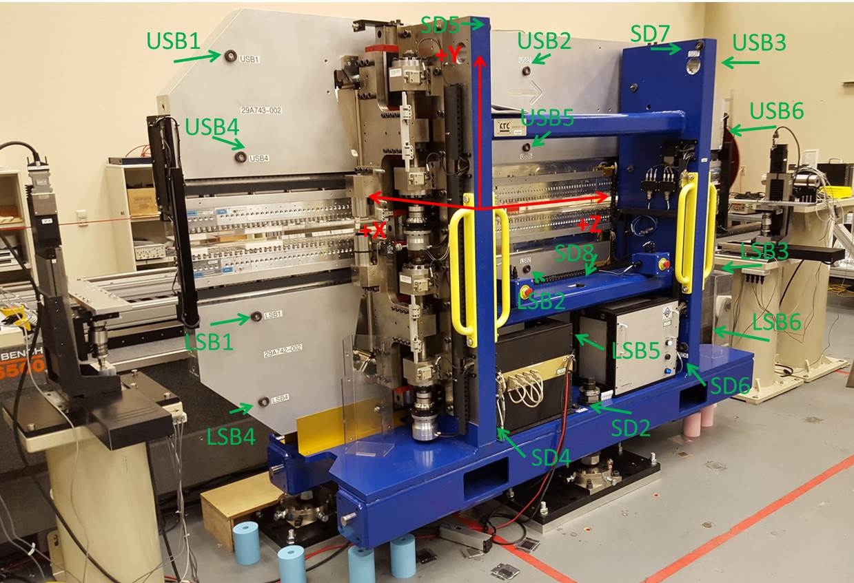

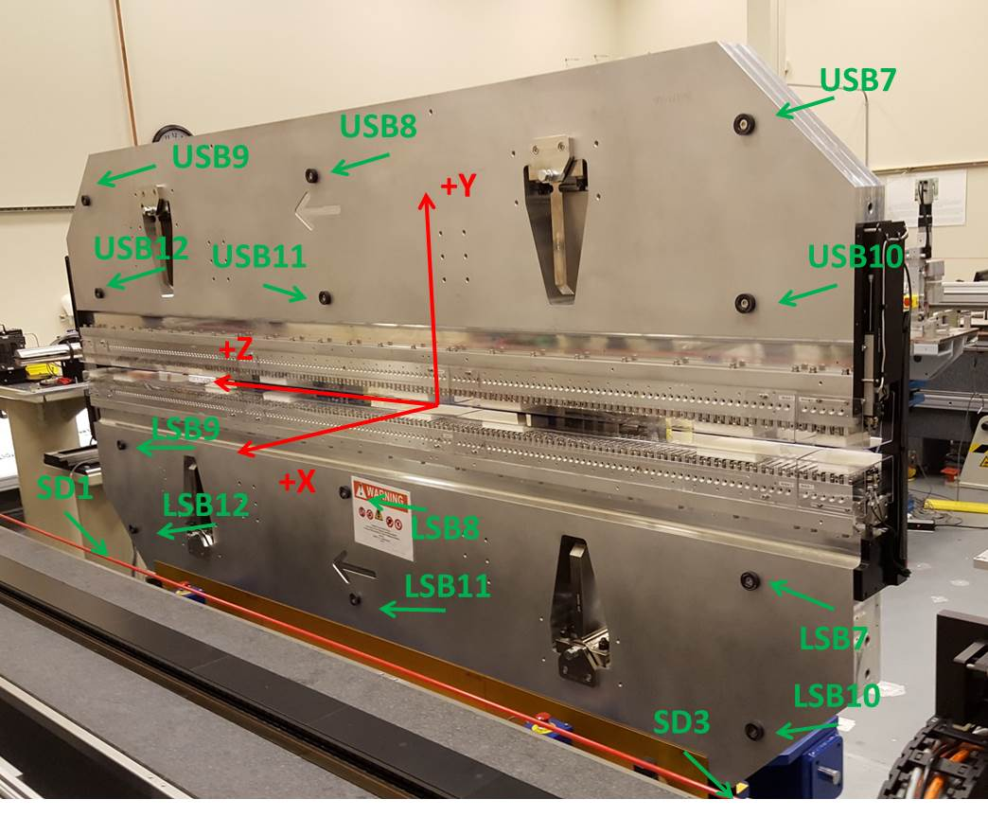

Tooling ball values to center of 1.5 inch sphere, all units are inches. Coordinates are to the SXR Undulator Magnetic Axis.
Tooling Ball | Z (in) | X (in) | Y (in)
LSB1 | -57.4778 | -3.4842 | -10.4889
LSB2 | -0.0021 | -3.4899 | -10.4851
LSB3 | 57.4812 | -3.4874 | -10.4928
LSB4 | -57.4792 | -3.4784 | -24.2641
LSB5 | -0.0079 | -3.4857 | -24.2630
LSB6 | 57.4767 | -3.4857 | -24.2772
LSB7 | -57.4795 | 3.4913 | -10.4923
LSB8 | -0.0058 | 3.4850 | -10.4990
LSB9 | 57.4698 | 3.4867 | -10.4859
LSB10 | -57.4906 | 3.4973 | -24.2737
LSB11 | -0.0001 | 3.4897 | -24.2634
LSB12 | 57.4750 | 3.4898 | -24.2800
SD1 | 50.9962 | 7.1451 | -34.8817
SD2 | -3.9220 | -19.5827 | -34.9392
SD3 | -50.9500 | 7.2011 | -34.8776
SD4 | -25.5988 | -21.5673 | -29.8079
SD5 | -25.5998 | -21.5646 | 29.2217
SD6 | 25.6080 | -21.6788 | -29.7919
SD7 | 25.5468 | -21.5676 | 29.2680
SD8 | -0.0020 | -16.9431 | -12.5431
USB1 | -57.4928 | -3.4872 | 24.2793
USB2 | -0.0033 | -3.4959 | 24.2722
USB3 | 57.4748 | -3.4891 | 24.2673
USB4 | -57.4851 | -3.4926 | 10.4976
USB5 | -0.0056 | -3.4984 | 10.4964
USB6 | 57.4591 | -3.4872 | 10.4936
USB7 | -57.4892 | 3.4893 | 24.2729
USB8 | -0.0089 | 3.4809 | 24.2760
USB9 | 57.4699 | 3.4858 | 24.2717
USB10 | -57.4895 | 3.4839 | 10.4885
USB11 | -0.0117 | 3.4767 | 10.4952
USB12 | 57.4664 | 3.4833 | 10.4811

Center | Z (m) | X (m) | Y (m) | Z (in) | X (in) | Y (in)
PM10M | -2.818806 | -0.026272 | 0.000591 | -110.9766 | -1.0343 | 0.0233
PM11M | 2.722796 | -0.026603 | 0.000623 | 107.1967 | -1.0474 | 0.0245
RFM | -2.674054 | 0.048701 | -0.000092 | -105.2777 | 1.9174 | -0.0036

PM10 and Granite coordinate system with Yurii shifts.
 |  | From Yurii |  |  | Measured
Device | Z (m) | X (m) | Y (m) | Z (m) | X (m) | Y (m) | dX (mm) | dY (mm)
PM10 | -0.368872 | -0.102096 | 0.000736 | -2.818806 | -0.102096 | 0.000736 | 0.000 | 0.000
PM11 | 5.172763 | -0.102414 | 0.000723 | 2.722796 | -0.102427 | 0.000768 | -0.013 | 0.045
Ref Block |  |  |  | -2.674054 | -0.027123 | 0.000053

