LCLS2 HE SXR Undulator

Alignment Engineering Group
L2?????
SN 29A804-024
October 03, 2024

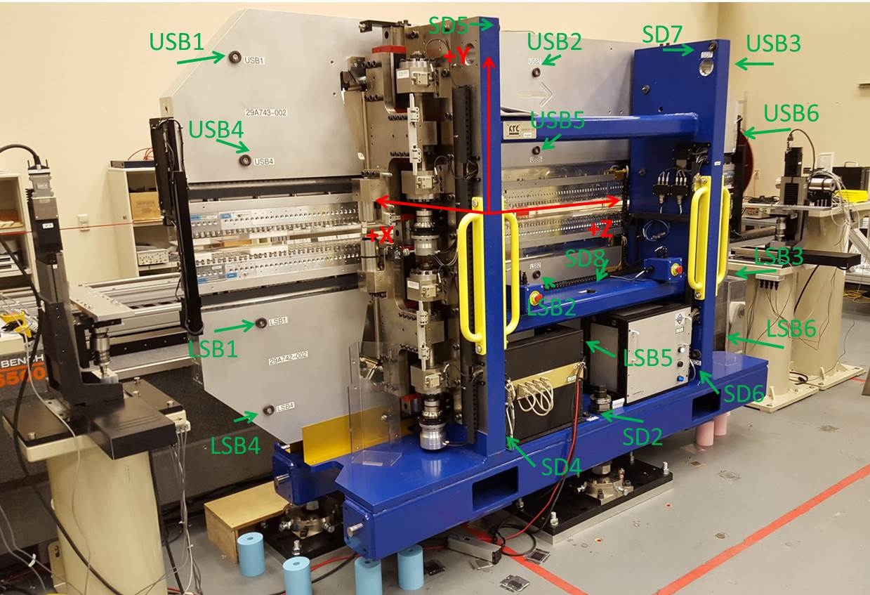

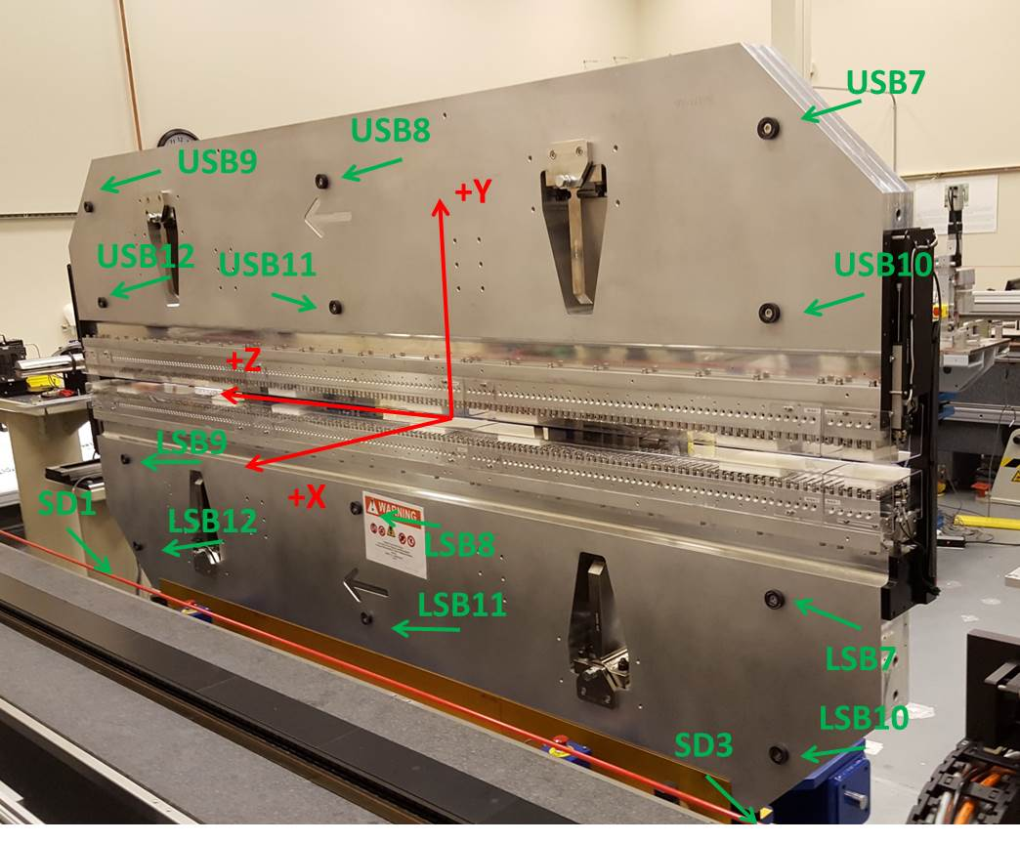

Tooling ball values to center of 1.5 inch sphere, all units are inches. Coordinates are to the SXR Undulator Magnetic Axis.
Tooling Ball | Z (in) | X (in) | Y (in)
LSB1 | -57.4431 | -3.4850 | -10.4889
LSB2 | 0.0313 | -3.4793 | -10.4836
LSB3 | 57.5111 | -3.4812 | -10.4935
LSB4 | -57.4569 | -3.4794 | -24.2730
LSB5 | 0.0327 | -3.4735 | -24.2713
LSB6 | 57.5027 | -3.4771 | -24.2607
LSB7 | -57.4663 | 3.4903 | -10.4889
LSB8 | 0.0106 | 3.4973 | -10.4891
LSB9 | 57.5065 | 3.4941 | -10.4875
LSB10 | -57.4654 | 3.4983 | -24.2720
LSB11 | 0.0180 | 3.5035 | -24.2760
LSB12 | 57.5056 | 3.4977 | -24.2722
SD1 | 50.9679 | 7.2248 | -34.6120
SD2 | -3.9511 | -19.5333 | -34.6722
SD3 | -50.9954 | 7.2406 | -34.6204
SD4 | -25.6359 | -21.5330 | -29.5460
SD5 | -25.6886 | -21.6372 | 29.5192
SD6 | 25.6185 | -21.6550 | -29.5187
SD7 | 25.6485 | -21.5541 | 29.5578
SD8 | -0.0030 | -16.9276 | -12.3508
USB1 | -57.5066 | -3.4891 | 24.2722
USB2 | -0.0243 | -3.4936 | 24.2659
USB3 | 57.4516 | -3.4852 | 24.2791
USB4 | -57.5049 | -3.4879 | 10.4870
USB5 | -0.0172 | -3.4941 | 10.4945
USB6 | 57.4540 | -3.4877 | 10.5035
USB7 | -57.5059 | 3.4869 | 24.2694
USB8 | -0.0284 | 3.4834 | 24.2654
USB9 | 57.4553 | 3.4911 | 24.2619
USB10 | -57.4955 | 3.4871 | 10.5017
USB11 | -0.0225 | 3.4819 | 10.4893
USB12 | 57.4661 | 3.4878 | 10.4923

Center | Z (m) | X (m) | Y (m) | Z (in) | X (in) | Y (in)
PM10M | -2.819267 | -0.026434 | 0.000912 | -110.9948 | -1.0407 | 0.0359
PM11M | 2.722506 | -0.026750 | 0.000970 | 107.1853 | -1.0531 | 0.0382
RFM | -2.674508 | 0.048542 | 0.000233 | -105.2956 | 1.9111 | 0.0092

PM10 and Granite coordinate system with Yurii shifts.
 |  | From Yurii |  |  | Measured
Device | Z (m) | X (m) | Y (m) | Z (m) | X (m) | Y (m) | dX (mm) | dY (mm)
PM10 | -0.369340 | -0.102330 | 0.001092 | -2.819267 | -0.102330 | 0.001092 | 0.000 | 0.000
PM11 | 5.172402 | -0.102640 | 0.001088 | 2.722506 | -0.102646 | 0.001150 | -0.006 | 0.062
Ref Block |  |  |  | -2.674508 | -0.027354 | 0.000413

