LCLS2 HE SXR Undulator

Alignment Engineering Group
L2?????
SN 29A804-018
November 10, 2025

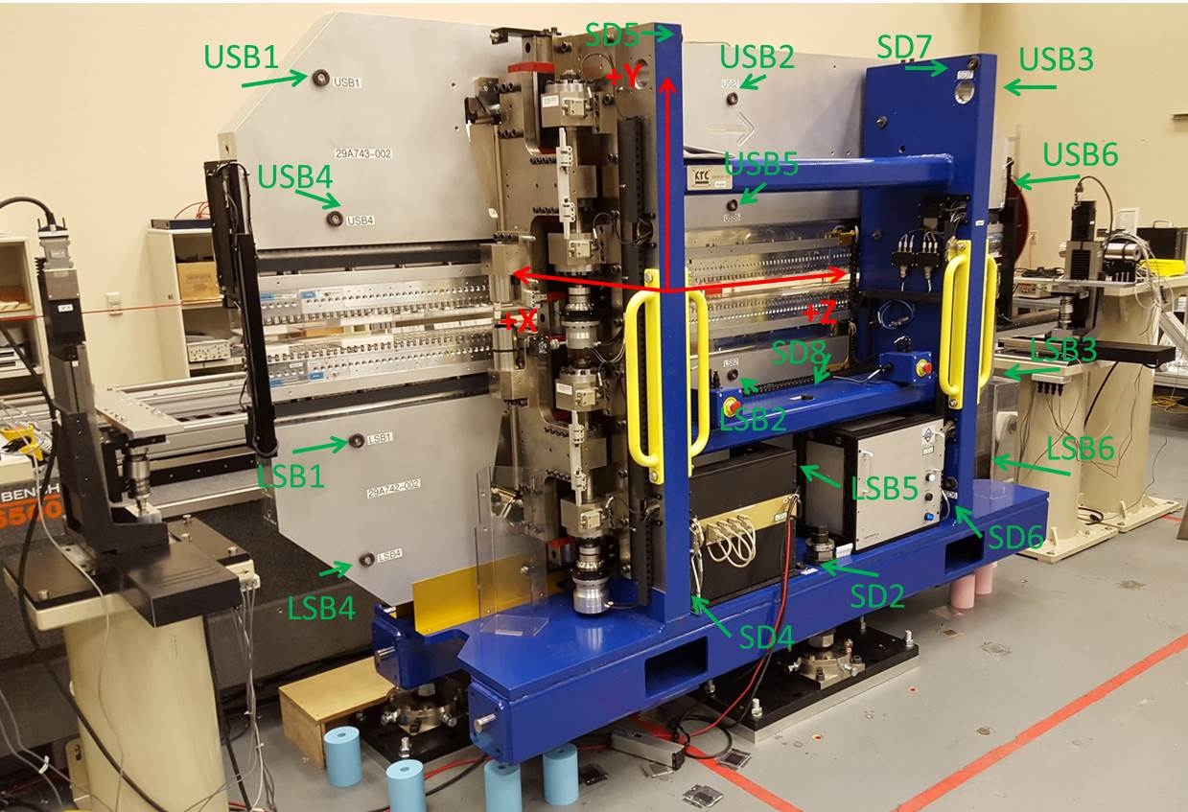

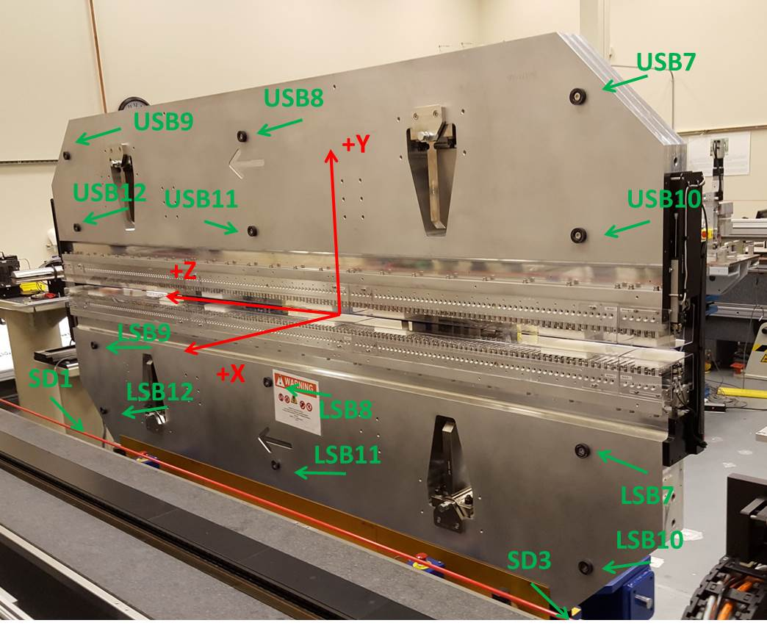

Tooling ball values to center of 1.5 inch sphere, all units are inches. Coordinates are to the SXR Undulator Magnetic Axis.
Tooling Ball | Z (in) | X (in) | Y (in)
LSB1 | -57.4745 | -3.4881 | -10.4957
LSB2 | -0.0109 | -3.4866 | -10.4891
LSB3 | 57.4700 | -3.4904 | -10.4964
LSB4 | -57.4800 | -3.4853 | -24.2765
LSB5 | 0.0076 | -3.4838 | -24.2630
LSB6 | 57.4672 | -3.4882 | -24.2720
LSB7 | -57.4714 | 3.4861 | -10.4929
LSB8 | -0.0031 | 3.4888 | -10.4917
LSB9 | 57.4724 | 3.4851 | -10.4997
LSB10 | -57.4790 | 3.4885 | -24.2836
LSB11 | 0.0009 | 3.4928 | -24.2774
LSB12 | 57.4666 | 3.4873 | -24.2778
SD1 | 50.9780 | 7.2309 | -34.6504
SD2 | -3.9320 | -19.5398 | -34.7257
SD3 | -50.9765 | 7.2391 | -34.6782
SD4 | -25.4972 | -21.7085 | -29.5744
SD5 | -25.5745 | -21.8079 | 29.4769
SD6 | 25.7644 | -21.8067 | -29.5673
SD7 | 25.7204 | -21.7176 | 29.4867
SD8 | 0.1166 | -17.0178 | -12.2902
USB1 | -57.4759 | -3.4921 | 24.2746
USB2 | -0.0067 | -3.4915 | 24.2771
USB3 | 57.4698 | -3.4924 | 24.2702
USB4 | -57.4835 | -3.4901 | 10.4901
USB5 | -0.0113 | -3.4908 | 10.4803
USB6 | 57.4617 | -3.4912 | 10.4895
USB7 | -57.4671 | 3.4837 | 24.2736
USB8 | -0.0028 | 3.4842 | 24.2717
USB9 | 57.4666 | 3.4868 | 24.2625
USB10 | -57.4830 | 3.4872 | 10.4885
USB11 | -0.0019 | 3.4865 | 10.4851
USB12 | 57.4748 | 3.4878 | 10.4972

Center | Z (m) | X (m) | Y (m) | Z (in) | X (in) | Y (in)
PM10M | -2.819143 | -0.026102 | 0.000630 | -110.9899 | -1.0276 | 0.0248
PM11M | 2.722446 | -0.026420 | 0.000649 | 107.1829 | -1.0402 | 0.0256
RFM | -2.674383 | 0.048874 | -0.000058 | -105.2907 | 1.9242 | -0.0023

PM10 and Granite coordinate system with Yurii shifts.
 |  | From Yurii |  |  | Measured
Device | Z (m) | X (m) | Y (m) | Z (m) | X (m) | Y (m) | dX (mm) | dY (mm)
PM10 | -2.8191425 | -0.026105 | 0.000647 | -2.819143 | -0.026102 | 0.000630 | 0.003 | -0.017
PM11 | 2.72248348 | -0.026417 | 0.000632 | 2.722446 | -0.026420 | 0.000649 | -0.003 | 0.017
Ref Block |  |  |  | -2.674383 | 0.048874 | -0.000058

