LCLS2 HE SXR Undulator

Alignment Engineering Group
L2?????
SN 29A804-003
March 11, 2026

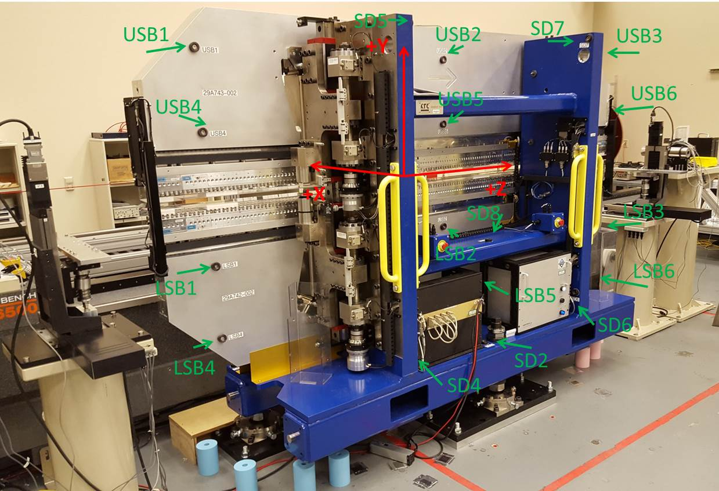

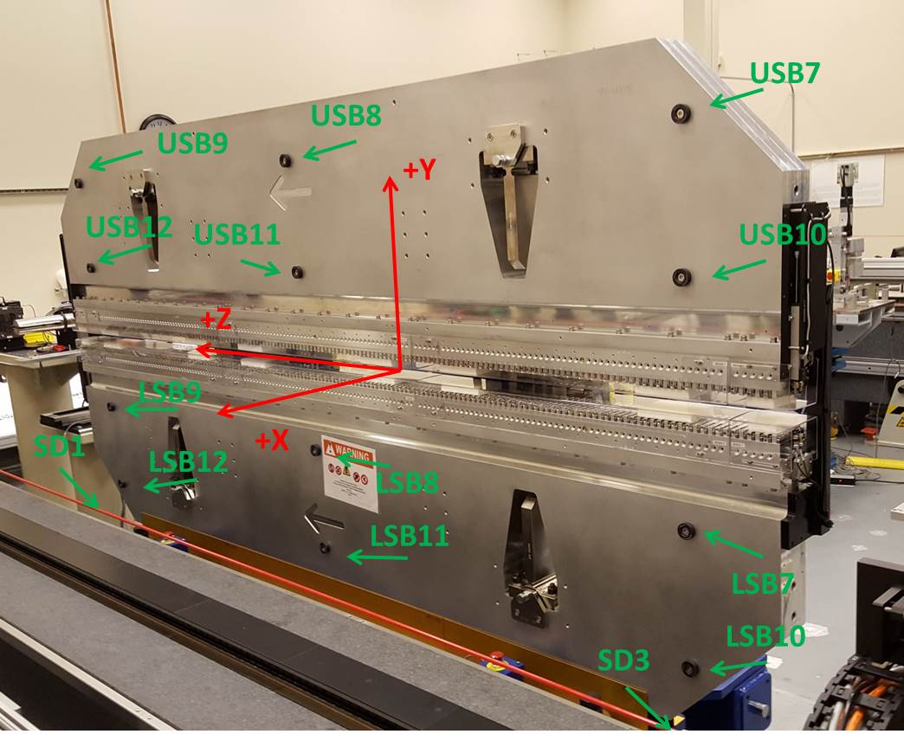

Tooling ball values to center of 1.5 inch sphere, all units are inches. Coordinates are to the SXR Undulator Magnetic Axis.
Tooling Ball | Z (in) | X (in) | Y (in)
LSB1 | -57.4793 | -3.4905 | -10.4911
LSB2 | -0.0047 | -3.4943 | -10.4879
LSB3 | 57.4646 | -3.4929 | -10.4926
LSB4 | -57.4829 | -3.4876 | -24.2737
LSB5 | -0.0110 | -3.4914 | -24.2711
LSB6 | 57.4665 | -3.4901 | -24.2709
LSB7 | -57.4789 | 3.4856 | -10.4954
LSB8 | -0.0109 | 3.4820 | -10.4874
LSB9 | 57.4689 | 3.4806 | -10.4927
LSB10 | -57.4892 | 3.4884 | -24.2633
LSB11 | -0.0078 | 3.4852 | -24.2693
LSB12 | 57.4738 | 3.4847 | -24.2656
SD1 | 50.9770 | 7.2406 | -34.7868
SD2 | -3.9595 | -19.5136 | -34.8216
SD3 | -50.9936 | 7.2581 | -34.7583
SD4 | -25.6687 | -21.6959 | -29.6792
SD5 | -25.6731 | -21.6752 | 29.3829
SD6 | 25.6202 | -21.6594 | -29.6703
SD7 | 25.6157 | -21.7032 | 29.3615
SD8 | -0.0165 | -16.9577 | -12.4767
USB1 | -57.4868 | -3.4895 | 24.2576
USB2 | -0.0073 | -3.4704 | 24.2682
USB3 | 57.4756 | -3.4891 | 24.2717
USB4 | -57.4742 | -3.4872 | 10.4816
USB5 | -0.0072 | -3.4680 | 10.4924
USB6 | 57.4746 | -3.4876 | 10.4898
USB7 | -57.4829 | 3.4881 | 24.2635
USB8 | -0.0063 | 3.5086 | 24.2651
USB9 | 57.4661 | 3.4883 | 24.2714
USB10 | -57.4882 | 3.4892 | 10.4901
USB11 | 0.0018 | 3.5086 | 10.4899
USB12 | 57.4719 | 3.4870 | 10.4831

Center | Z (m) | X (m) | Y (m) | Z (in) | X (in) | Y (in)
PM10M | -2.819033 | -0.025851 | 0.000573 | -110.9856 | -1.0178 | 0.0226
PM11M | 2.722455 | -0.026150 | 0.000579 | 107.1833 | -1.0295 | 0.0228
RFM | -2.674281 | 0.049123 | -0.000111 | -105.2867 | 1.9340 | -0.0044

PM10 and Granite coordinate system with Yurii shifts.
 |  | From Yurii |  |  | Measured
Device | Z (m) | X (m) | Y (m) | Z (m) | X (m) | Y (m) | dX (mm) | dY (mm)
PM10 | -2.8190437 | -0.02586 | 0.000594 | -2.819033 | -0.025851 | 0.000573 | 0.009 | -0.021
PM11 | 2.7224663 | -0.026141 | 0.000558 | 2.722455 | -0.026150 | 0.000579 | -0.009 | 0.021
Ref Block |  |  |  | -2.674281 | 0.049123 | -0.000111

