LCLS2 HE SXR Undulator

Alignment Engineering Group
L2?????
SN 29A804-004
September 08, 2025

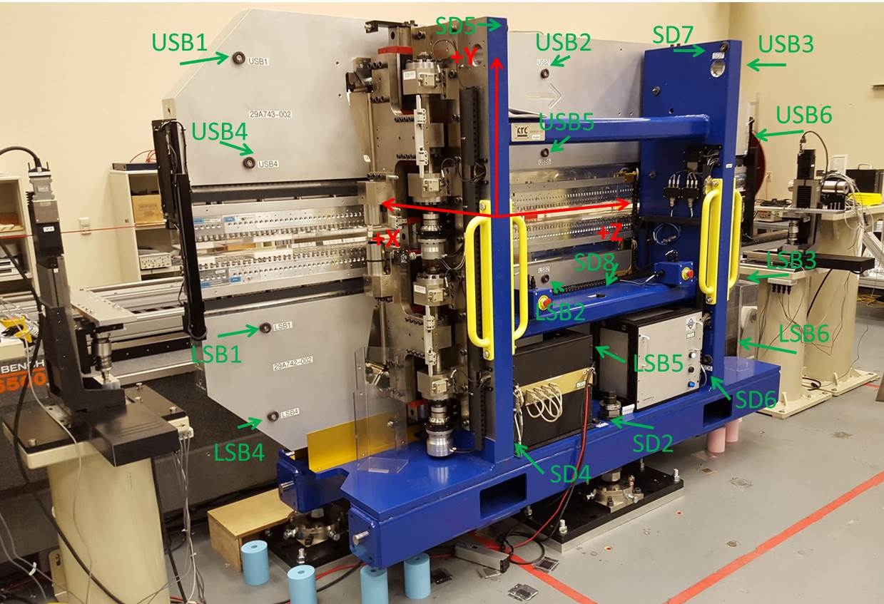

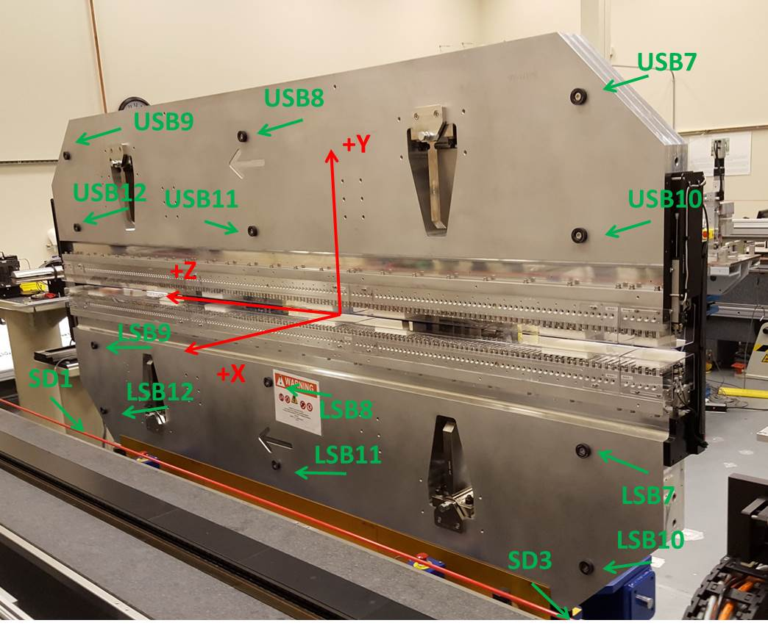

Tooling ball values to center of 1.5 inch sphere, all units are inches. Coordinates are to the SXR Undulator Magnetic Axis.
Tooling Ball | Z (in) | X (in) | Y (in)
LSB1 | -57.4767 | -3.4916 | -10.4852
LSB2 | -0.0043 | -3.4968 | -10.4881
LSB3 | 57.4797 | -3.4899 | -10.4875
LSB4 | -57.4767 | -3.4863 | -24.2656
LSB5 | -0.0008 | -3.4914 | -24.2707
LSB6 | 57.4733 | -3.4849 | -24.2681
LSB7 | -57.4778 | 3.4895 | -10.4836
LSB8 | -0.0071 | 3.4890 | -10.4794
LSB9 | 57.4750 | 3.4874 | -10.4899
LSB10 | -57.4710 | 3.4944 | -24.2591
LSB11 | -0.0076 | 3.4938 | -24.2579
LSB12 | 57.4665 | 3.4918 | -24.2588
SD1 | 50.9524 | 7.2484 | -34.7993
SD2 | -3.9573 | -19.5124 | -34.8344
SD3 | -51.0022 | 7.2730 | -34.7743
SD4 | -25.6194 | -21.6836 | -29.6762
SD5 | -25.6203 | -21.6502 | 29.3804
SD6 | 25.6478 | -21.6584 | -29.6857
SD7 | 25.6495 | -21.6877 | 29.3534
SD8 | 0.0426 | -16.8633 | -12.5187
USB1 | -57.4844 | -3.4796 | 24.2704
USB2 | -0.0136 | -3.4683 | 24.2667
USB3 | 57.4731 | -3.4802 | 24.2682
USB4 | -57.4834 | -3.4811 | 10.4903
USB5 | -0.0141 | -3.4707 | 10.4921
USB6 | 57.4639 | -3.4837 | 10.4848
USB7 | -57.4784 | 3.4982 | 24.2691
USB8 | -0.0050 | 3.5094 | 24.2607
USB9 | 57.4705 | 3.4953 | 24.2636
USB10 | -57.4850 | 3.4957 | 10.4975
USB11 | -0.0087 | 3.5047 | 10.4914
USB12 | 57.4687 | 3.4931 | 10.4895

Center | Z (m) | X (m) | Y (m) | Z (in) | X (in) | Y (in)
PM10M | -2.818909 | -0.026108 | 0.000512 | -110.9807 | -1.0279 | 0.0202
PM11M | 2.722705 | -0.026437 | 0.000534 | 107.1931 | -1.0408 | 0.0210
RFM | -2.674159 | 0.048869 | -0.000177 | -105.2819 | 1.9240 | -0.0070

PM10 and Granite coordinate system with Yurii shifts.
 |  | From Yurii |  |  | Measured
Device | Z (m) | X (m) | Y (m) | Z (m) | X (m) | Y (m) | dX (mm) | dY (mm)
PM10 | -2.818909 | -0.026119 | 0.000529 | -2.818909 | -0.026108 | 0.000512 | 0.011 | -0.017
PM11 | 2.722758 | -0.026425 | 0.000517 | 2.722705 | -0.026437 | 0.000534 | -0.012 | 0.017
Ref Block |  |  |  | -2.674159 | 0.048869 | -0.000177

