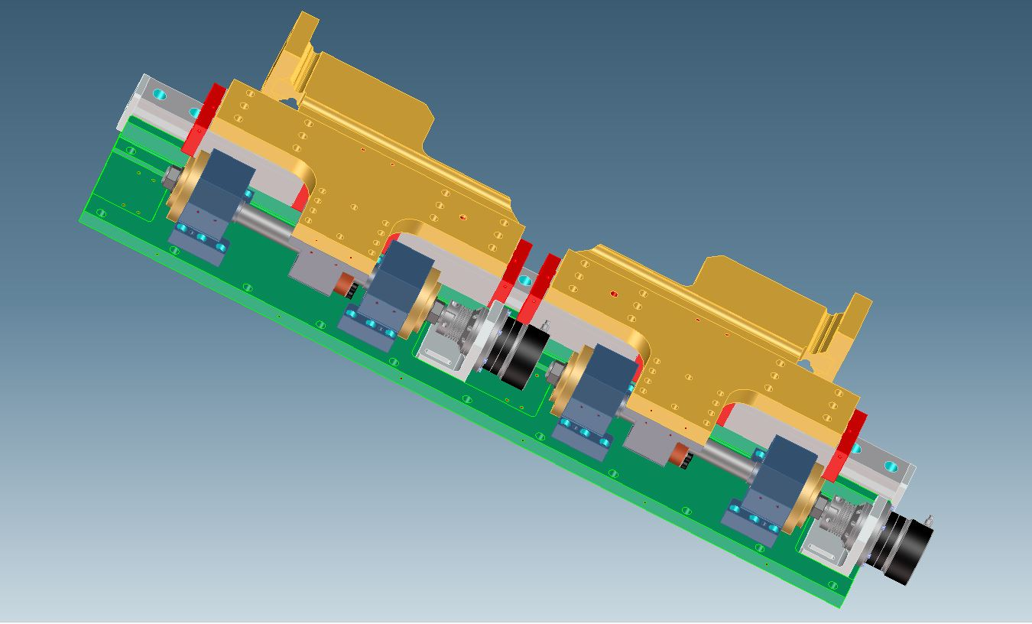
Loose coupling set screw

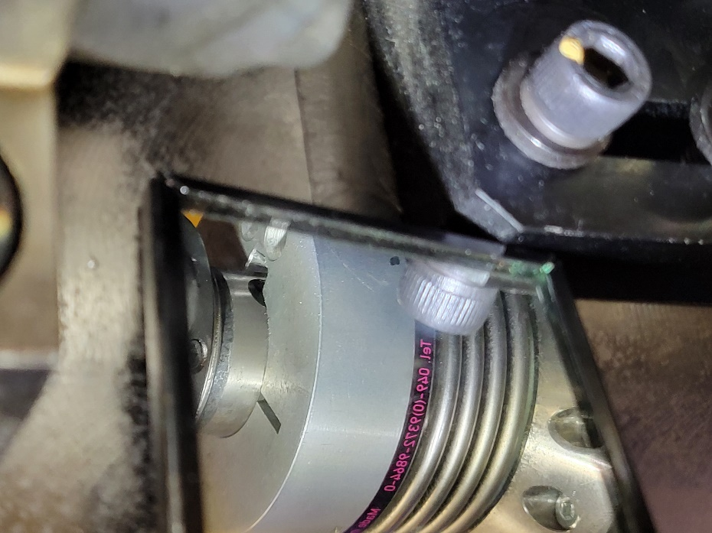
Coupling slipped

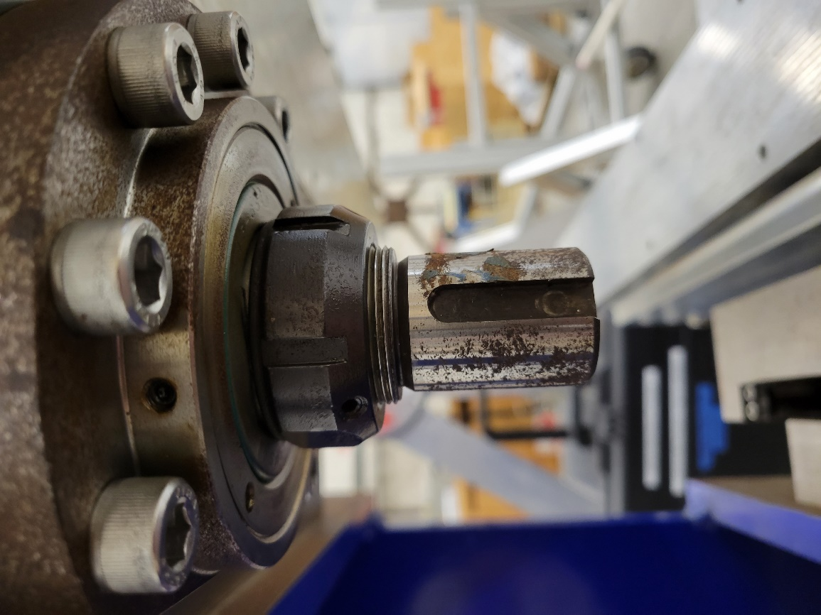
Epoxy
Key

External Bx = 0.096 G, By = -0.107 G

