Document Approval:
Originator: Yurii Levashov, MMF Lead Physicist

Reviewer: Zack Wolf – Magnetic Measurements Group Leader

Approver: Georg Gassner – Metrology Department Head
Approver: Richard E Atkinson – METS Division Health and Safety Coordinator
Revision History
Revision | Date Released | Description of Change
R0 | Month Day, Year | Original Release.

Table of Content
1 Scope 2
2 Roles and Responsibilities 2
3 Preparation/Prerequisite Actions ………………………………………………………..…………….. 2
4 Tools 2
5 Safety ……………………………………………………………………………………………………..… 2
6 Probe installation ……………..……………………....…………………..……………………………… 2
7. Probe calibration ……………………………………..…………………………………………………… 3
8. Post-calibration data processing …………………………………………………………………..… 10

Scope
The Hall probes are used for high accuracy mapping of magnetic fields. Due to zero offset drift and the gain drift the probes need periodic (once in 3 months) re-calibration.
This document provides a procedure to calibrate a Hall probe for precise magnetic field measurements with 10⁻⁴ accuracy.

Roles and Responsibilities
Preparation for calibration. | MMF technician
Calibration | MMF physicist

Preparation/Prerequisite Actions
The Hall probe should be removed from the measurement bench, mounted inside the calibration magnet, and aligned (yaw and roll). The probe power cable and the signal cable should be properly connected. The probe should be powered ON for at least 2 hours before the calibration starts. It is recommended to install the probe on the calibration stand one day and leave it ON overnight for a good warm-up. The probe water cooling system should be connected. The power to the calibration magnet power supply should be switched ON.

Tools
- A set of Allen wrenches, a Phillips screwdriver.

Safety
- Electrical hazard operating the disconnect switch.
Course 251 training required to operate the switch. Wear leather gloves and safety glasses.
- Force from high magnetic field.
Be aware of magnetic force on the tools. Keep Allen wrenches away from the calibration magnet gap when the magnet is ON. Put a safety chain 3ft. around the magnet.

Probe installation
6.1 Switch OFF the probe power supply.

Disconnect two cables from the probe electronics box, see picture 2.

Swap the signal wires on bench DMMs to the calibration magnet wires. Pay attention to labels.

Remove probe with the probe holder from the bench stages by losing two 4-40 screws and sliding the ceramic piece out of the clamp, see picture 3.

Disconnect the ceramic block from the G-10 probe holder by removing two 6-32 screws, see picture 4.

Take the probe with the electronics box to the calibration stand, see picture 1.

Power disconnect box

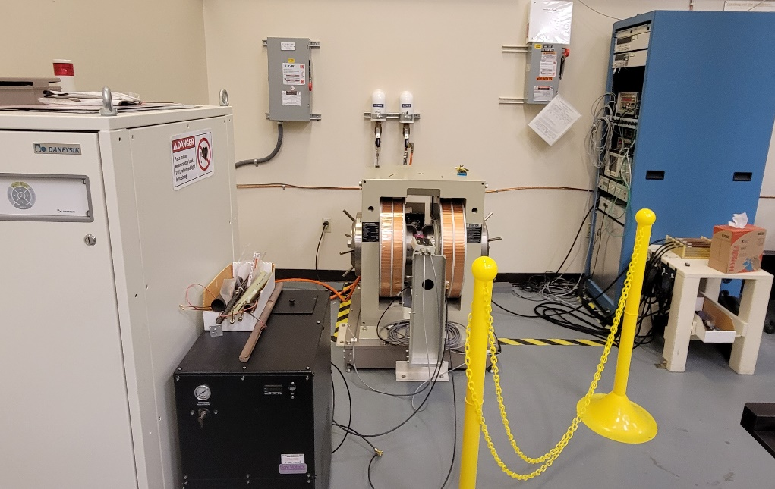
NMR probes
Electronics rack
Hall probe box on the vertical support
Calibration magnet
Magnet Power Supply
Water chiller
Picture 1. Hall probe calibration stand.

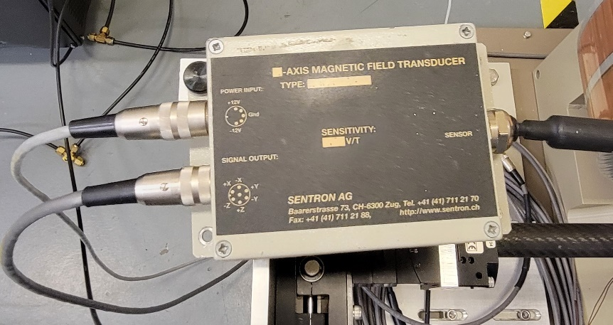
Signal cable
Power cable
Thumb screw
Picture 2. Hall probe electronics box.

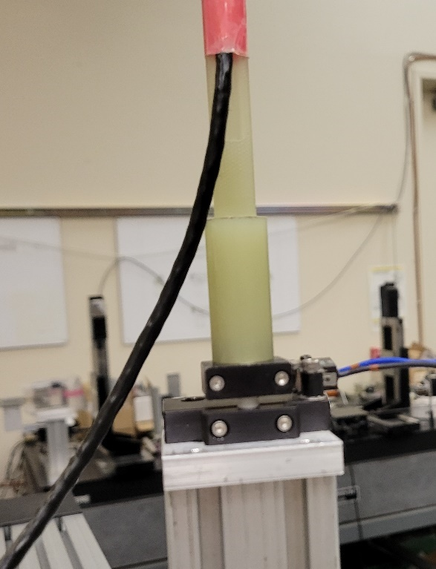
Screws to disconnect
safety switch
Probe G-10 holder
Picture 3. Hall probe mounting on the measurement bench.

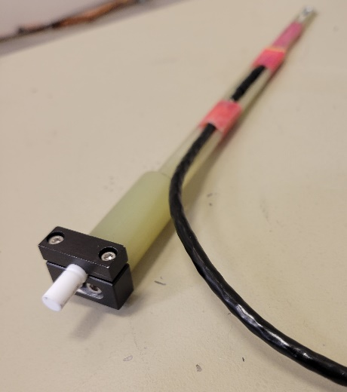
Screws to disconnect
Ceramic pin
Probe G-10 holder
Picture 4. Ceramic block.

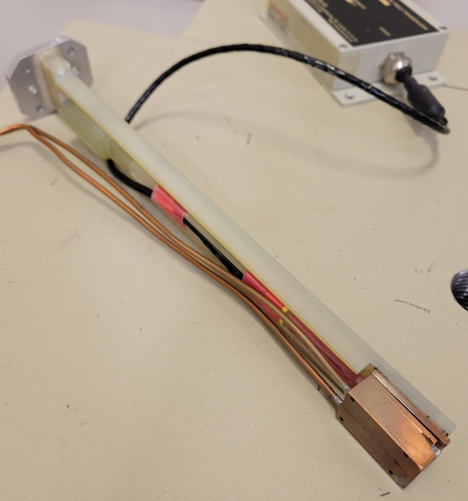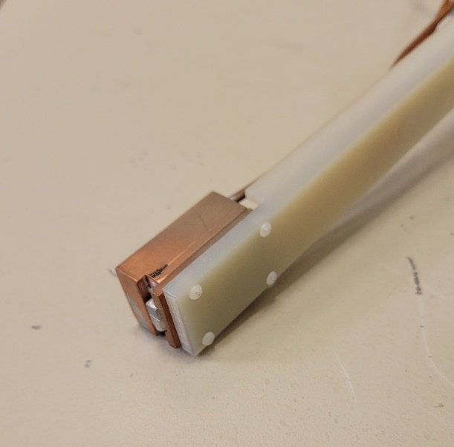
Plastic screws
Copper block with water tubes
Hall probe
Picture 5. Hall probe mounted in copper block.

Attach the electronics box to the bracket by a thumb screw and a nut, as in the picture 2.

Connect power cable and signal cable to the electronics box. Make sure the signal cable is correctly connected to the bench DMMs.

Turn ON the probe power supply located in the calibration stand rack.

Install the probe inside copper cooling block attached to the G-10 calibration bracket as in picture 5. Make sure the end of the probe holder is flash with the copper block side and the probe signal cable is up. Do not apply excessive force on the plastic screws.

Install the calibration bracket with the probe into the calibration magnet gap. Attach with four 6-32 screws as in the picture 6. Pay attention to orientation of the bracket and the probe. Make sure all cables are free of twisting. Secure the cables and the water tubing to the vertical support with a cable tie.

Insert the temperature sensor into the special hole in the copper block, as in picture 6.

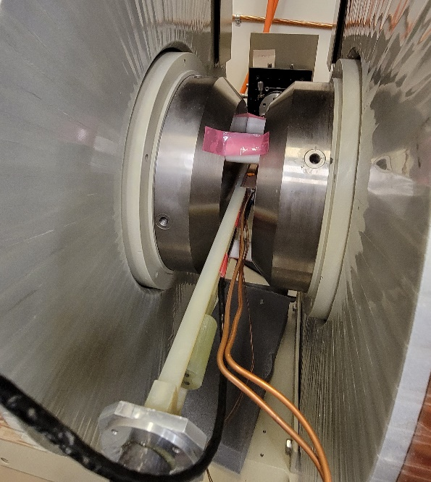
Screws for fixing bracket
Water tubing
Temperature sensor
Picture 6. Hall probe in the calibration magnet gap.

6.13 Turn ON the water chiller.

6.14 Turn ON power to the magnet power supply.

7. Probe calibration
7.1 Turn ON the rotary stage controller.
7.2 Turn ON the NMR.
7.3 Install NMR probe #5 into the undulator gap, secure it with the plastic clamp as in picture 7. Make sure the probe is against the groove end.
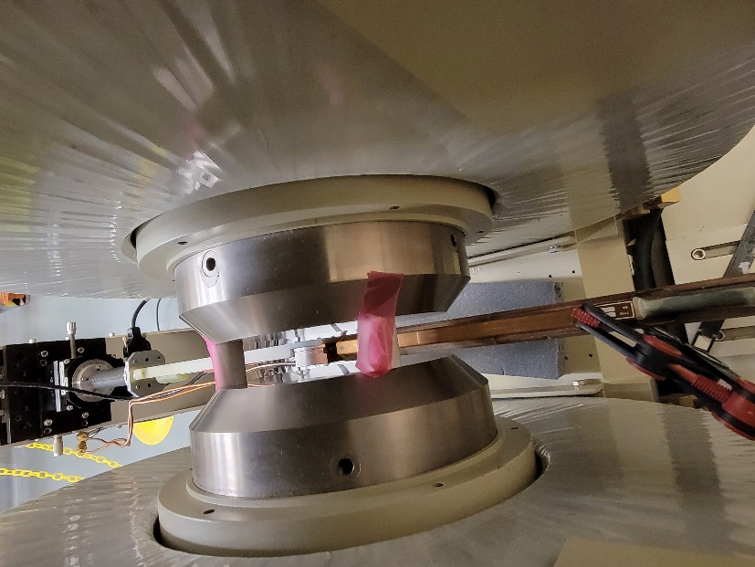
NMR probe
Translation stage and goniometer
Copper block with Hall probe
Plastic clamp
Picture 7. NMR probe in the calibration magnet gap.

7.4 Check voltmeters using the voltage standard, see picture 8. First, set the output voltage to 6,00000. Attach BNC cable from the rear input of y-voltmeter to the voltage standard output and click “operate/standby” button to switch the voltage output on. Switch the voltmeter input to “rear”. Write down the voltmeter reading for positive voltage. It will be used later.
Operate/standby button
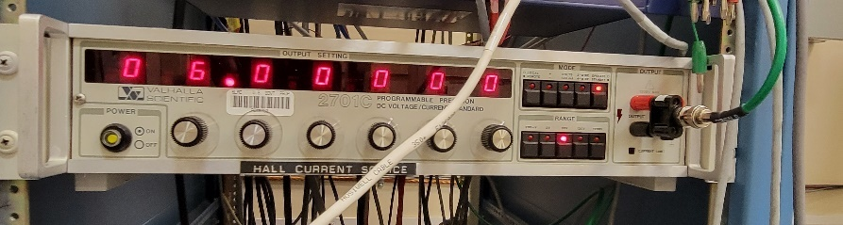
BNC cable to DMM
Picture 8. Voltage standard

7.5 Click “operate/standby” button again to switch the voltage output off. Flip over the cable connector to reverse the output polarity. It is recommended to shorten the connector contacts briefly to remove residual charge.
7.6 Click “operate/standby” button to switch the voltage output on. Write the voltmeter reading for negative voltage.
7.7 Click “operate/standby” button to switch the voltage output off, disconnect cable, switch the voltmeter input to “front”.
7.8 Log-in to the calibration stand computer.
7.9 Start DDMs control program “2Vs.exe”.
7.10 Start the power supply control program “mps853.exe”. The user interface is as in picture 9.

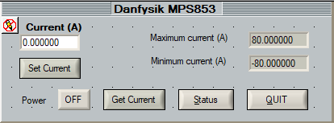
Picture 9. Magnet power supply GUI.

7.11 Switch the power supply ON by clicking the “Power OFF” button on the user interface.
7.12 Type 70.0 in “current (A)” box and click “Set Current”. When setting the current operation will be completed the “current” box will be updated with the latest reading.
7.13 Write down/remember x-voltmeter output on DMMs user interface for +70A current, “+V”.
7.14 Type -70.0 in “current (A)” box and click “Set Current”. When setting the current operation will be completed the “current” box will be updated with the latest reading.
7.15 Write down/remember x-voltmeter output on DMMs user interface for -70A current, “-V”.
7.16 Calculate an average between two x-voltmeter readings, V. If “-V” deviates from V more than 0.05mV, adjust the probe yaw using the goniometer, picture 7. Make sure the probe stays in the center of the gap; adjust, if necessary, using the translation stage.
7.17 Repeat steps 7.12 to 7.16 until |”-V”+ “+V”| < 0.1mV. Probe yaw is set. Exit the “mps853.exe” program.
7.18 Close the DMMs control program.
7.19 Start calibration program “HPCS.exe”.
7.20 In parameters user interface, picture 10, input required information about the probe. In comments, write down Y-voltmeter serial number and the results of the positive and negative voltage checks from items 7.13 and 7.15. All other fields will be filled in automatically; check for correctness.

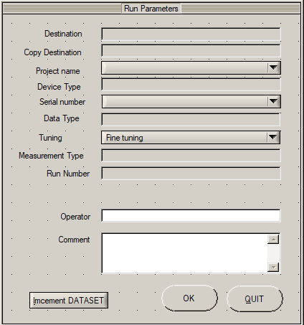
Picture 10. Parameters GUI

7.21 Click “OK”. The main program GUI will upload, as in picture 11.

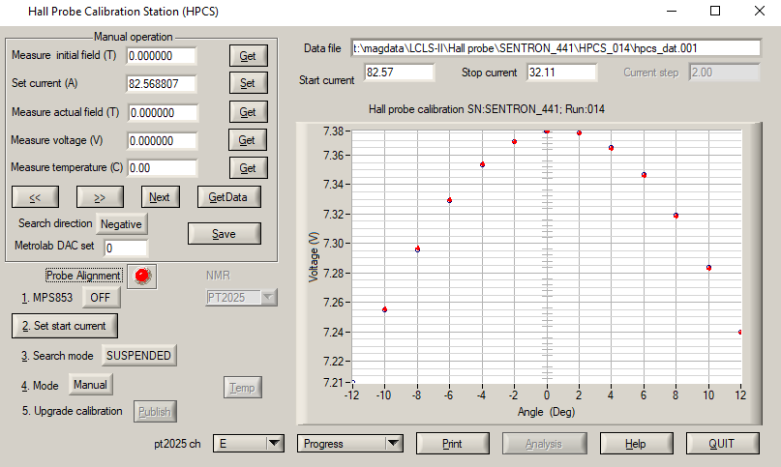
Picture 11. Hall probe calibration main program GUI after probe roll alignment.

7.22 Start probe roll alignment by clicking “Probe alignment” button. It will rotate the probe ±6° in both directions with 2° steps. At each step the y-voltmeter reading will be saved, and a point placed in the user interface graph window. After completion of the measurements in one direction a parabola fit will be made to the measurements to find the maximum. The same procedure will be repeated rotating the probe backwards. At the end the probe zero roll will be found, the stage rotated to the new zero, and the probe will be aligned. The probe roll alignment takes ~ 15 minutes.
7.23 Check the yaw angle, items 7.9 to 7.19, correct if necessary. The roll angle will not change.
7.24 Turn the magnet power supply ON by clicking “MPS853 OFF” button. It will change to “MPS853 ON”
7.25 Click ”Set start current” button. After the current is set the real current reading will appear in the Standard Input/Output Window.
7.26 Click “Search mode Suspended” button to start the NMR search for the resonance. It will change to “Search”.
7.27 In a minute, click “Mode Manual” button to start measurements. It will change to “Auto”.
7.28 When measurements for the range of the current NMR probe are completed, a pop-up window will appear, as in picture 12.

The Picture will be added later.
Picture 12. NMR probe change pop-up.
7.29 Swap the probe in the calibration magnet for the next one and click “OK”.
7.30 Repeat item 7.29 until the last probe.
7.31 After measurements with probe #1 finished, click “Publish” button to save the calibration data into the proper place.
7.32 Check the calibration quality by checking the fit residuals. Click the “Progress” drop-down menu and choose “residuals”. The fit residuals will be in the graph window and could be printed by clicking “Print” button.
7.33 Compare results with the previous calibration. Click the “Progress” drop-down menu and choose “compare”. Select the previous calibration file. The differences in calibrations will be in the graph window and could be printed by clicking “Print” button.
7.34 Exit the calibration program, turn off the chiller, the NMR, the stage controller, and the probe power supply.
7.35 Carefully remove the probe from the calibration stand by reversing the installation procedure. Make sure the power to the probe is OFF when disconnecting/connecting the cables.
7.36 Install the probe back on the measurement bench, connect cables, switch the power on. Make sure to swap the signal wires on DMMs; pay attention to polarities.

8. Post-calibration data processing

8.1 Start Matlab on measurement bench computer.
8.2 Open “hall_probe_calib_param.m” file in Matlab editor.
8.3 Change the HPCS_xxx to the latest run number in the line:
INPUT_FILE_DIR = 'T:\MagData\LCLS-II-HE\Hall probe\SENTRON_463\HPCS_002\'.
8.4 Run “hall_probe_calib.m” program.
8.5 Open “hall_probe_calib_spline.m” file in Matlab editor.
8.6 Change the HPCS_rrr to the latest run number in the line (“rrr” is for the run number):
INPUT_FILE_DIR = 'T:\MagData\LCLS-II-HE\Hall probe\SENTRON_463\HPCS_002\'.
8.7 Run “hall_probe_calib_spline.m” program.
8.8 Copy files:
“calib_spline.dat” from T:\MagData\LCLS-II-HE\Hall probe\xxx
and “SENTRON_463_Y.ini” from T:\MET\MagServe\MMFCalib\xxx
to C:\CVI\current_calib\xxx (“xxx” is for the probe name folder).
Make sure to rename old files on C-drive before copying.

