SLAC Magnetic Measurement Plan for LCLS-II-HE Chicane Dipole Magnets
(5/21/2025)

This measurement plan covers the receipt, mechanical fiducialization, and magnetic measurements of the LCLS-II-HE SXRSS chicane dipole magnets, BXSS1, BXSS2, BXSS3 and BXSS4. These dipoles are water cooled to reach the design field of 0.45 Tm, so they can deflect an 8 GeV beam by 16.7 mrad. The table below gives the MAD names, engineering name, barcode and polarities of the LCLS-II-HE SXRSS chicane dipole magnets. The assembly drawing file for the magnets is Everson Tesla Drawing # 53274. Main coil has 80 turns, Trim coil has 18 turns.

MAD Name | Eng. Name | Barcode | Polarity
BXSS1 | 0.315D14.39-C | 4591 | P
BXSS2 | 0.315D14.39-C | 4592 | N
BXSS3 | 0.315D14.39-C | 4593 | N
BXSS4 | 0.315D14.39-C | 4594 | P

Receiving:
The following information is to be noted upon receipt of the magnets by SLAC:
Date of arrival to SLAC (mm-dd-yyyy): | 04/24/2025
Received by (initials) | SDA
Verify Crate is undamaged (initials): | SDA
Verify shock indicators are not activated. (initials): | SDA
Verify magnet is undamaged and required documentation is included in crate. (initials): | SDA
Serial number: | 03

Preparation:
A beam direction arrow, with text “Beam Direction”, is to be applied to the top and connector side of the magnet. The MAD name label and barcode label must also be attached to the magnet.
Beam-direction arrow and MAD name in place (initials): | SDA
Barcode placed on magnet. | SDA

Fiducialization:
Fiducialization must be done before magnetic measurements. The magnet is to be fiducialized by the CMM group. This will require the location of the geometric axis of the poles of the magnet, and location of tooling balls with respect to the center of this geometric axis. The pole gap, their length, flatness and parallelism should also be measured and noted in a report.

CMM technician (initials): | KC

URL of on-line CMM fiducialization data (please modify or correct if necessary):
http://www-group.slac.stanford.edu/met/MagMeas/MAGDATA/LCLS-II-HE/ Fiducial Reports/4593

Magnetic Measurements:
- Verify that the magnets are complete and undamaged, including wiring connections.
Date of arrival to Mag. Meas.(mm-dd-yyyy): | 5/12/2025
Incoming inspection OK (initials): | SDA

Enter URL of on-line magnetic measurements data (please modify or correct if necessary):
http://www-group.slac.stanford.edu/met/MagMeas/MAGDATA/LCLS-II-HE/Dipole/4593

- Measure the inductance and resistance of the main and trim magnet coils and note the magnet temperature:
Magnet Coil Temperature (ºC): | 20.6
Inductance of main coil (mH) @ 100 Hz: | 3.78
Resistance of main coil (Ohms): | 0.0532
Inductance of trim coil (mH) @ 100 Hz: | 0.257
Resistance of trim coil (Ohms): | 0.0349

- Determine the main coil connection polarity and mark the polarity near the magnet leads with clear “+” and “-” labels as shown below. This will set the polarity as “positive” (P) for BXSS1W and BXSS4W and “negative” (N) for BXSS2W and BXSS3W.

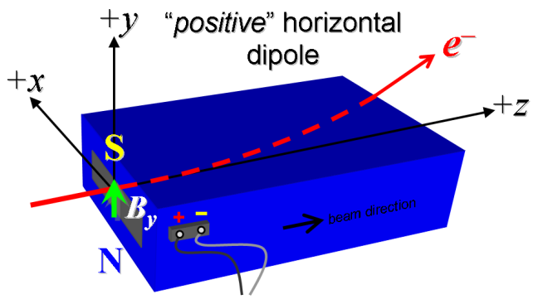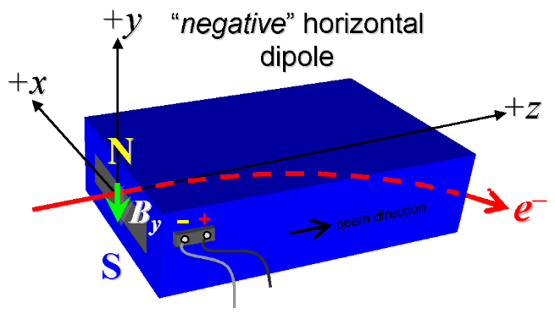

Figure 1. “Positive” polarity (bending electrons up) . “Negative” polarity (bending electrons down).
Main Coil Polarity is marked according to Fig. 1 (initials): | Marked Negative - SDA

- Mark the trim leads with clear “+” and “−” labels such that, with the trim supply outputting positive current, the trim coil increases the absolute value of the magnetic field established by the main coil. This will set the trim polarity as “positive” (P) for BXSS1W and BXSS4W and “negative” (N) for BXSS2W and BXSS3W.
Trim coil polarity chosen from Fig. 1 is (P or N): | Marked Negative - SDA

- Connect magnet to LCW supply. Adjust supply pressure to a ∆P of 80 psi to achieve a flow rate of 0.64 gpm. Run the magnet up to 120 A for 2 hours to warm it up and record the delta Pressure (∆P), flow rate, LCW, magnet coil, steel and ambient air temperatures.
LCW ∆P (psi) | 80 psi
LCW flow rate (gpm) | 0.63 gpm
LCW delta T (°C) | 2.60 °C
Ambient temperature (°C): | 23.87°C
Final magnet core temperature (°C): | 26.73 °C
Top Coil temperature (°C): | 29.76 °C
Side Coil temperature (°C): | 29.19 °C

- Ramp the main of the magnet to 120 A and measure the pole tip field. It should be > 1.1949 Tesla.
Pole Tip Field and Current | 1.330 T @ 120.0188 Amps

- Ramp the main of the magnet to 0 A and then ramp the trim to +6 A and measure the pole tip field. After measurement turn off trim supply.
Trim Pole Tip Field and Current | 0.0204 T @ 5.99958 Amps

- Run the magnet up to 120 A for 1 hour to warm it up and record ∆P, flow rate, and magnet coils and core temperature.
- Standardize magnet using a a three-linear ramp rate of 15.0 A/sec, starting from zero to +120 A, then to −120 A, through three of these full cycles, and ending again at -120 A, all with a flat-top pause time (at each setting of −120 and +120 A) of 10 seconds.
Standardization complete (initials): | SDA

- Maintaining the cycle history, and with the trim coils still not powered, measure the length-integrated vertical dipole field, ∫B_{y}dl, from -120 to +120 A in 10.0 A steps (25 ‘up’ measurements with at least a 10-sec pause at each setting). Then, still maintaining the cycle history, measure ∫B_{y}dl back down from +120 A to −120 A in 10.0 A steps (25 ‘down’ measurements). Resolve the , ∫B_{y}dl measurements to < 1e-4.
Filename & run number of ∫B_{y}dl up & down data: | Wiredat.ru2, Wireplt.ru2

- Fit the data from step 11 and determine the currents for 0.02, 0.150 and 0.45 T-m. Standardize and measure, on the up slope, the fields at ∫B_{y}dl = 0.02, 0.150 and 0.45 T-m three different times, each after being standardized. This will be used to determine repeatablility.
Filenames & run number at up data ∫B_{y}dl = 0.02, 0.150 and 0.45 T-m:
Filename & run number for repeatiblity Run 1 | Wiredat.ru3, wireplt.ru3
Filename & run number for repeatiblity Run 2 | Wiredat.ru4, wireplt.ru4
Filename & run number for repeatiblity Run 3 | Wiredat.ru5, wireplt.ru5
Currents for = 0.02, 0.150 and 0.45 T-m (Amps) | 5.0329, 33.1736, 102.6633 Amps

- Repeat the bipolar standardization of step #10 above with the trim coils still not powered, measure the length-integrated vertical dipole field, ∫B_{y}dl, at I_{main} = 0.
Filename & run number of ∫B_{y}dl at I_{main} = 0: | Wiredat.ru6, wireplt.ru6

- With the trim coil at zero, standardize the magnet as described above in step #10, then set the main coil at I_{main} = 0 amps. Then measure ∫B_{y}dl as a function of trim coil current from 0 to −6 A in 0.5-A steps, including zero (13 ‘down’ measurements), and then from −6 to +6 A in 0.5-A steps (25 ‘up’ measurements) and then from +6 to 0 amps (13 ‘down’ measurements),.
Filename & run # of ∫B_{y}dl trim data at I_{main} = 0 amps: | Wiredat.ru9, wireplt.ru9

- With the trim coil at zero, standardize the magnet as described above in step #10, then set the main coil at to the current found in step 12 for 0.45 T-m. Then measure ∫B_{y}dl as a function of trim coil current from 0 to −6 A in 0.5-A steps, including zero (13 ‘down’ measurements), and then from −6 to +6 A in 0.5-A steps (25 ‘up’ measurements) and then from +6 to 0 amps (13 ‘down’ measurements),.
Filename & run # of ∫B_{y}dl trim data at I_{main} = Amps: | Wiredat.r10, wireplt.r10

- Standardize using the bipolar method of step #10, then measure the length-integrated vertical field over a horizontal span of ± 10 mm at 1-mm intervals, at the following main and trim coil current settings.
- I_{main} = +75 A, and I_{trim} = 0 (all 4 magnets)
- I_{main} = Current for 0.45 T-m Amps, and I_{trim} = 0 (all 4 magnets)

Filename & run # of ∫B_{y}dl vs. x data at 75 A, 0 A: | Wiredat.r7, wireplt.r7
Filename & run # of ∫B_{y}dl vs. x data at Current for 0.45 T-m Amps, 0 A: | Wiredat.r8, wireplt.r8

- Run the best degauss procedure known using cycling of the main coil current (trim current at zero) and record the smallest final measured |∫B_{y}dl| achievable, that is reproducible with I_{main} = 0. A remnant field < 40µT-m is the goal. Note, the degauss procedure should finish with a positive step, by setting the current in the positive direction to zero (i.e., from I_{main} < 0 to I_{main} = 0). Record the degauss procedure applied (ramp rate, hold times, current sequence, etc). See file SRXSSW Dipole Degauss Procedure.docx for more details.
Filename & run # of ∫B_{y}dl after degauss: | Wiredat.r11, wireplt.r11
Poletip Field (G) | Centerline of Pole = -0.2 +/- 0.2, Chamfer = 0.0 +/-0.2
De-Gauss procedure’s mean |∫B_{y}dl| and Stdev (T): | -1.435e-05 +/- 6.0335e-06
Measurements used for mean and stdev (T). | -0.0000230, -0.0000123, -0.0000131, -0.0000090
Ramp rate: | 15 A/s using Three Linear ramp
Hold times: | 2 sec
Current sequence: | {120.0, -120.0, 0.0, -60.0, 51.0, -43.35000, 36.84750, -31.32037, 26.62232, -22.62897, 19.23463, -16.34943, 13.89702, -11.81246, 10.04059, -8.53451, 7.25433, -6.16618, 5.24125, -4.45507, 3.78681, -3.21878, 2.73597, -2.32557, 1.97674, -1.68023, 1.42819, -1.21396, 1.03187, -0.87709, 0.74553, -0.63370, 0.53864, -0.45785, 0.38917, -0.33079, 0.28117, -0.23900, 0.20315, -0.17268, 0.14677, -0.12476, 0.10604, -0.09014, 0.07662, -0.06512, 0.05536, -0.04705, 0.03999, -0.03400, 0.02890, -0.02456, 0.0}

- Using the degauss procedure above, degauss the magnet. With the I_{main} = 0, from the degauss, vary the trim coil current from 0 to -6 A in 0.5-A steps, while measuring the length-integrated vertical dipole field, ∫B_{y}dl, at each setting, including zero (13 ‘up’ measurements), and again from -6 A to +6 A in 0.5-A steps (25 ‘down’ measurements), and finally from +6 A to -6 A in 0.5-A steps (25 more ‘up’ measurements). These field integral values will be quite small, so try to resolve the measurements at the level of < 1 G-m (0.0001 T-m), if possible.
Filename & run # of ∫B_{y}dl vs. trim after degauss: | Wiredat.r12, wireplt.r12

- For the BXSS1 magnet only, after bipolar standardization (step #10 above) measure the harmonics with a rotating coil with main coil at -120, -60, -20, +20, +60 A and +120 A, with trim off. Record probe designation, radius, and data file name:
Coil designation (text): | N/A
Coil radius (mm): | N/A
BXSS1W harmonics filename: | N/A

- For the BXSS1 magnet only, and at a main current of 120 A, with the trim off, measure the vertical magnetic fringe field component, B_{y}, at x = y = 0, as a function of the longitudinal beam-direction coordinate, z (from −10 cm to +30 cm in 1-cm steps, where z = 0 is defined at the iron edge), at the one end of this one magnet. Please also measure the background field at z = +30 cm with magnet switched off (separate file).
Filename of B_{y} vs. z data for BXSS1W exit edge: | N/A
Background filename of B_{y} (z = 30 cm), magnet OFF: | N/A

- Upon completion of tests, send data link to Mark Woodley who will produce a data analysis file. Place data analysis file in magnetic measurements data directory
Magnet data accepted and data analysis file produced | SDA

Enter URL of on-line magnetic measurements analysis data :
http://www-group.slac.stanford.edu/met/MagMeas/MAGDATA/LCLS-II-HE/Dipole/4593/ BCXSS3.pptx

