Revision History
Revision | Date Released | Description of Change
R0 | September 5, 2024 | Original draft
R1 | October 8, 2024 | First revision, with comments from SDA
R2 | March 5, 2025 | Final revision

This traveler is intended to cover reception, preparation, mechanical fiducialization, and magnetic measurements of the Compton Spectrometer magnet to be used in the FACET-II experimental area. The magnet has been designed and fabricated by UCLA. The top level assembly drawing is CPT-A001-BFIELD.pdf. This will be added to the engineering database at a later date. The magnet should be assigned the name COMPS with EPICS name BENDS:LI20:3471.
The magnet will be installed inside the beamline vacuum so handling should be performed with vacuum gloves, and tools wiped with alcohol prior to use, and a tented area to keep debris from contaminating the magnet. The magnet will be disassembled and cleaned for vacuum installation after magnetic testing is completed.
This traveler has been adapted from the FACET BC20 dipole magnet travelers.

Receiving:
The following information is to be noted upon receipt of the magnets by the SLAC MM group:
Received by (initials): | SDA
Date received (dd-mmm-yyyy): | 7/11/2025
SLAC drawing number (enter number): | Not available

Fiducialization:
The magnet is to be fiducialized by the CMM group. MFD will weld the four tooling ball sockets in the locations shown in Fig. 1. These locations will be indicated on the magnet cores by a machined divot at the locations that they will sit. The total mass of the magnetic assembly (cores, coils, stage, and ancillaries) is estimated to be roughly 600 lbs.
All measurements shall be made in reference to the planes indicated in Fig. 1. The primary plane shall be the Y-plane, defined as the horizontal symmetry plane of the magnet. The secondary plane shall be the X-plane, defined in reference to the vertical face of the magnet mounting stage, as shown in Fig. 1. The tertiary plane shall be the Z-plane, defined reference to the perpendicular vertical face of the magnet mounting stage, as shown in Fig. 1. This defines the origin of the coordinate system to be at the location of a convertor target, shown as the source of the electron paths shown in Fig. 3.
The locations of the removable tooling balls and reference planes shall be recorded according to this coordinate system, in addition to the upper and lower faces of the magnet.

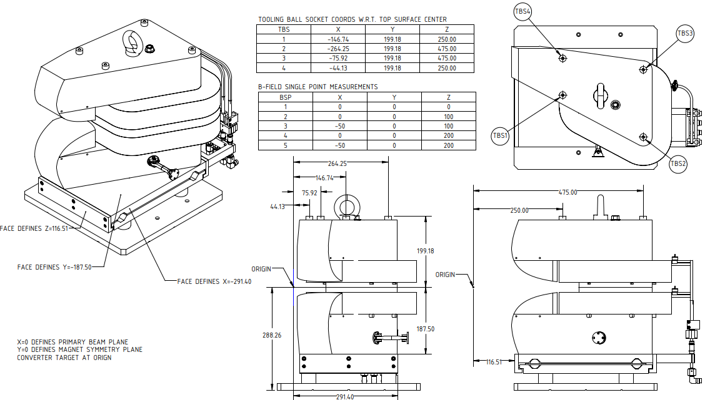
Beam Direction
+z
Figure 1: The definition of the reference planes and origin of the COMPS magnet.
The beam travels in the +Z direction.

CMM technician: | Keith Caban

URL of on-line CMM fiducialization data (please modify or correct if necessary):
http://www-group.slac.stanford.edu/met/MagMeas/MagData/FACET_II/Fiducial%20Reports/Compton Spectrometer

Magnetic Measurements:
- Verify that the magnet is complete and undamaged, including wiring connections. See Figure 2 for details.
Incoming inspection OK (initials): | SDA
Date of arrival to mag. meas.(mmm-dd-yyyy): | 7/11/2025

Enter URL of on-line magnetic measurements data (please modify or correct if necessary):
http://www-group.slac.stanford.edu/met/MagMeas/MagData/FACET-II/Dipole/Compton_Spectrometer

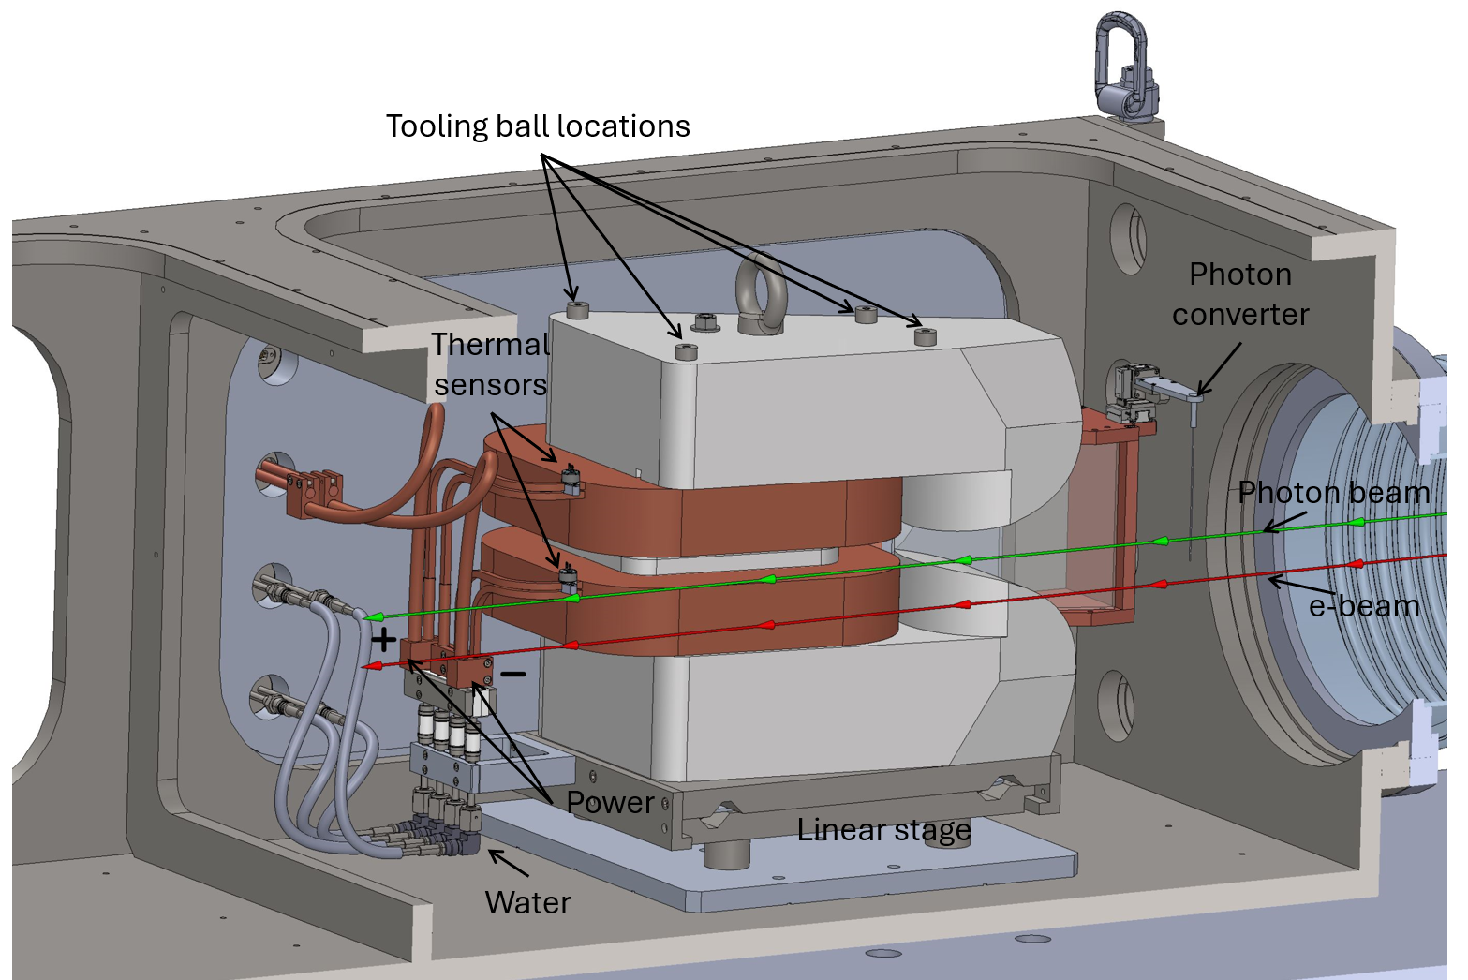
Figure 2: The COMPS magnet as it will be installed in vacuum on the beamline.

- Measure the inductance and resistance of the main and trim magnet coils for each magnet:
Inductance of main coil (mH) @ 100 Hz: | 7.16 mH
Resistance of main coil (Ohms): | 0.0663 Ohm
Coil Temperaure (ºC) | 27.8 ºC

- Determine the main-coil connection polarity (with main supply outputting positive current) which produces a “positive” field polarity for the magnet. The sketches below show the negative polarity, where an electron travelling in positive z direction is deflected towards negative x.

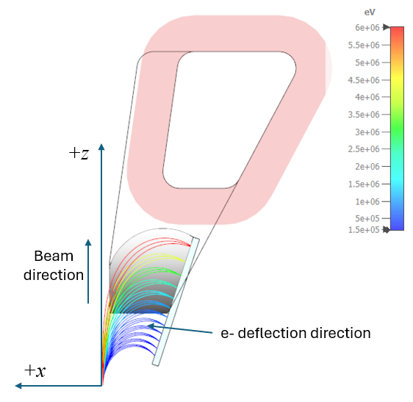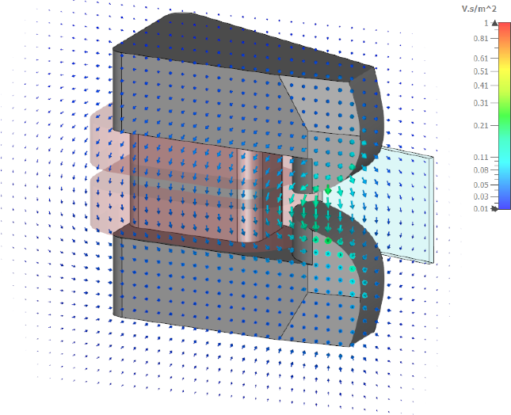
Figure 3: Negative polarity is defined when the magnetic field deflects electrons towards the magnet as indicated.

- Confirm that the magnet leads are with clear “+” and “−” label that provide the field polarity as shown above. The top pole should be the north pole in this field configuration.
Coil polarity set to Negative from Figure 3: | Negative

- Connect the magnet terminals in the correct polarity as established above, to a unipolar power supply with maximum current I ≥ 75 A . The estimated voltage required at 75A is 6.8 V.

- Connect magnet to LCW supply. Adjust supply pressure to a delta P of ~120 psi. Run the magnet up to 70 A for ~1 hour to warm it up (record, delta P, flow rate, and temperature).
LCW delta P (psi) | 124.7 psi
LCW flow rate (gpm) | 0.35 gpm
LCW delta T (°C) | 1.67 °C
Ambient temperature (°C): | °23.8 C
Final Top Coil temperature (°C): | 28.9 °C
Final Core temperature (°C): | 26.2 °C

- Standardize the magnet, starting from zero to 75 A and back to zero, through three full cycles, finally ending at zero, with a flat-top pause time (at both 0 and 75 A) of 30 seconds. Use a Cosine ramp rate of 15 A/sec and record the ramp rate used.
Standardization complete (initials): | SDA
Ramp rate used (A/sec): | 15 A/sec

- Maintaining this cycle history, measure the magnetic field components, $B_{x}$, $B_{y}$, and $B_{z}$ over the measurement region described below at 0, 45, 60, and 75 A.
Measurements shall be acquired at 10mm grid spacing over the volume shown in Figure 4. A 4mm stay clear distance has been used from any pole surfaces. A data file containing the coordinates of the measurement points will be provided, with filename CPT-P033-grid-10mm.h5.
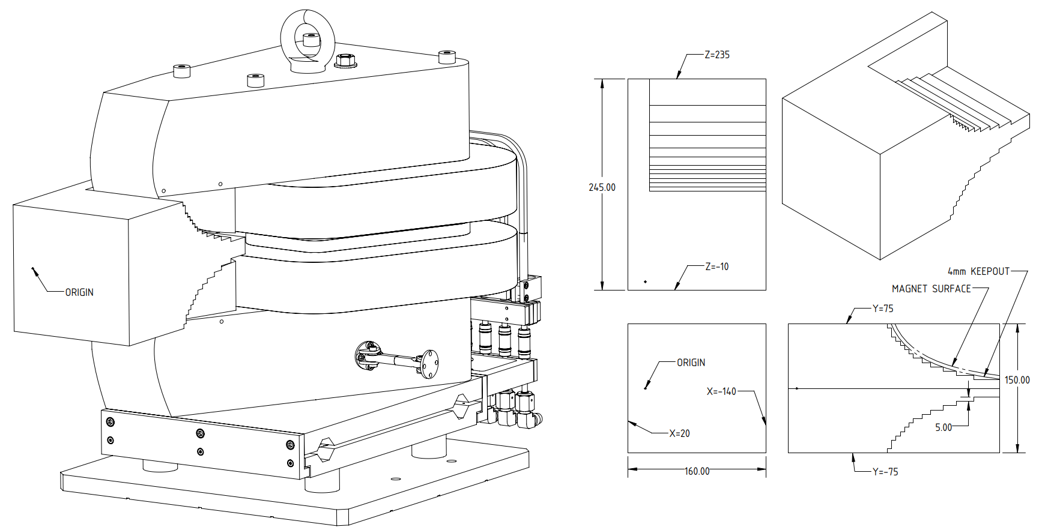
Figure 4: The measurement region covers the noted volume with a 10mm grid spacing for a total number of 4958
measurement points.

Filename of $B_{x}$, $B_{y}$, and $B_{z}$ vs $(x, y, z$) at 45 A | bhxyzvsxyzdat.ru2, bhxyzvsxyzplt.ru2
Filename of $B_{x}$, $B_{y}$, and $B_{z}$ vs $(x, y, z$) at 60 A | bhxyzvsxyzdat.ru3, bhxyzvsxyzplt.ru3
Filename of $B_{x}$, $B_{y}$, and $B_{z}$ vs $(x, y, z$) at 75 A | bhxyzvsxyzdat.ru4, bhxyzvsxyzplt.ru4
Filename of $B_{x}$, $B_{y}$, and $B_{z}$ vs $(x, y, z$) at 0 A | bhxyzvsxyzdat.ru5, bhxyzvsxyzplt.ru5

- Standardize the magnet and record measurement of field components at several coordinates at 1 A increments between 0 and 75 A, then repeat the measurements from 75 to 0 A. Measure at coordinates:
  - P1 (x, y, z) = ( 0, 0, 0) mm
  - P2 (x, y, z) = ( 0, 0, 100) mm
  - P3 (x, y, z) = (-50, 0, 100) mm
  - P4 (x, y, z) = ( 0, 0, 200) mm
  - P4 (x, y, z) = (-50, 0, 200) mm

Filename & run number of $B_{x}$, $B_{y}$, and $B_{z}$ vs $(x, y, z$) up & down data: | bhxyzvsxyzdat.ru6, bhxyzvsxyzplt.ru6

- Upon completion of tests, email URL of on-line data to Doug Storey (dstorey@slac.stanford.edu for determination if the magnet is accepted. Upon acceptance of magnet, analysis data will be placed in on-line data folder.
Magnet accepted:
Assigned beamline location (MAD-deck name): | COMPS

