SLAC Magnetic Measurement Plan for FACET-II IP Chicane Dipole Magnets
Author:
PA#:

This measurement plan covers the mechanical fiducialization, and magnetic measurements of the FACET-II IP chicane dipole magnets, BCX203280, BCX203282, BCX203284, and BCX203286. The table below gives the MAD names, engineering name, barcode and polarities, of the FACET-II chicane dipoles. The Stangenese assembly drawing number is 731-30822-10 Rev 2.

MAD Name | Eng. Name | Barcode | Polarity
BCX203280 | 0.315D13.08-C | 4595 | P
BCX203282 | 0.315D13.08-C | 4596 | N
BCX203284 | 0.315D13.08-C | 4597 | N
BCX203286 | 0.315D13.08-C | 4598 | P

Receiving:
The following information is to be noted upon receipt of the magnets by the SLAC MM group:
Received by (initials): | SDA
Date placed on test stand (dd-mmm-yyyy): | 11/21/2025
SLAC barcode number: | 4597
Serial number: | 30822-1

Preparation:
A beam direction arrow, with text “Beam Direction”, is to be applied to the top and/or connector side of the magnet as directed by FACET-II. The MAD name label should also be attached to the magnet.
Beam-direction arrow and MAD name in place (initials): | SDA

Fiducialization:
Fiducialization must be done before magnetic measurements. The magnet is to be fiducialized by the CMM group. This will require the installation of sockets for removable tooling balls, location of the geometric axis of the poles of the magnet, and location of tooling balls with respect to the center of this geometric axis when the poles are aligned precisely horizontal. The pole gap, flatness and parallelism should also be measured and noted in a report.

CMM technician: | Keith Caban

URL of on-line CMM fiducialization data (please modify or correct if necessary):
http://www-group.slac.stanford.edu/met/MagMeas/MAGDATA/FACET-II/ Fiducial Reports/FACET-II IP CHICANE DIPOLE MAGNETS

Magnetic Measurements:
- Verify that the magnets are complete and undamaged, including wiring connections.
Incoming inspection OK (initials): | SDA
Date of arrival to mag. meas.(mmm-dd-yyyy): | 11/21/2025

Enter URL of on-line magnetic measurements data (please modify or correct if necessary):
http://www-group.slac.stanford.edu/met/MagMeas/MAGDATA/FACET-II/Dipole/4597

- Determine the main-coil connection polarity from the first table and mark the polarity near the magnet leads with clear “+” and “-” labels as shown below. This will set the main polarity as “positive” (P) for BCX203280 (4595) and BCX203286 (4598) and “negative” (N) for BCX203282 (4596) and BCX203284 (4597).
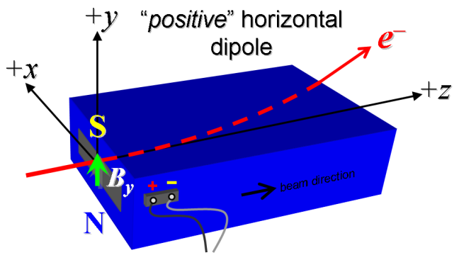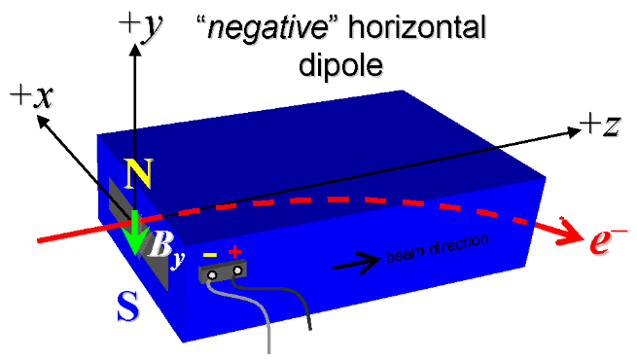

Figure 1. “Positive” polarity (bending electrons left). “Negative” polarity (bending electrons right).
Main Coil Polarity is marked according to Fig. 1 (initials): | N

- Mark the trim leads with clear “+” and “−” labels such that, with the trim supply outputting positive current, the trim coil increases the absolute value of the magnetic field established by the main coil. This will set the trim polarity as “positive” (P) for BCX203280 (4595) and BCX203286 (4598) and “negative” (N) for BCX203282 (4596) and BCX203284 (4597).
Trim coil polarity chosen from Fig. 1 is (P or N): | N

- Connect the magnet terminals, in the correct polarity as established above, to a bipolar power supply with maximum current I ≥ 14.5 A. Measure pole tip field of the main at 14.5.
Pole Tip Field and Current | -1.403 T at 14.49896 Amps

- Connect the magnet terminals, in the correct polarity as established above, to a bipolar power supply with maximum current I ≥ 6 A. Measure pole tip field of the trim at 6 amps.
Pole Tip Field and Current | -0.1513 T at 6.00586 Amps

- In an environment with ambient temperature of about 20°C (68°F), set the magnet’s main to 14.5 A for ~5 hours to warm it up (verify this is steady-state temp. and record value). Do not let the coil temperatures exceed at delta temperature rise of 45 °C.
Ambient temperature (°C): | Magnet can’t run at 14.5 without fan!!
Final magnet top core surface temperature (°C):
Final magnet inner top coil surface temperature (°C):
Final magnet outer coil surface temperature (°C):

- Repeat the previous step with a fan blowing air over the back face of the magnet, opposite the gap, from ~5 inches distance. Record the temperature every half hour or more as well as the final, steady-state temperature. Do not let the coil temperatures exceed at delta temperature rise of 45 °C.
Ambient temperature (°C): | 19.64
Final magnet top steel surface temperature (°C): | 25.96
Final magnet top coil inner surface temperature (°C): | 42.89
Final magnet top coil outer surface temperature (°C): | 44.97

- Standardize magnet using a cosine ramp, starting from zero to +14.5 A, then to -14.5 A, and finally back to zero, through three of these full cycles, and ending again at -14.5 A, all with a flat-top pause time (at each setting of -14.5 And +14.5 A) of 10 seconds. Use a cosine ramp rate of 2.0 A/sec and record the ramp rate used.
Standardization complete (initials): | SDA
Ramp rate used (A/sec): | 2 A/sec

- Maintaining the cycle history, and with the trim coils still not powered, measure the length-integrated vertical dipole field, ∫B_{y}dl, from -14.5 to +14.5 A in 1.0 A steps (41 ‘up’ measurements with at least a 10-sec pause at each setting). Then, still maintaining the cycle history, measure ∫B_{y}dl back down from +14.5 A to -14.5 A in 1.0 A steps (40 ‘down’ measurements).
Filename & run number of ∫B_{y}dl up & down data: | Wiredat.ru2, wireplt.ru2

- Repeat the bipolar standardization of step #6 above with the trim coils still not powered, measure the length-integrated vertical dipole field, ∫B_{y}dl, at I_{main} = 0.
Filename & run number of ∫B_{y}dl at I_{main} = 0: | Wiredat.ru3, wireplt.ru3

- With the trim coil at zero, standardize the magnet as described above in step #6, then set the main coil at I_{main} = 0. Then measure ∫B_{y}dl as a function of trim coil current from 0 to -6 A in 0.5-A steps, including zero (13 ‘down’ measurements), and again from -6 to +6 A in 0.5-A steps (25 ‘up’ measurements). Then set the trim current to zero.
Filename & run # of ∫B_{y}dl trim data at I_{main} = 0: | Wiredat.ru4, wireplt.ru4

- With the trim coil at zero, standardize the magnet as described above in step #6, then set the main coil at I_{main} = 13 A. Then measure ∫B_{y}dl as a function of trim coil current from 0 to -6 A in 1.0 A steps, including zero and again from -6 to +6 A in 1.0 A steps . Then set the trim current to zero.
Filename & run # of ∫B_{y}dl trim data at I_{main} = 13 A: | Wiredat.ru5, wireplt.ru5

- Run the best degauss procedure known using cycling of the main coil current (trim current at zero) and record the smallest final measured |∫B_{y}dl| achievable and reproducible with I_{main} = 0. Please also finish the degauss procedure with a positive step, by setting the current in the positive direction to zero (i.e., from I_{main} < 0 to I_{main} = 0). Record the degauss procedure applied (ramp rate, hold times, current sequence, etc). See file SRXSS Dipole Degauss Procedure.docx for more details.
De-Gauss procedure’s mean |∫B_{y}dl| and Stdev (T-m): | 1.69E-05 +/- 3.63868E-06
Measurements used for mean and stdev (T-m). | 0.0000211, 0.0000149, 0.0000147
Ramp rate: | 2 A/s
Hold times: | 3 sec
Current sequence: | 14.5, -12.47, 10.7242, -9.22281, 7.93162, -6.82119, 5.86622, -5.04495, 4.33866, -3.73125, 3.20887, -2.75963, 2.37328, -2.04102, 1.75528, -1.50954, 1.29820, -1.11646, 0.96015, -0.82573, 0.71013, -0.61071, 0.52521, -0.45168, 0.38845, -0.33406, 0.28729, -0.24707, 0.21248, -0.18274, 0.15715, -0.13515, 0.11623, -0.09996, 0.08596, -0.07393, 0.06358, -0.05468, 0.04702, -0.04044, 0.03478, -0.02991, 0.02572, -0.02212, 0.01902, -0.01636, 0.01407, -0.01210, 0.0

- With the degauss procedure finished, the trim coil still at zero, and without having changed the main coil current at all from its I_{main} = 0 setting after step #10 above, please vary the trim coil current from 0 to -6 A in 0.5-A steps, while measuring the length-integrated vertical dipole field, ∫B_{y}dl, at each setting, including zero (13 ‘up’ measurements), and again from -6 A to +6 A in 0.5-A steps (25 ‘down’ measurements), and finally from +6 A to -6 A in 0.5-A steps (25 more ‘up’ measurements). These field integral values will be quite small, so please take care to resolve the measurements at the level of <0.001 kG-m, if possible.
Filename & run # of ∫B_{y}dl after degauss: | Wiredat.ru6, wireplt.ru6
Poletip Field (G) | 0.0 +/- 0.0
Filename & run # of ∫B_{y}dl vs. trim after degauss: | Wiredat.ru7, wireplt.ru7

- For all four dipoles, with stretched wire, and after re-standardization using the bipolar method of step #6, measure the length-integrated vertical field over a horizontal span of ±13 mm at each 2-mm interval, at the following main and trim coil current settings.
- Imain = +13 A, and I_{trim} = 0 (all 4 magnets)
- Imain = +14.5 A, and I_{trim} = 0 (all 4 magnets)

Filename & run # of ∫B_{y}dl vs. x data at 13 A, 0 A: | wirevsx.ru8, wirepltvsx.ru8
Filename & run # of ∫B_{y}dl vs. x data at 14.5 A, 0 A: | wirevsx.ru9, wirepltvsx.ru9

- Measure the inductance at 100 Hz and resistance of the main and trim magnet coils and also verify the concurrent magnet temperature:
Magnet Coil temperature on top surface (ºC): | 19.9
Inductance of main coil (mH): | 229.1
Resistance of main coil (Ohms): | 1.3710
Inductance of trim coil (mH): | 20.7
Resistance of trim coil (Ohms): | 2.554
OhmMeter | Keithly 580
Inductance meter | BK Precision 880

- Upon completion of tests, send data link to Mark Woodley who will produce a data analysis file. Place data analysis file in magnetic measurements data directory
Magnet data accepted and data analysis file produced

Enter URL of on-line magnetic measurements analysis data :
http://www-group.slac.stanford.edu/met/MagMeas/MAGDATA/FACET-II/Dipole/4597

