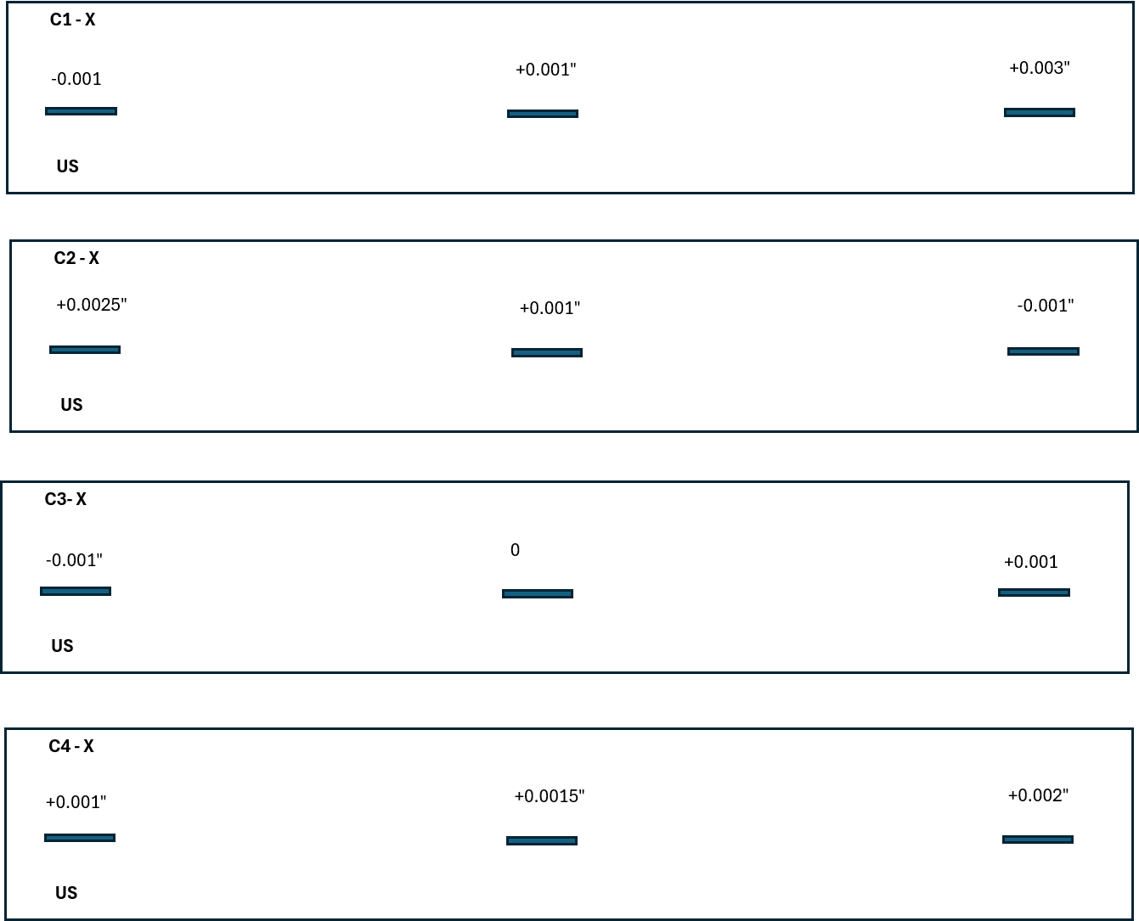
C1 - Y
-0.0015"
-0.0015
-0.0015
-0.0015
-0.001
-0.001
-0.001
-0.001"
US
C2 - Y
0"
"
0"
0"
0"
0"
-0.0005
0.0
0.0
US
C3 - Y
+0.0005"
"
+0.0005"
0
0"
0"
0.0
0
0
US
C4 - Y
0
"
0"
0"
+0.0005"
+0.0005"
+0.0005"
0
0"
US

